University of Baltimore Furniture Request Form

Please indicate if you are requesting used furniture from UB storage or new furniture. If requesting new furniture, you must make selection from the standardized furniture selection below.
Note: All new furniture purchases must be approved by department supervisor.
UB Storage New Furniture

Item | Description | Dimensions | Price | Colors | Links
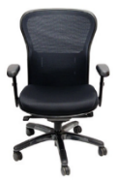  Bel Air Junior | Adjustable height chair with black mesh back and  Upholstered seat, adjustable arms.  Options: Arms or No Arms | 27.5" W x 25" D x 44.25" H | $179 (no arms)  $226 (w/ arms) | Black | https://store.mce.md.gov/p-1731-bel-air-jr.aspx
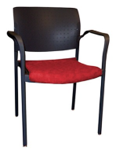  Rockville w/ Arms | Upholstered seat with plastic back and metal arms  Options: Variable Fabric Choice | 23 1/2"W x 23"D x 32"H | Varies w/ fabric choice | Varies | Chair: https://store.mce.md.gov/p-1446-rockville-with-arms-upholstered-seat-poly-back-plastic-glide.aspx  Fabric: https://mce.md.gov/Portals/0/Containers/MCE/images/page/Contract%20Seating%20Fabrics%202017.pdf
Canton L-Shaped Desk | L-shaped desk with (3) file drawers and two (2) box drawers, adjustable keyboard tray  Options: Left return or Right Return | Desk: 72"L x 30"D x 30"H  Return: 48"L x 24"D x 30"H | $1104.00 | Mahogany | https://store.mce.md.gov/p-168-canton-l-shaped-desk.aspx
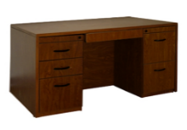  Canton Executive Desk | Standard desk has pencil drawer, Box/Box/ File drawer unit and file/file drawer unit | 60"L x 30"D x 30"H | $692.00 | Mahogany | https://store.mce.md.gov/p-169-canton-executive-desk.aspx
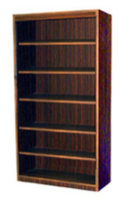  Canton Bookcase | Bookcase with (5) adjustable shelves | 36"L x 12"D x 72"H | $241.00 | Mahogany | https://store.mce.md.gov/p-170-canton-36-x-72-bookcase.aspx
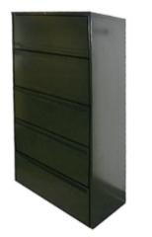  Lateral File Cabinet | File cabinet with (5) drawers | 36”W x 18” D x 65”H | $797.00 | Black | https://store.mce.md.gov/p-176-lateral-file-cabinet-5-drawer.aspx

Furniture Needed | Addl. Options (If Applicable) | Quantity | Location

 | Requestor Information | Approval Signature
Name
Title
Signature
Date

Requestor Additional Comments:

