Interior Signage Request Form
Installation of any signs on facilities and properties of the University must be approved, coordinated, and designed by the Office of Capital Planning and Campus Operations. This effort is necessary to ensure that the project meets all State and Federal codes and standards for signs established by the University. Types of signs requiring this approval include, but are not limited to all interior signs for buildings, directories, and bulletin boards.
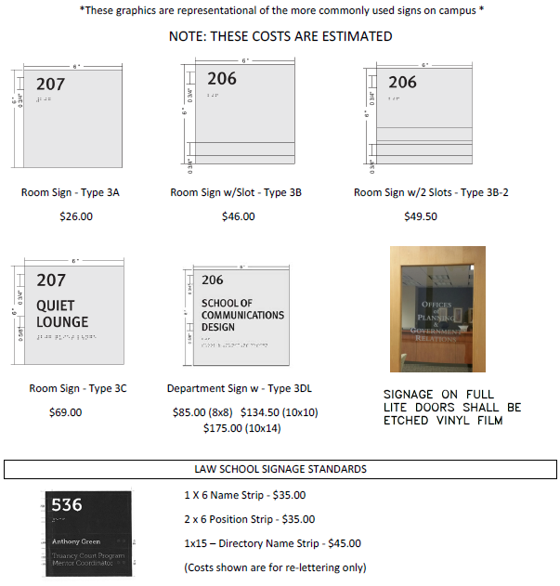
*Please fill in form below, obtain required signatures, and submit to Office of Capital Planning and Campus Operations.
Email: capitalprojects@ubalt.edu
Add rows for each sign type as needed.
Sign Type | Location | Text on Sign

 | Requester Information | Approval Signature
Name
Title
Signature
Date

Requestor Additional Comments:

