Student Success at the University of Baltimore

Our first priority at UB is the success of our students. We are working diligently to help students reach their college completion goals in a timely manner through various efforts to ensure student success. We continue to serve an undergraduate population that skews heavily toward adult and transfer students; in fact, the average age of a UB student is 28 years old for undergraduates and 33 years old for graduate students. Seventy-nine percent of our undergraduate students transfer into the University from community colleges or from other higher education institutions. The University delivers undergraduate, graduate and legal education through its four schools and colleges: the UB School of Law, the Yale Gordon College of Arts and Sciences, the College of Public Affairs and the Merrick School of Business. Here are a few of the opportunities for students at the University of Baltimore:

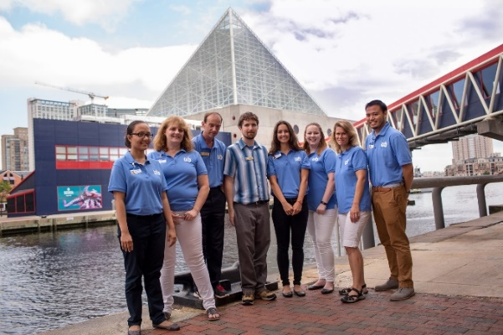
- National Aquarium Conservation Research

Undergraduate and graduate psychology students and several faculty members from the Division of Applied Behavioral Sciences conduct conservation behavior research as part of an ongoing partnership with the National Aquarium. Students engage in systemic applied psychological research to change conservation behaviors. Projects entail detailing and preparing specifications and requirements for meeting the aquarium’s overall needs, while others involve students engaging in scientific research. Several students continue to work at the aquarium as volunteers or as part of a practicum course to strengthen their survey development and analytic skills.

- Court Navigator Pilot Project

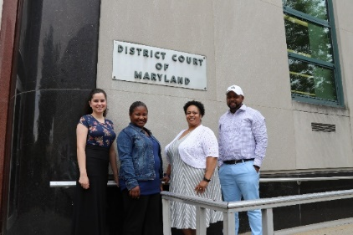
UB has partnered with the city’s District Court on a pilot project called the Court Navigator Pilot Project. UB students in this pilot program are trained on court proceedings to help unrepresented tenants with lawsuits seeking repairs and financial compensation. Currently, 25 UB students are assisting hundreds of tenants while learning firsthand about the legal system.
Students in this program provide tenants with basic information about legal options and assist tenants with filling out court forms, organizing their paperwork, figuring out budgets, coping with the court processes and hallway negotiations, and accessing resources—all that is permitted under law for non-lawyers to do. If UB’s pilot is successful, it may be permanently established and expanded to include a greater variety of cases and more Maryland courts.
Fun Facts About UB
- U.S. News & World Report ranked UB’s Clinical Law Program #12 in the nation.
- UB is ranked #1 in Maryland and #35 in the United States on the Social Mobility Index (the extent to which education enables students to make upward progress).
- 40 percent of UB students are first-generation.
- 40 percent of UB students are first-generation American.
- 75 percent of undergraduates are over 24 years old.
- 50% of undergraduates and 80% of graduate students work full time.
- UB is ranked #4 out of 29 Maryland colleges for highest median earnings for former students 10 years after admission, according to the Baltimore Business Journal.

- Second Chance College Program
UB’s Second Chance College Program, a special U.S. Department of Education re-entry program, is offered at Jessup Correctional Institution, a medium-security prison for men. In fall 2017, 28 JCI students enrolled to study toward a Bachelor of Arts in Nonprofit Management and Community Leadership with a minor in entrepreneurship. UB has also developed a mentorship and tutoring program for the JCI students. The mentors and tutors are incarcerated men at JCI who are active leaders and role models in the prison. Many of the mentors have a college education and are strongly committed to higher education.
UB’s Second Chance College Program model allows most Jessup Correctional Institution students to begin their coursework at JCI and to transition to UB once released. JCI students receive support services to assist with the transition to their communities and immediately attend classes at UB.

- Community Development Fellowship Program

The Community Development Fellowship Program, launched in fall 2016, offers motivated students with a strong interest in effecting positive change in urban areas the opportunity to strengthen their leadership skills and gain hands-on experience in Baltimore neighborhoods. UB Fellows are matched with a community-based organizations in the city. Organizations include the Baltimore Main Streets program, Bon Secours Community Works, Historic Greenmount West Community Association and public-private partnerships dedicated to economic or community-development work. By matching students with organizations that directly support Baltimore neighborhoods, this grant-funded fellowship program aims to improve the city while cultivating the next generation of community development leaders.

- Global Experiences in Criminal Justice

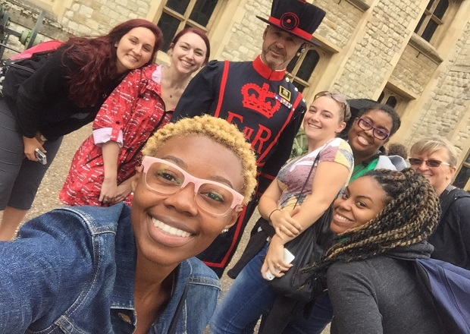
Each year, the Comparative Issues in Criminal Justice course offers undergraduate and graduate options that combine in-class instruction and global immersion. These opportunities provide UB students with the opportunity to learn, explore and experience current issues in criminology, criminal justice and victim services around the world. In 2015, students studied human rights and traveled to Belgium, England and the Netherlands. In 2016, students studied human trafficking and traveled to Czech Republic, Germany and The Netherlands. In 2017, students studied gender-based violence and traveled to Barcelona, Spain. And in summer 2018, students will examine public policy issues related to crime and violence, particularly in a post-communist nation, and will travel to Poland.

- Ratcliffe Entrepreneurship Fellows Within UB’s Entrepreneurship Fellows Program

The Entrepreneurship Fellows Program at UB offers a new way to educate the next generation of entrepreneurs. The program balances classroom theory with periods of practical, hands-on experience prior to graduation. Through this program, students are able to engage in an alternative academic study, gaining practical experience by working side by side with expert entrepreneurs and faculty.

Thanks to the scholarships provided by Philip E. and Carole R. Ratcliffe Foundation, these student entrepreneurs are able to fully fund four semesters of their education (as well as some additional expenses) while building their business. The scholarship is a key element for of the program’s success. Scholarship recipients, known as Ratcliffe Fellows, are expected to launch a new venture on or before graduation. Students focus on building ventures rather than funding their education, and the fellowship provides another layer of support for their success.

- Fannie Angelos Program for Academic Excellence

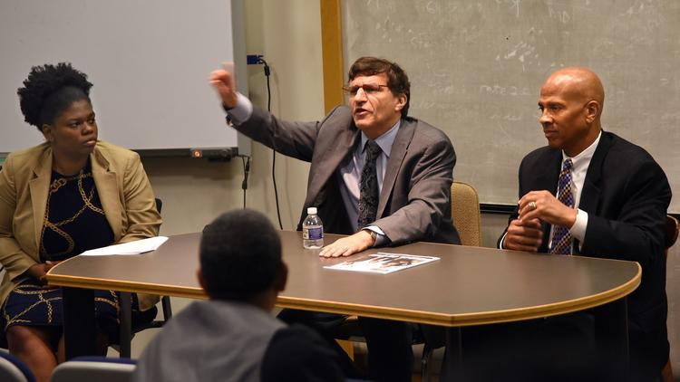
The Fannie Angelos Program for Academic Excellence is a collaboration among the UB School of Law and Maryland’s historically black colleges and universities. Founded in 1995 as the Baltimore Scholars Program, the program aims to help students pass the Law School Admissions Test (LSAT), to prepare them to excel once they begin their formal legal education and to increase diversity in the legal profession. The Fannie Angelos Program comprises two main components: the LSAT Award Program and the Fannie Angelos Scholars Program. The LSAT Award Program provides LSAT preparation to help up to 72 students build strategies to increase their LSAT scores. The Fannie Angelos Scholars Program is open to eight juniors and seniors attending Bowie State University, Coppin State University, Morgan State University and the University of Maryland Eastern Shore. Each year, the students selected to participate in this program are eligible for a full law-school tuition scholarship at the University of Baltimore School of Law. Many members of the UB community—faculty, staff and alumni—contribute time and resources to make the program a success.

- The Bob Parsons Veterans Center

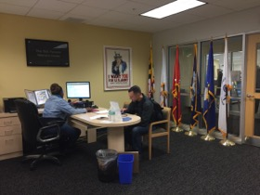
In 2017, Victory Media named UB a Top 10 Military Friendly Institution, a distinction is awarded to institutions delivering an outstanding experience to military students. The Bob Parsons Veterans Center, established via a $1 million dollar gift from The Bob and Renee Parsons Foundation, champions the success of military-connected students at the University of Baltimore by providing purposeful opportunities for growth and excellence. The approximately 350 military-connected students at UB benefit from initiatives and programs such as benefits counseling, community service activities, recognition events such as Salute Our Troops Week and Armed Forces Day, student organizations, counseling support and one-on-one coaching.

- The Bob Parsons Veterans Advocacy Clinic in the UB School of Law

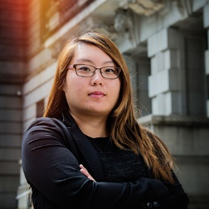
The Bob Parsons Veterans Advocacy Clinic provides pro bono legal services to Maryland's veterans, helping them apply for disability payments and pensions they may be entitled to as a result of their service. Clinic students and their supervisors prepare the extensive and complex documentation their clients need to apply for benefits successfully and represent any clients on appeal when their benefits are denied. They also help wrongfully discharged veterans petition for upgrades to their discharge status, as if veterans exit the military under conditions other than honorable, they are not eligible for veterans affairs services.
UB's clinic is funded through a generous gift from Bob Parsons, B.S. '75, D.H.L. '08, a veteran who attended the University following his military service. Participating students practice their skills in research, analysis, case file management and oral and written communication. During the semester-long clinic, they spend about 20 hours a week working with clients, attending instructional seminars and meeting with their supervisors to discuss cases.

Current UB Students Soar with Success

The University of Baltimore knows how to support its students, as is evidenced by its four schools and colleges, each offering a practical, career-focused education; a nearly 100-year history of helping students balance learning, work, family and more; and an undergraduate and graduate curriculum emphasizing experiential opportunities. UB is here to help students bring their venture to reality—from idea to plan to fruition.

University of Baltimore students leverage this support all the time. It's not unusual for an MBA student to seek advice from professors and fellow students about how to finance a venture. It's typical to see students in the B.S. in Simulation and Game Design program work together on a product that they have every intention of bringing to market. It is expected in the Entrepreneurship Fellows Program that every participating student will launch a real business as a capstone project. Students studying government and public policy in the College of Public Affairs and in the UB School of Law learn the ins and outs of nonprofits, while those enrolled in the M.F.A. in Creative Writing & Publishing Arts cover every aspect of authoring and publishing their own books. Supporting student ventures is what UB does.

- Alan Tsao: Just Watch Him Succeed
Alan Tsao, B.S. ’11 and a current MBA student at UB, is the creator and owner of Tsao Baltimore, a company making and selling Tsao’s own line of luxury watches. Tsao plunged ahead into the setup of the company with a business and financing strategy and an initial marketing strategy with a focus on social media. Tsao launched a Kickstarter campaign with an out-of-the-gate goal of $41,500, which he exceeded in a matter of hours; to date, he has raised more than $115,000.

Now, Tsao is preparing to enter the next phase of product development and is negotiating with retailers to carry his watch line. Tsao partnered with an Ellicott City company, Clockwork Synergy, to produce a range of watchbands that matches his desire for a look that differentiates the Tsao line from those of other watchmakers. Eventually, he would like to establish both a manufacturing and retail presence in Baltimore for his company.

- Natasha Guynes: Helping Young Women to Thrive

Natasha Guynes, a student in the University of Baltimore's Master of Public Administration program, is a living testimony of UB's philosophy of applied learning with a focus on community. A survivor of a traumatic childhood, Guynes has figured out how to apply her hard-won knowledge to help bring stability into the lives of other women. A nonprofit organization she started in Washington, D.C., the HER Resiliency Center, is helping young women overcome huge challenges in their lives. Guynes decided to establish HER Resiliency Center as a place for women battling issues including substance abuse, homelessness and trauma. The HER Resiliency Center is for women who identify as female and are between the ages of 18 and 25. In fall 2017, HER Place opened as a transitional home that gives young women a safe place to live and get on their feet. HER Place can be a home for five young women to live for up to 18 months with 24-hour intensive support and care. In addition to a welcoming home, the emergency shelter bed program helps get young women off the streets and into a safe place as soon as possible.

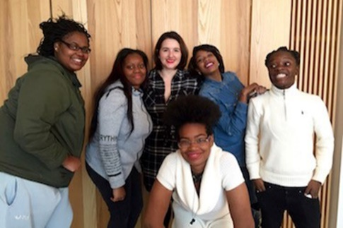
Guynes is setting up mentorships and jobs for the women in the program; recruiting an active, high-quality board of directors; and working on funding sources. As Guynes continues her classes at UB, she is also seeking grants, arranging services and establishing standards such as trauma-informed certification for staff members. As president, she is strengthening the name of the center through outreach across the city and beyond and seeing her nonprofit as a model that could be replicated in other cities.

- Robin Holmes: Grab Success While It’s Hot

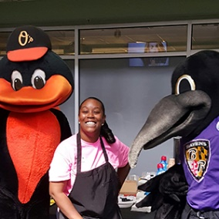
In the span of only a couple of years, Robin Holmes, B.S. '12, went from being the model University of Baltimore student—older, working, raising a family and meeting the goals of her education on her terms—to winning a door-opening business prize at the University. Now, she's an independent businesswoman who runs Deddle’s Donuts, which provides freshly made, intricately decorated donuts.

Holmes returned to UB to pursue a master’s degree and entered the fall 2016 Leonard and Phyllis Attman Business Prize Competition, a chance for students and recent alumni to present their startup business ideas to a panel of expert judges in pursuit of cash prizes, including a $2,500 grand prize. Holmes showed off her donut business, which she started out of a food truck bought with her own money. The business competition prize money was the seed fund money she needed to launch the next step of her business with the purchase of a free-standing donut making machine.

A Selection of the University of Baltimore’s Centers and Institutes

- Center for Drug Policy and Enforcement

In April 2017, the University of Baltimore's College of Public Affairs established the new Center for Drug Policy and Enforcement—a gathering of policy experts, advocates and scholars dedicated to scientific research and best practices for stopping the proliferation of drugs and violence in our communities. The center focuses on initiatives to reduce drug trafficking, money laundering, firearms trafficking, drug-related violence and gang activity and to pursue strategies to advance a public-health approach to resolving the core problem of addiction. The center's efforts, entirely funded by government grants, focus on Maryland, the District of Columbia, Virginia and West Virginia.

A cornerstone of the CDPE is the High Intensity Drug Trafficking Area (HIDTA), a federal grant program. There are 28 HIDTA locations throughout the country that are administered by the White House and provide resources to federal, state and local agencies with the goal of reducing drug trafficking and production. The data provided by UB’s center and by HIDTA can help law enforcement and policymakers develop evidence-based strategies. The Overdose Detection Mapping Application Program, developed by HIDTA, is a mobile-based application that allows first responders to log incidents of overdoses with a push and a button. This information is then mapped and analyzed. By mapping these overdoses, law enforcement and public health officials can anticipate and prepare for overdose spikes before they happen. This is one example of the the Center for Drug Policy and Enforcement’s real and positive impact on drug policy issues.

- Schaefer Center for Public Policy

The William Donald Schaefer Center for Public Policy is one of UB’s most visible components, connecting the University with leaders, policymakers and residents throughout Maryland. To ensure Baltimore’s election judges—known as poll workers in other states—were prepared to discharge their duties, the Schaefer Center provided in-person, hands-on training for more than 4,100 election judges for the 2016 general election. Training sessions were held at the University of Baltimore and Maritime Industries Academy School #431. The center also held the first “Election Judge Training Open House” at UB Nov. 4-5, 2016, featuring mock precincts providing an opportunity for election judges to practice using the voter equipment prior to the Nov. 8, 2016, election.

- The Jacob France Institute

In the fall 2017, the Baltimore Neighborhood Indicators Alliance-Jacob France Institute (BNIA-JFI) announced the launch of the GEOLOOM co>map, an online, interactive map of Baltimore featuring arts and culture information along with community indicators such as census demographics, children and family health, and crime and safety data. The "co" in GEOLOOM co>map stands for community, collaboration and cohesion in Baltimore.

The GEOLOOM co>map tool adds cultural data that is a vital but often missing element in conversations about neighborhoods. The GEOLOOM co>map is rooted in the idea that arts and culture play a significant role in fostering the vitality of a place. Neighborhood-based arts and cultural activity can have an impact on residents’ attachment to their community, on the overall economic conditions in their neighborhood and on the quality of life for the entire city. This project is the result of more than three years of research, listening and data-gathering integrated into the web map. In order to expand on the existing data collected—a broad, inclusive and community-defined range of arts and culture—the GEOLOOM co>map allows users to add data and to continuously seek new types of information to include on the map.
Championing Future Generations

UB is actively engaged in the development of successful college-going youth from Baltimore City and other areas. Among UB’s many initiatives, the following programs are excellent examples:

- Early College Initiatives

B-Power College Readiness Academy
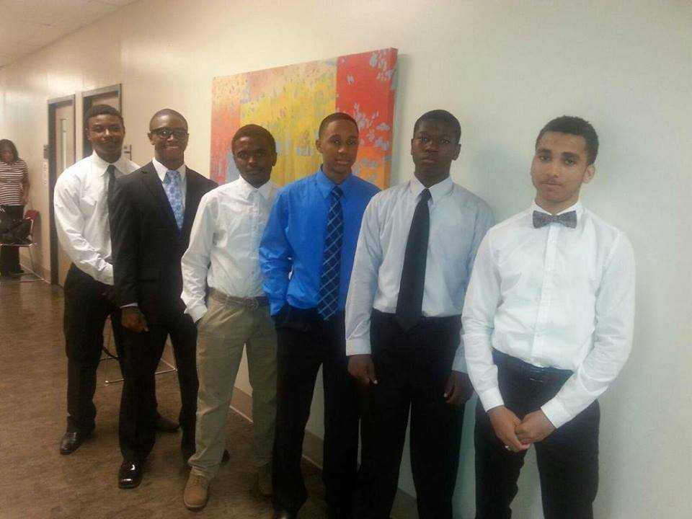
The College Readiness Academy expanded greatly over the past two years, with B-Power Initiative enhancement funds from the University System of Maryland Office of the Chancellor providing a major catalyst. High school students in the academy take a 10-week-long preview course in either writing or math, with embedded college success skills content, delivered by UB instructors at their high schools. Students who complete the academy (or meet UB placement requirements) are eligible to take a 3-credit Dual Enrollment course the following semester. In 2017, UB partnered with two middle schools for the first time to offer the academy’s services to 7th and 8th graders. The College Readiness Academy served 132 students in 2016 and 329 in 2017.

B-Power Dual Enrollment
UB also expanded its Dual Enrollment program, again largely as a result of B-Power Initiative funding along with private funding from The Shelter Group and the ABELL Foundation. Students who pass the College Readiness Academy course or meet UB placement criteria are eligible to take WRIT 101: College Composition or MATH 115: Introductory Statistics. Courses are held on site at high schools, with select sections held on the UB campus. The number of Dual Enrollment cohorts increased from two in 2016 to 11 in 2017, and the number of students increased from 61 to 258 in that same time period. The number of partner schools increased from three to 11, while the number of community-based partners increased from four to 10.

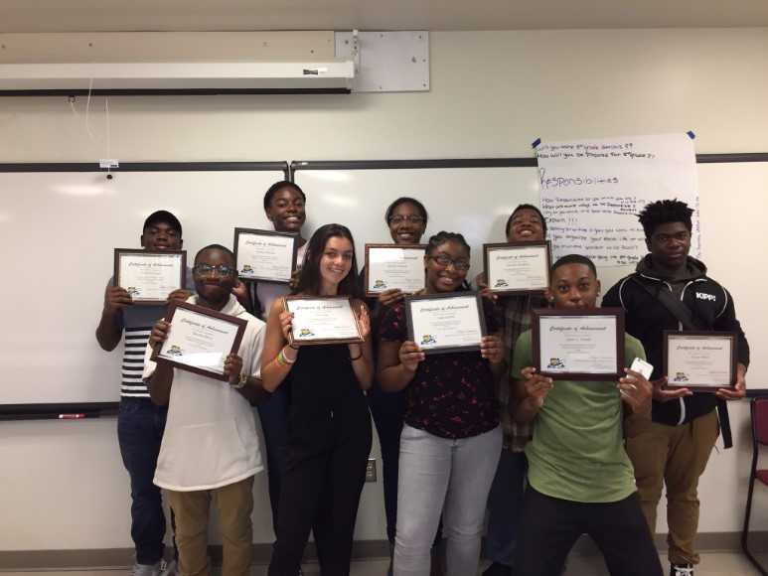
Summer Academy
The Summer Academy is a collaboration among UB, community-based partners and the YouthWorks program in the Mayor’s Office of Employment Development. Students in the five-week Summer Academy, held on the UB campus, register with YouthWorks and are sponsored by a community-based organization that provides programming. Students have the option to enroll in a 1-credit UB course with support from their sponsoring organization. In 2016, 198 students participated in the Summer Academy, and 49 students earned 1 college credit. In 2017, 223 students participated in the Summer Academy, and 91 students earned 1 college credit.

Summer Achievement Institute
Students who apply to UB but fall within an academic achievement band just short of freshman admission criteria are invited to attend the Summer Achievement Institute. These students take a four-week refresher course in math, reading, writing and study skills, learning about and engaging with the UB campus and its resources. Completion of the program allows students to fully enroll as freshmen in the fall.

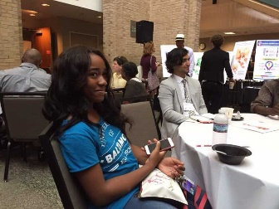
Freshman Transition Program
Students who apply to UB but do not meet admissions criteria for freshmen or for the Summer Achievement Institute are invited to the Freshman Transition Program, a partnership with the Community College of Baltimore County launched in fall 2016. Students enroll at CCBC, but their classes (taught by CCBC instructors) are held on the UB campus. FTP students participate fully in the UB community and receive Bee Cards, may attend campus events and have access to student services and resources. Upon completing all developmental coursework and earning 24 billable credit hours in two or three semesters with a 2.5 GPA or higher, students may transfer directly to UB.

- UB Hosts Inaugural Philosophy Camp for Teens
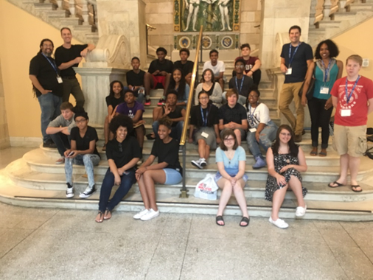
From July 10-14, UB’s Hoffberger Center for Professional Ethics held its first-ever Philosophy Camp for Teens on campus, drawing more than 20 Baltimore-area high school students. Each day of the camp demonstrated to the students that philosophical thinking is relevant and valuable to them in their daily lives. Topics and activities included social media bullying and shaming as well as texting obsession; police brutality; moot court cases on ethical dilemmas; robots and artificial intelligence (from The Matrix and more); ethics bowl competitions; and a role-playing exercise as a city mayor.

