P-Card Transaction Reconciliation and Reallocation
Reconcile Statement

Navigate to the P-card Reconcile Statement Screen: Purchasing > Procurement Cards > Reconcile / Reconcile Statement | 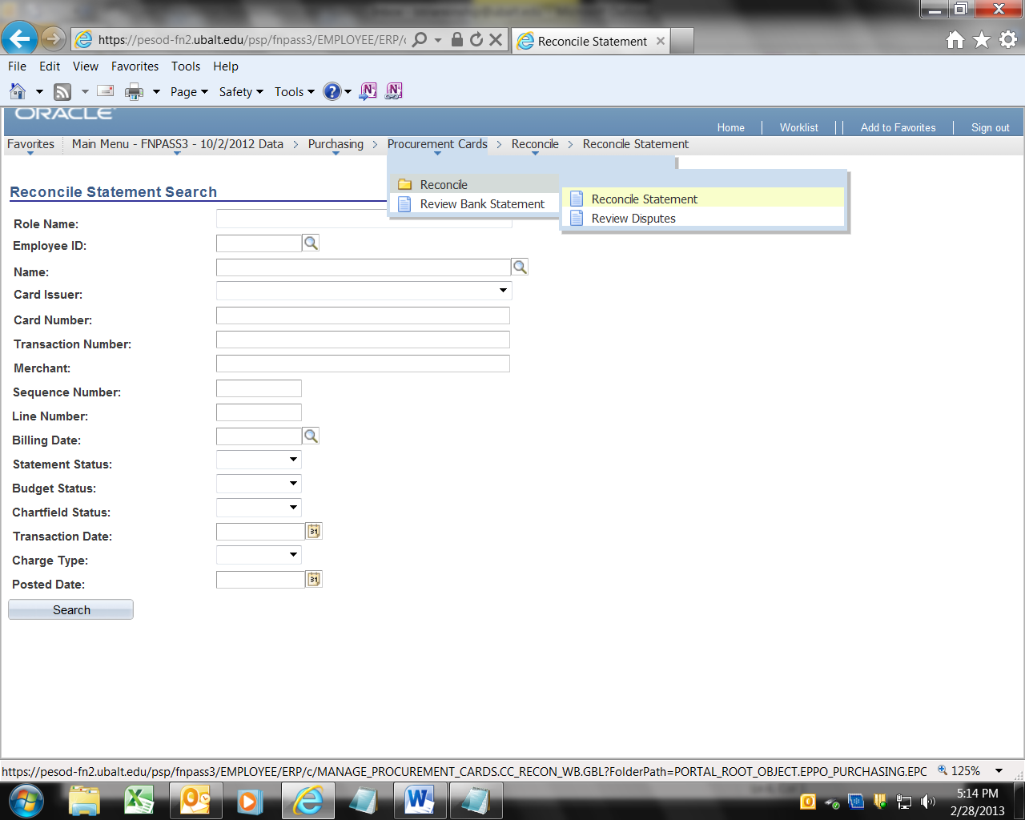
The Reconcile Statement Search screen will appear.  In the first drop down, labeled “Role Name” Select the appropriate entry:  Purchasing Card Reviewer, or  Purchasing Card User | 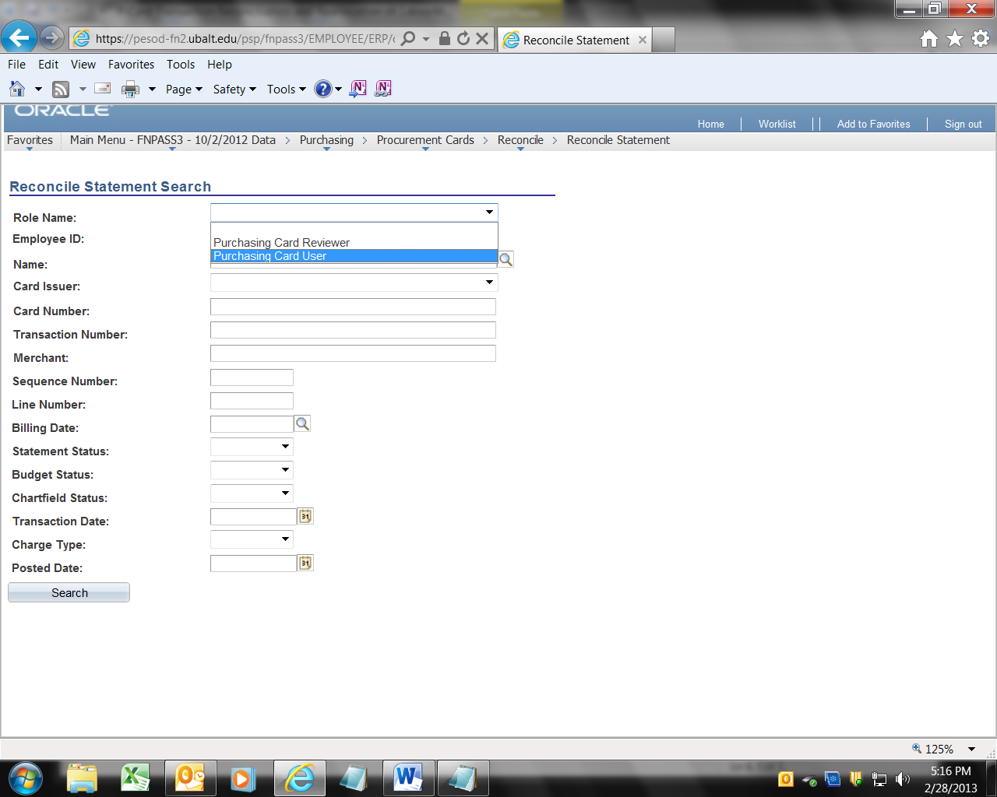
In the Card Issuer field, select Bank of America. Note: In April this should change to US Bank, but for now, select  Bank of America. | 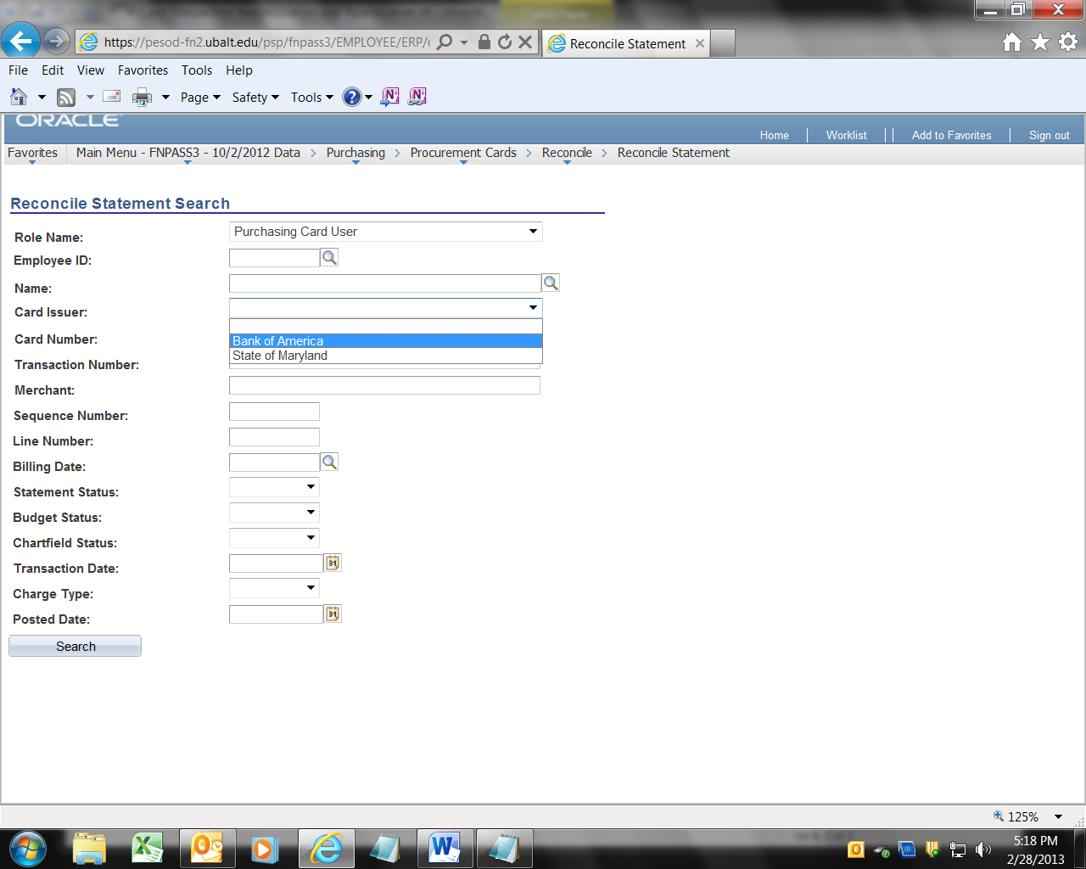
Then click Search. | 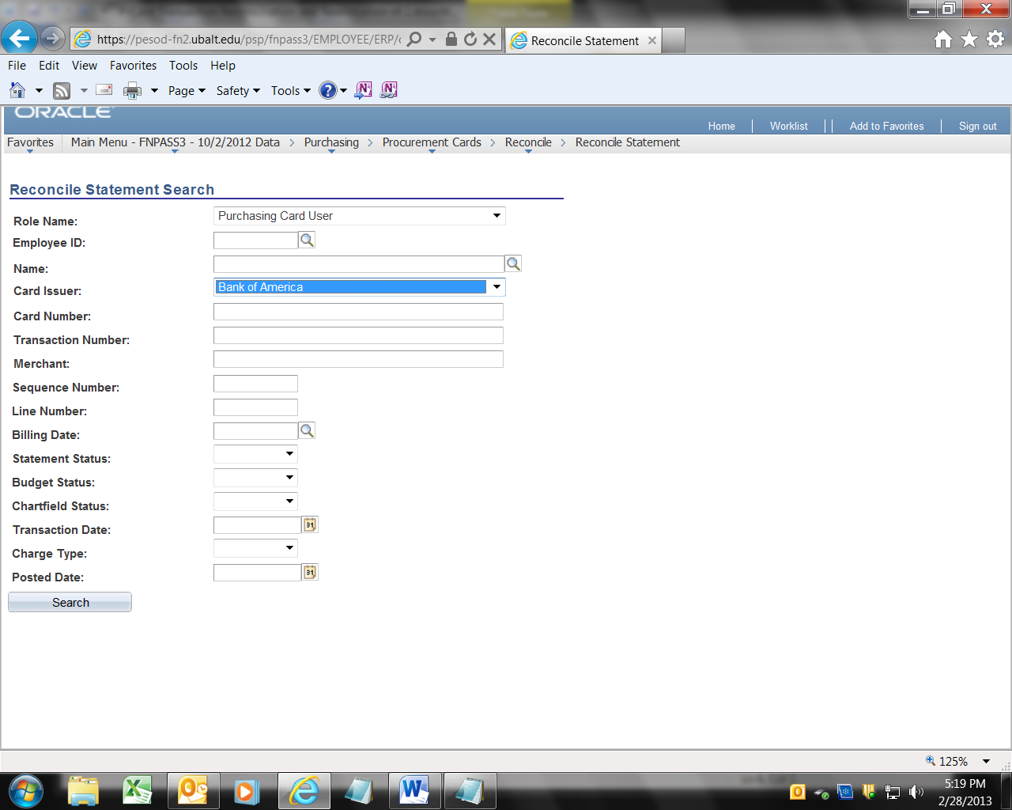
You will see the list of transactions for the cardholder for the current cycle.  Note that in the example to the right, the first four transactions have been completed.  Note that we are seeing 1 – 9 of 60 transactions. To see all 60, click “view all”. | 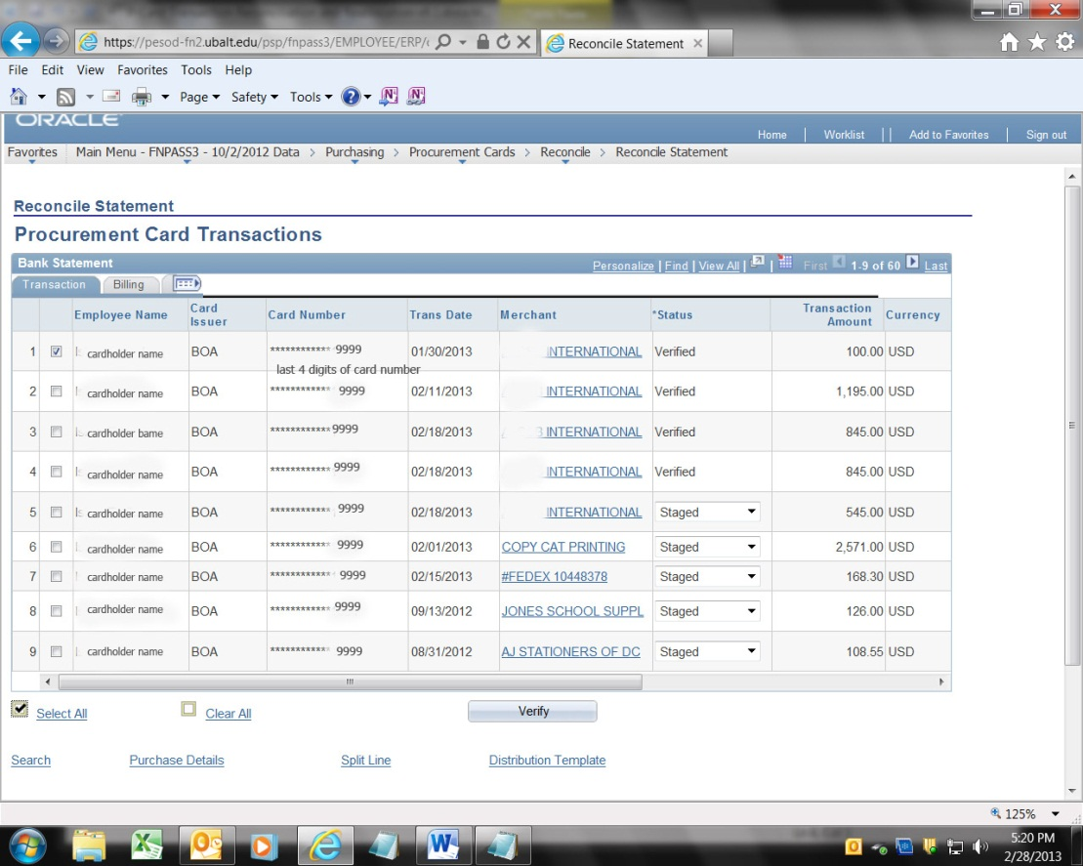
The sequence of steps in this process is very important. If you do the steps out of sequence, you may not be able to complete the reallocation process.

1. Click the tab labeled “Billing”
2. Add a description of the item that was purchased. | 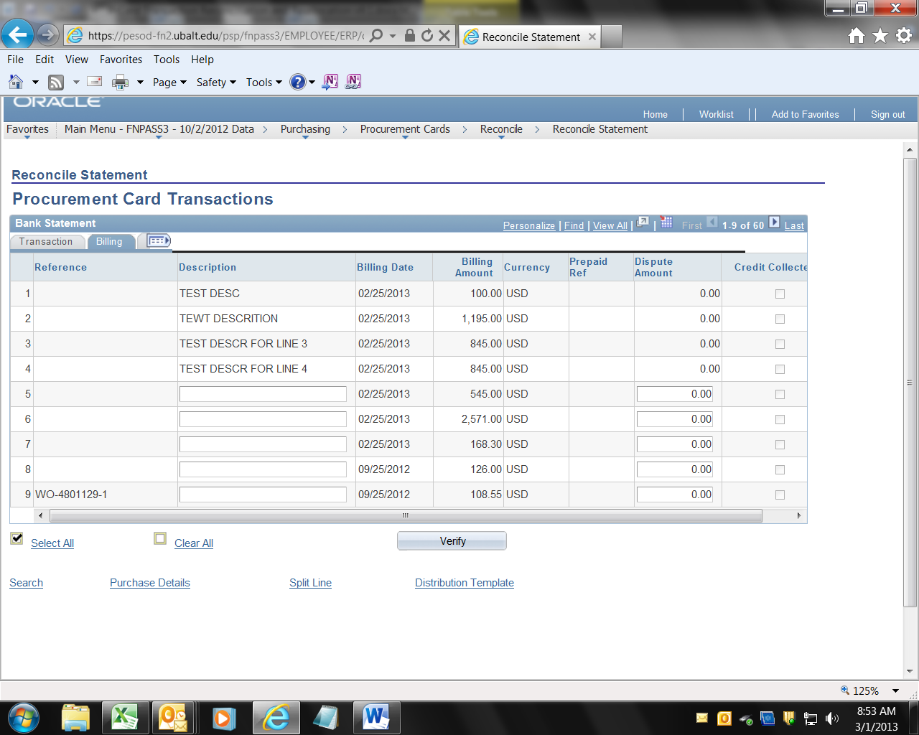
3. Click on the Transaction Tab.  4. Click on the Distribution icon. That will access the Chartfield Distribution (Account, Dept, Fund, Program and Project). | 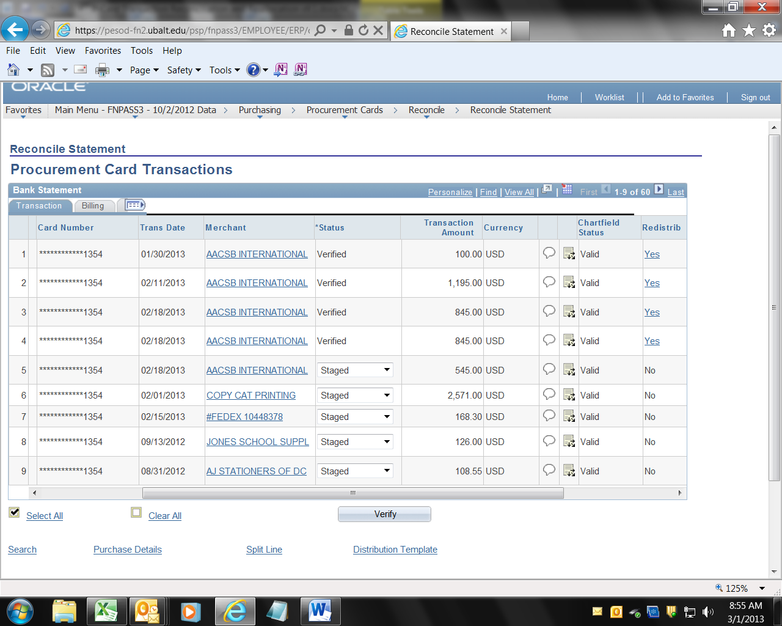
5. Delete the Alt Account. You must do this FIRST.  6. Click into the Account Field.  If you forget to delete the Alt Account first and you get a screen you do not recognize, click the button labeled “Cancel”. That should take you back to the list of transactions, and you can start again. | 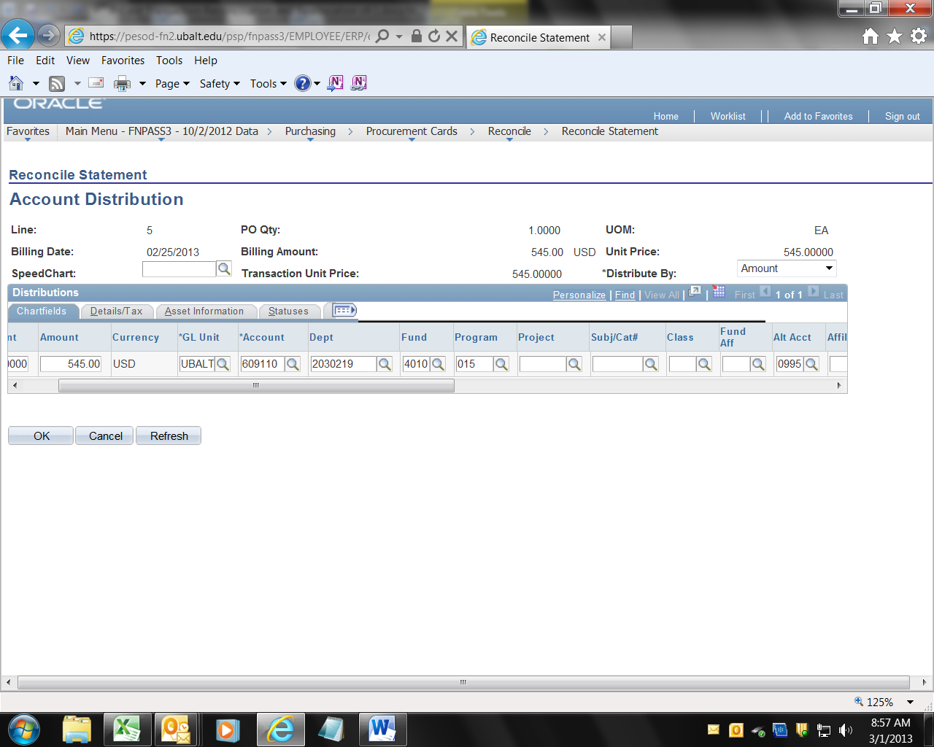
6. (continued) When you click into the Account field the default account number will vanish.  7. Enter the correct Account number. A list of Account numbers is available on the Comptroller’s web site.  8. Change the Department, Fund, Program and Project numbers as necessary.  9. click the button labeled “OK” | 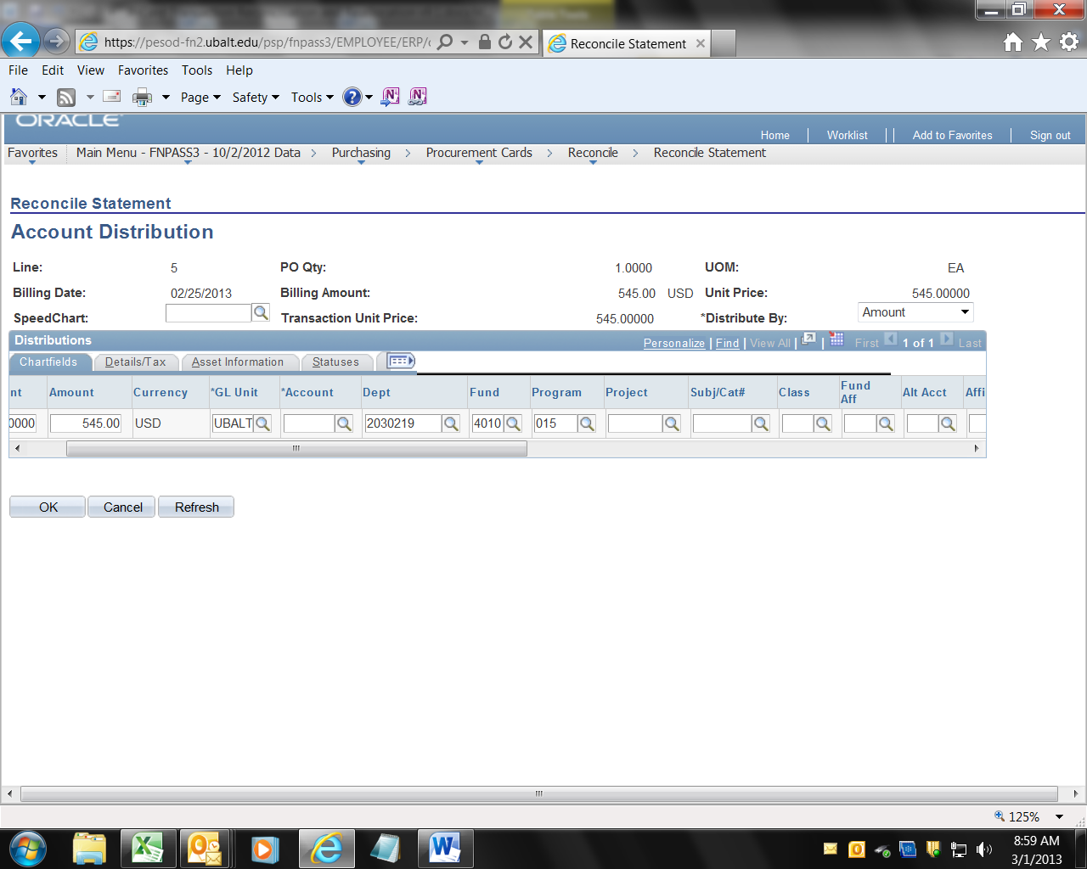
10. You will be taken back to the Transaction tab. Click the drop down arrow in the Status field and select Verified.

11. Then click the save button. You may need to scroll down a little – the Save button is in the lower left corner of the screen.

You should click save after completing each line.
12. Repeat steps 1 – 11 for each line on the statement.

13. Be sure you accessed all the lines. PeopleSoft will generally only show 9 lines (or less) at a time. You may need to click the “next arrow” or “View All” to see all your lines/transactions.

14. After you have added a description to each line, reallocated each line to the correct Account, and clicked Verified on each line, notify your Reviewer. The Reviewer should check each line, and change the Status flag to “Dpt Apprvd” (Department Approved).

