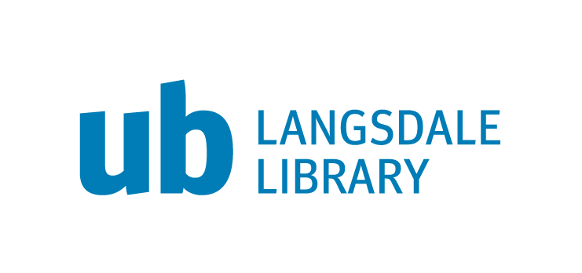
UB Information Literacy Guidelines

Draft guidelines for developers and instructors of courses that satisfy the UB information literacy graduation requirement

- UB Information Literacy Program
Information literacy is the set of integrated abilities encompassing the reflective discovery of information, the understanding of how information is produced and valued, and the use of information in creating new knowledge and participating ethically in communities of learning. The information literacy program should be considered an integral part of the way the university meets its goals of providing an educated and skilled student body capable of functioning both within the academic environment and in career and non-academic settings.

  - Program Learning Goals

- Students can successfully implement a plan to find needed information using a range of appropriate resources.
- Students can assess the quality and value of a source when used in a specific context.
- Students can create a research product building on existing scholarly work.

  - Student Learning Outcomes
An information literate graduate from UB will be able to successfully:

- Create a thesis statement with an appropriate scope
- Revise searches by use of broader, narrower and related terms
- Employ multiple strategies for revising and enhancing searches
- Apply evaluation criteria to an information source
- Apply current ethical standards in the gathering, use, and dissemination of information
- Incorporate outside information into their own arguments

  - Information Literacy Curriculum
The information literacy program ensures students meet the information literacy graduation requirement through the following curriculum:
- Introduction to Information Literacy (INFO 110) is a required class for students with 45 or fewer credits, and is a pre/co-requisite to the sophomore seminar.
- Composition and Research (WRIT 300) is a required class for all students, and reinforces SLOs introduced in INFO 110.
- Designated, required Information Literacy Intensive Courses, using the SLOs below, are taught at the 300 or 400 level in each program. Courses’ compliance with these guidelines would be verified by the General Education Council.

  - Information Literacy Intensive Courses Student Learning Outcomes
(From draft proposal Information Literacy Intensive Courses Guidelines, rev. 12-15-2015, Langsdale Library)

The following are proposed outcomes required for courses in the majors flagged as meeting the information literacy graduation requirements.

After taking an Information Literacy Intensive Course, students will:

  - Demonstrate an ability to successfully identify and navigate discipline-specific resources. (Maps to Info Lit Program Outcome 3)
  - Apply discipline-specific evaluation criteria to an information source (Maps to Info Lit Program Outcome 4)

Additionally, information literacy intensive courses must:
- Use class time to discuss information literacy concepts.
- Produce assignments to assess the ILIC SLOs.
- State ILIC SLOs in the syllabus.

- UB Learning Goals related to Information Literacy
(From the University of Baltimore 2015-16 Undergraduate Catalog)

The UB Undergraduate Learning Goals address information literacy skills. The outcomes are:

Apply strategies that enhance professional and personal competence.
This set of skills is demonstrated by the ability to:
- use digital technology to communicate and investigate
- find and judge the credibility of different sources of information.

Communicate effectively in various media.
This set of skills is demonstrated by the ability to:
- make efficient use of information resources and technology for personal and professional communication
- comprehend, interpret and analyze texts.

Think critically and creatively to solve problems and adapt to new environments.
This skill is demonstrated by the ability to:
- generate and explore new questions
- analyze complex issues and make informed decisions
- synthesize information to arrive at reasoned conclusions
- evaluate the logic, validity and relevance of data.

- External Guidelines/Mandates

- Middle States Commission on Higher Education
(From Middle States Commission on Higher Education. (2011). Characteristics of excellence in higher education: Eligibility requirements and standards for accreditation. Philadelphia, PA: MSCHE).

Standard 11 Educational Offerings: Fundamental Elements states:

“Several skills, collectively referred to as “information literacy,” apply to all disciplines in an institution’s curricula. These skills relate to a student’s competency in acquiring and processing information in the search for understanding, whether that information is sought in or through the facilities of a library, through practica, as a result of field experiments, by communications with experts in professional communities, or by other means. Therefore, information literacy is an essential component of any educational program at the graduate or undergraduate levels.

These skills include the ability to:
- determine the nature and extent of needed information;
- access information effectively and efficiently;
- evaluate critically the sources and content of information;
- incorporate selected information in the learner’s knowledge base and value system;
- use information effectively to accomplish a specific purpose;
- understand the economic, legal and social issues surrounding the use of information and information technology; and
- observe laws, regulations, and institutional policies related to the access and use of information.” (p. 42)

- Association of College & Research Libraries (ACRL)
(From ACRL. (2016). Framework for information literacy. Retrieved from http://www.ala.org/acrl/standards/ilframework)

The Association of College and Research Libraries has defined six threshold concepts central to information literacy as part of the Framework for Information Literacy. This Framework is “based on a cluster of interconnected core concepts, with flexible options for implementation, rather than on a set of standards or learning outcomes, or any prescriptive enumeration of skills.”

- Authority Is Constructed and Contextual
- Information Creation as a Process
- Information Has Value
- Research as Inquiry
- Scholarship as Conversation
- Searching as Strategic Exploration

Each of these concepts are defined, along knowledge practices and dispositions in the original document. This framework informs the goals of the information literacy program and are reflected in the learning outcomes.

- Assessment
Over the course of three years all learning objectives will be assessed. Within a given semester one of the following procedures can be used:

Sections of various courses identified as fulfilling the information literacy requirement would be randomly sampled; an assignment, a series of test questions or other evaluation relevant to the course would be designed to measure the objective using course embedded assessment;
OR
All courses identified as fulfilling the information literacy requirement would focus on a selected object; in each section/course an assignment, a series of test questions or other evaluation would be designed to measure the objective; and students’ work would be randomly samples from all sections/course for assessment purposes.

Updated draft: March 2016
Submitted by: Natalie Burclaff, Head of Information Literacy Initiatives

Definition from Association of College and Research Libraries (2016). Framework for information literacy: Appendix 1. Retrieved from http://www.ala.org/acrl/standards/ilframework

