- Choose the appropriate link for the college that needs to receive and approve your request:
Grade Change to the College of Arts and Sciences
Grade Change to the College of Public Administration
Grade Change to the Merrick School of Business
Grade Change to the School of Law
- Authenticate using your UB NetID and password:
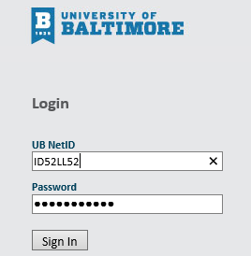
If you currently do not work for The University of Baltimore please contact the respective Dean’s office.
- The form asks for your name and email address as the Faculty member. 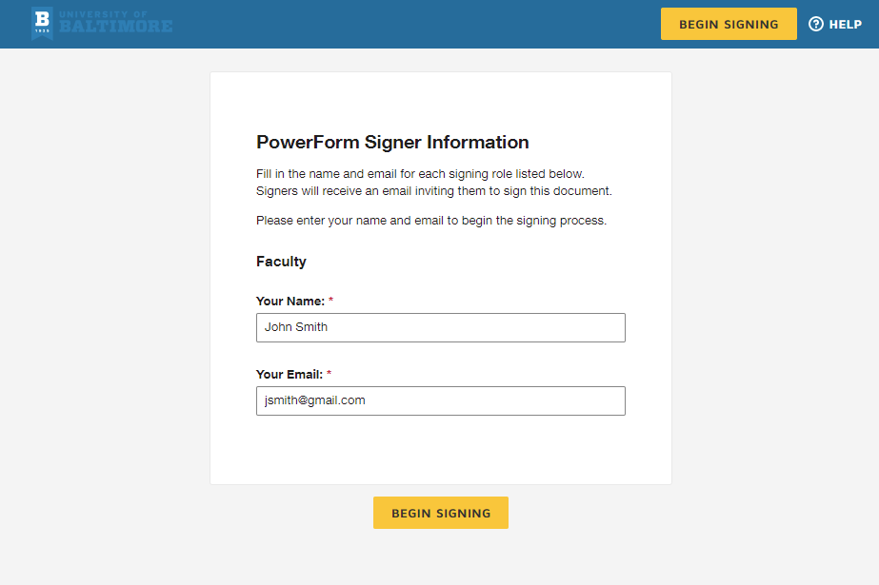 Once you enter the information then click begin signing.
- This brings you to the document for completion.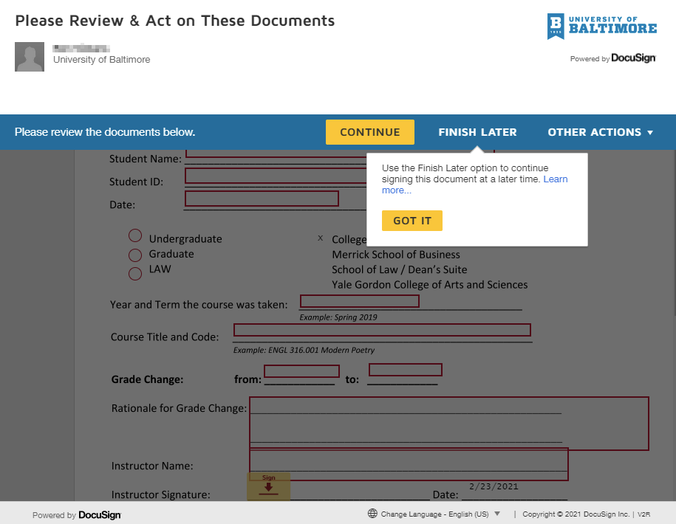 You can click FINISH LATER if you need to come back to the form later. Once you click it you will receive an email with a link which will bring you back to the form. Otherwise, click CONTINUE to fill out the form.

- The form is ready for you to fill out. 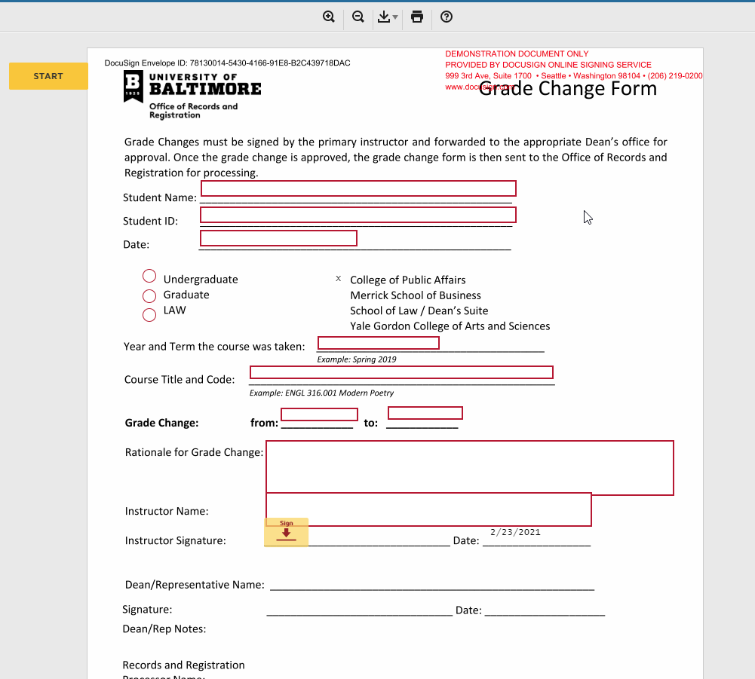

- Once you have completed the required data entry, the form is ready to sign: 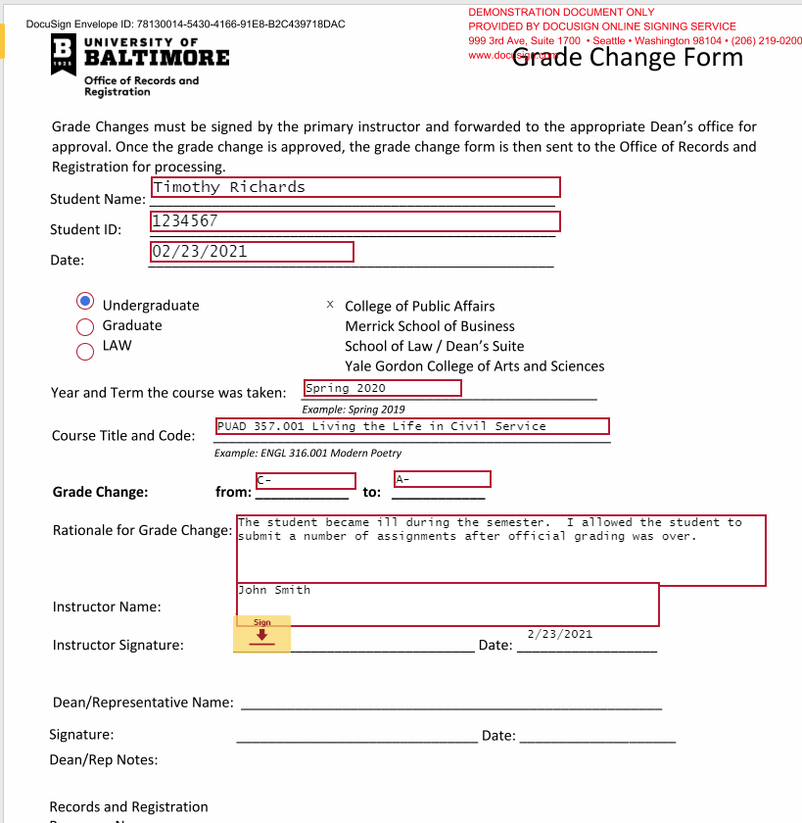

- Click the Sign Icon next to the Instructor Signature section: 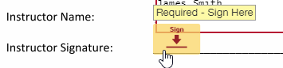

- This will bring up the signature window: 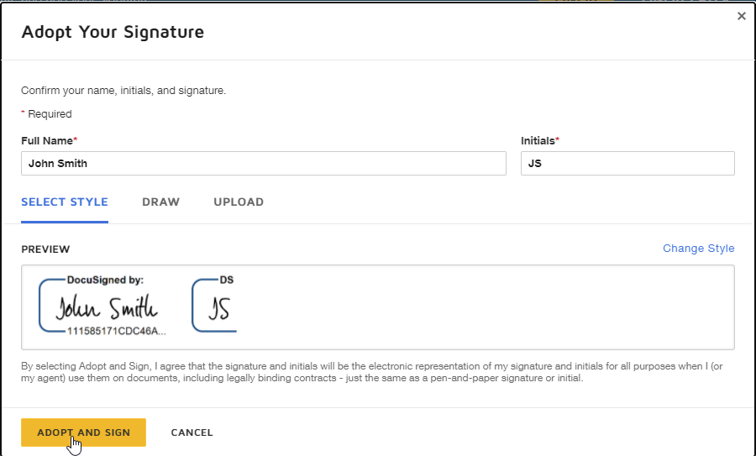 Click on the ADOPT AND SIGN button

- You are now ready to submit your form to the Office of the Dean of the College you have chosen by clicking the FINISH button at the top or bottom of the form: 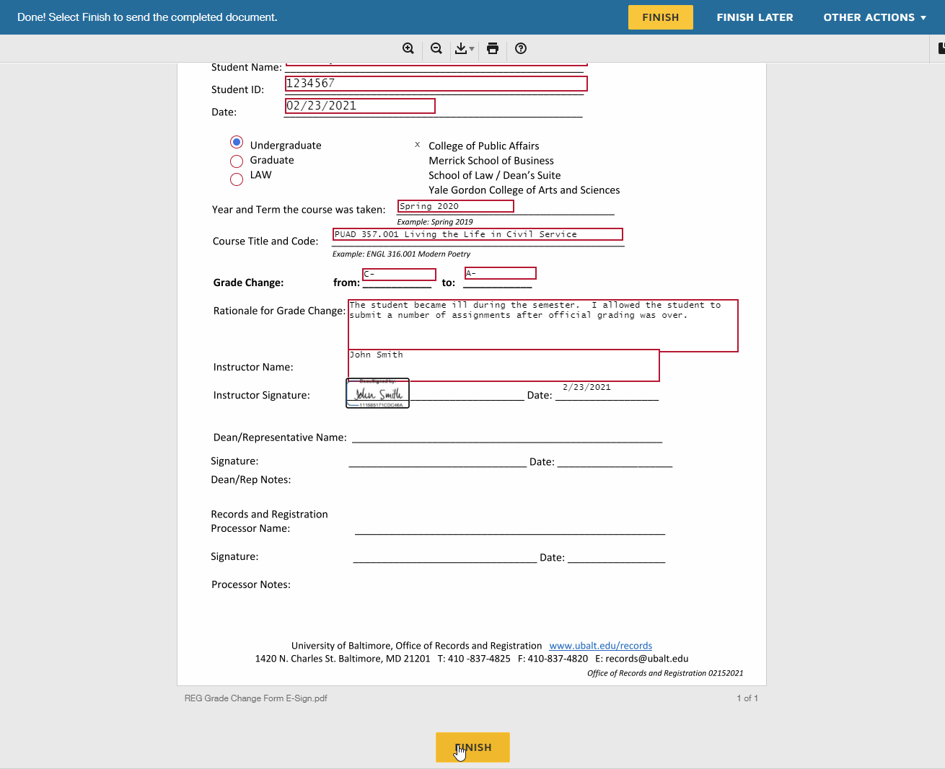
- You are given the option to print or download the document in its current state of completion. 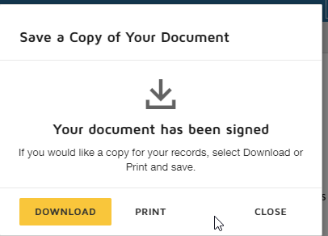
Please note that you will receive a copy of the completed document once all signers have completed their sections.

