Adding a Signature to a PDF
- Open the PDF file in Adobe Pro DC
- Click the File menu > Open… then, select the PDF file you want to sign.
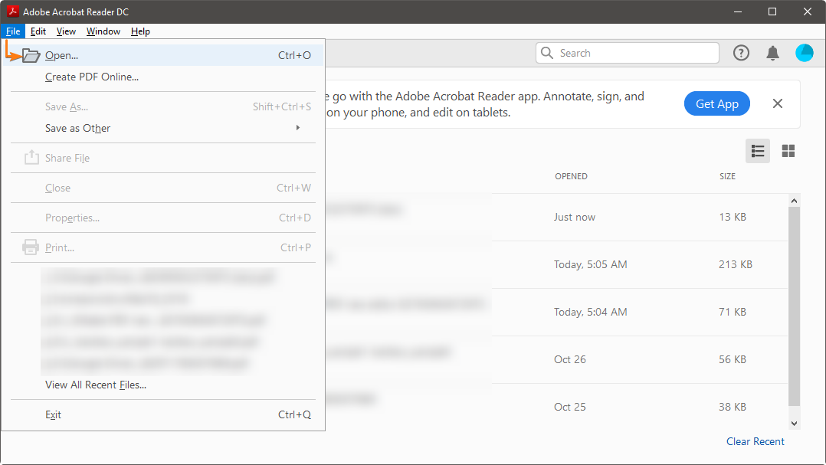

- Click on Fill & Sign in the Tools pane on the right.
- If you’re not seeing the Tools pane, press Shift+F4 on your keyboard. A toolbar will appear at the top of your document.
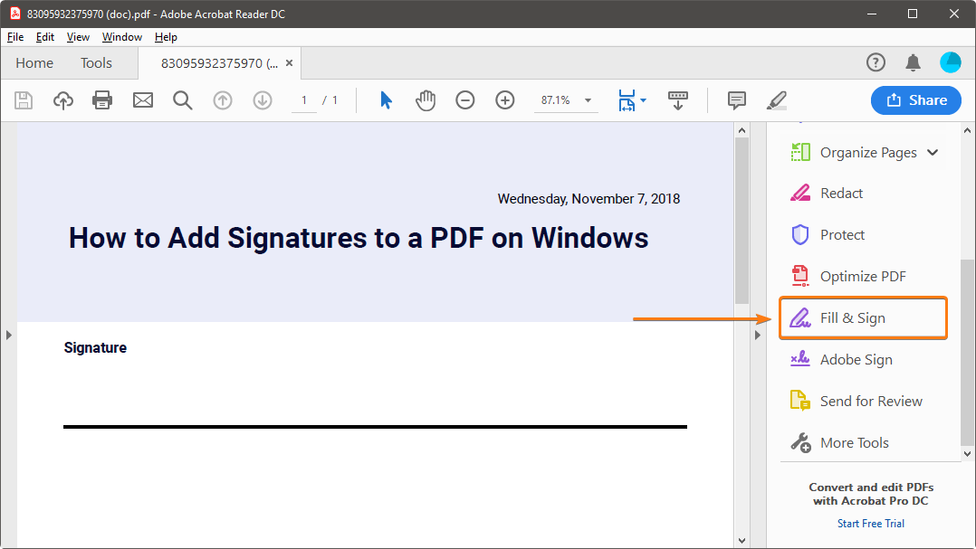

- Click Sign, and then select Add Signature.

- A popup will open, giving you three options – Type, Draw and Image. Once you’re done, click the Apply button.
- Type allows you to type your name in cursive format. You’re free to change the style of the signature.
- Draw allows you to draw the signature using your mouse, touchpad, or a pen if you’re using a touchscreen device.
- Image allows you to select an image file of your signature.
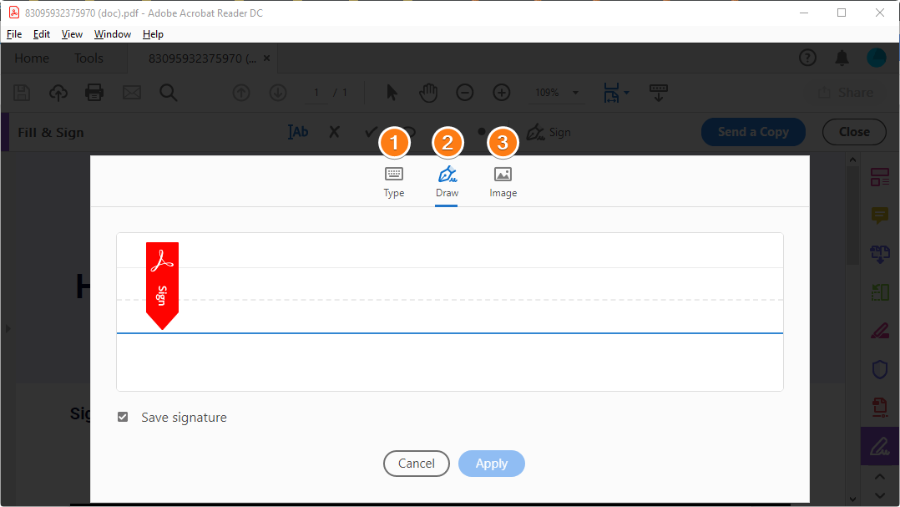

- Drag, resize and position the signature inside your PDF file.
If you have any questions about adding a signature to a PDF please reach out to the call center at callcenter@ubalt.edu or be calling 4108-837-6262

