How to Change a Default App

- Setup Default Apps in Windows 10

- Windows 10 offers a dedicated setting to setup default apps to open different files. Press Window Key + I (shortcut keys) which opens the Windows Settings App and click on the Apps option.
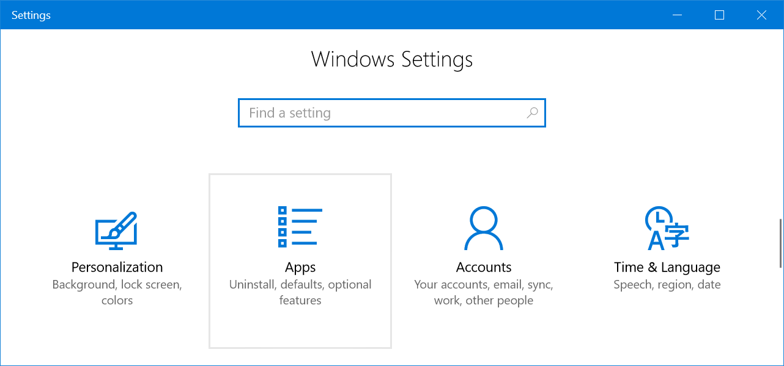

- Select Default Apps from the left sidebar. You will see a list of default apps assigned to open email, music, photos and web browser.
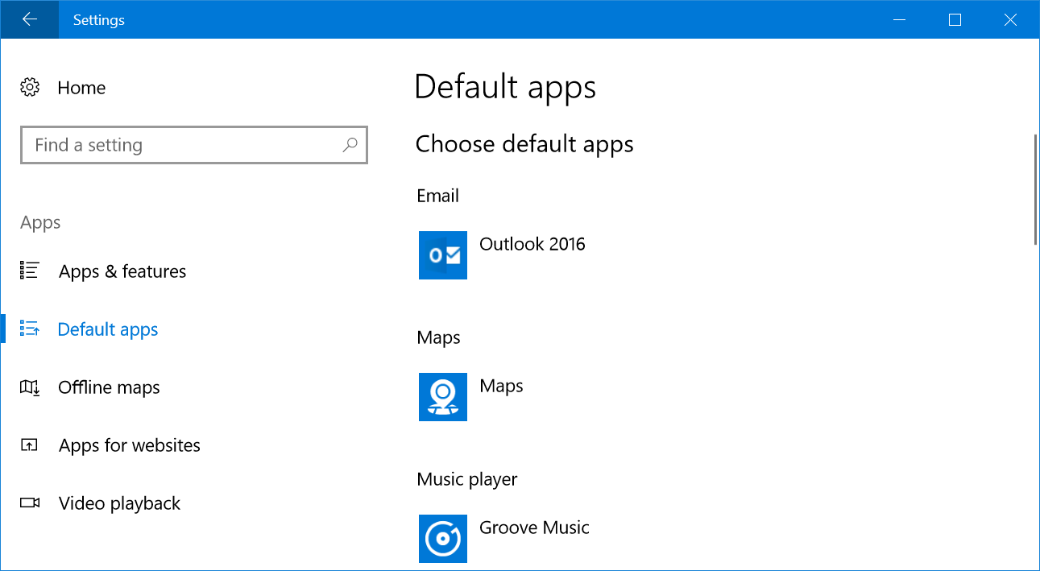

- Click on any of the apps to change the default settings. Selecting any app from the list and it will change automatically, however, when changing web browsers, Windows will push you to confirm the switch.
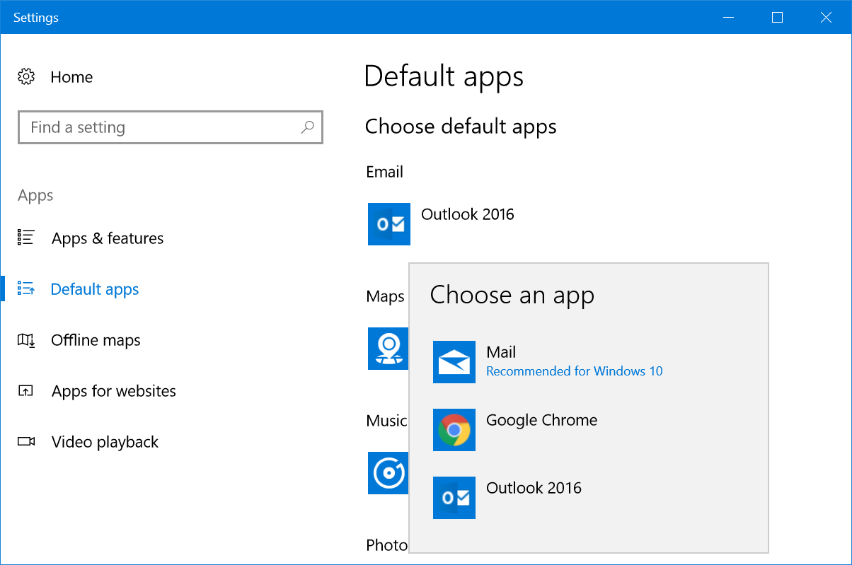

- Additional Default App Settings

Scroll down the settings page to view additional options:
- Reset
- Assign app for file types
- Setup apps for protocols
- Set defaults by app
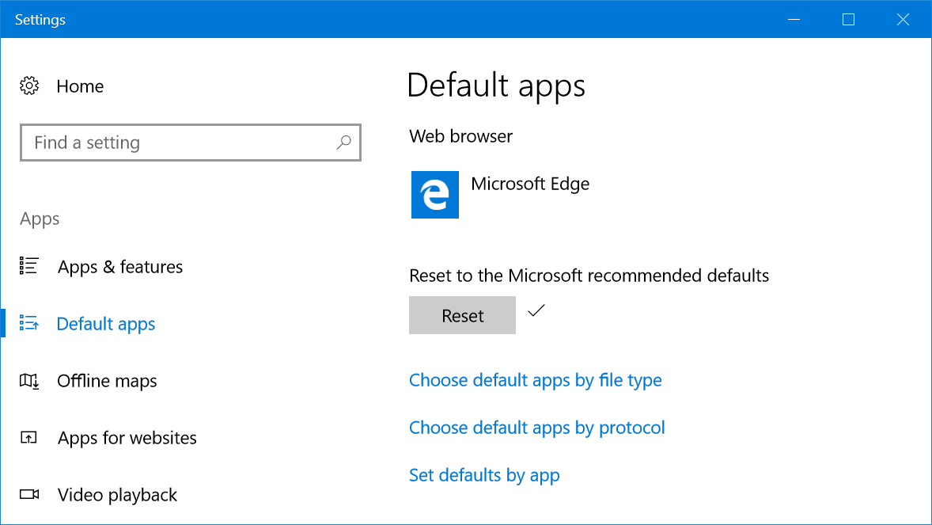

- Resetting Default Apps to Recommended Apps

- Windows 10 recommends apps like Mail for opening emails. If the default app settings were changed, click on the Reset button, which will help you reset back the recommended apps as your default apps.

- Choose Apps for File Types

- Scroll down to the bottom of Default Apps settings screen and click on the link that says, Choose default apps by file type. You will then see a long list of file extensions and the application you can use to open each file type.

- You will see a Choose a Default option when there aren’t any default apps available. Use this option to check and assign apps or install required apps to open a file type.

- Choose Default Apps by Protocol

- Windows use many protocols to open specific files. Click on Choose default apps by protocol link if you want to set up default apps according to individual protocols. You can assign new apps when there are no default apps setup or change the existing app by clicking on it and choosing a new one.
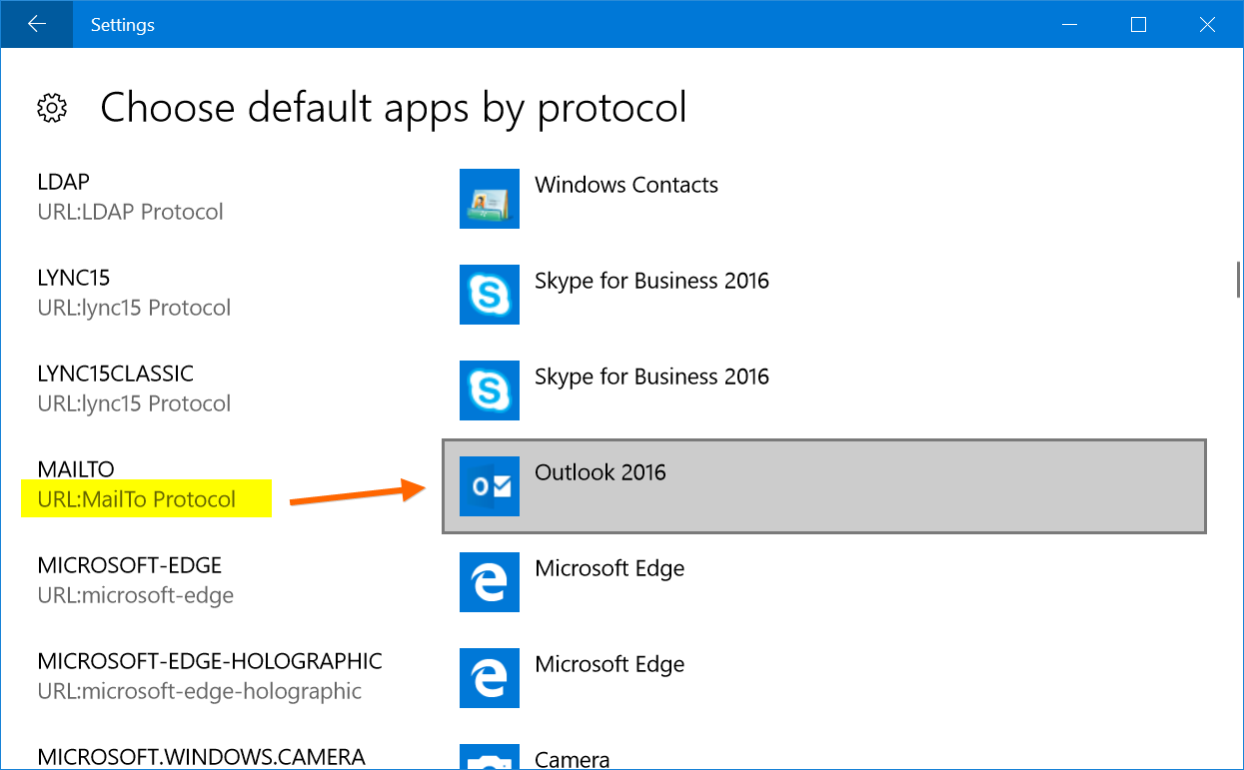

- Set Defaults by App

- Windows 10 allows you to set defaults for any installed apps that’s on your computer. Click on Set defaults by app link and choose the app from the list. You will see a Manage button and click on it.
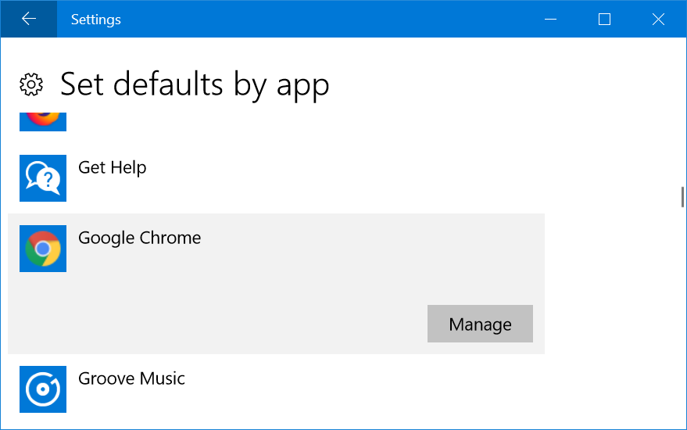

- On the next screen, you can assign the app to open supported file types.

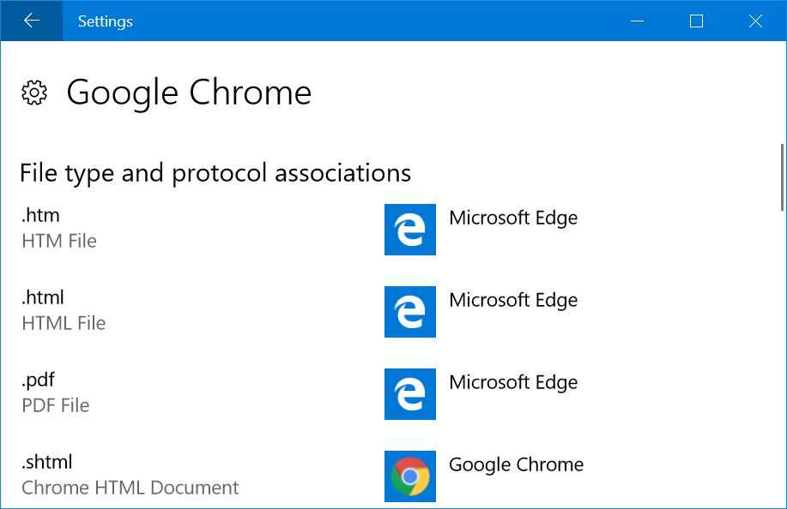

- Accessing Default Apps from Control Panel

- You can also access Default Apps settings from Control Panel.
- Press Win + E keys to open File Explorer.
- Paste this path on the address bar Control Panel\Programs\Default Programs and hit enter key.
- You should see the Default Programs settings open from Control Panel like below.
- Click one of the following links to go to the Default Apps settings as explained previously.
          - Set your default programs
          - Associate a file type or protocol with a program
          - Set program access and computer defaults
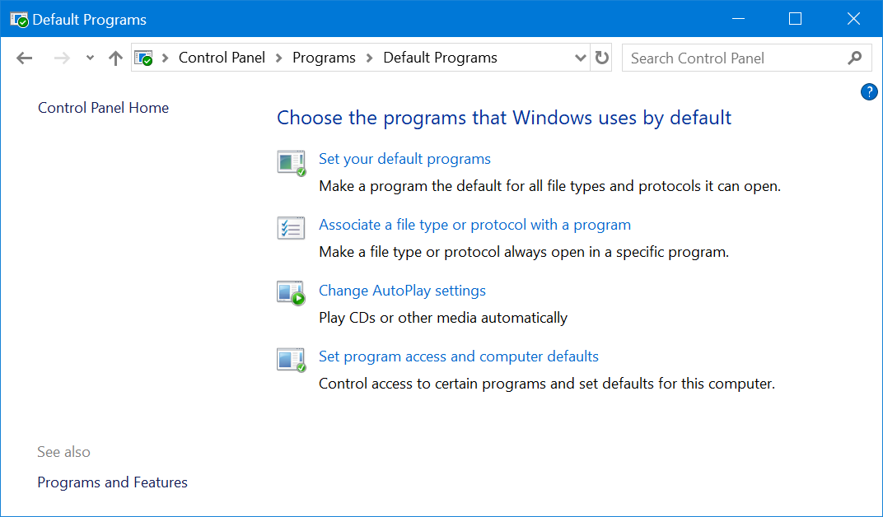

- Choosing Default App when Opening File

    - When you have a file with no associated apps, Windows 10 will show the file with plain white file icon. Double click on the file and choose Try and app on this PC.
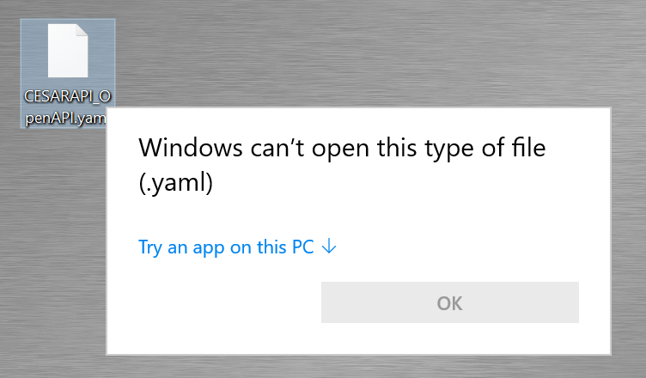

      - You will then see a list of apps that can help you open the file. Choose an app and click OK to open file.
      - If you always want to open the file type with the selected app, then check the option Always use this option to open .xxx files.

- Change Default Apps

      - When choosing the wrong default app to file type, you can right click on the file and see a different content menu depending on the file type.
        - Click on Open with… option
        - Select More Apps.
        - Choose the app you want to change.
        - You can use different app for one time or check Always use this app… option to change the default app.
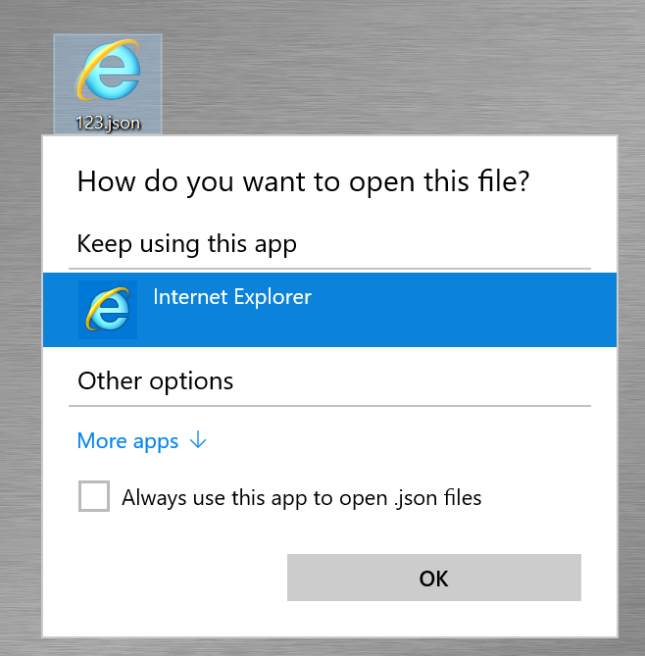

      - On certain apps, the “Open with” menu will also show additional sub-menu items like below.

      - Choose one of the available apps to open the file for one time with that app.
      - Select “Search the Store” to open Windows Store and search relevant apps to open the file.
      - Click “Choose another app” and choose another app that is not showing in the list. You can use the app for one time and set it as a default app.

