Installing Adobe Acrobat

- Run the “Creative Cloud” app
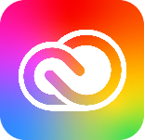

- Sign into Creative Cloud with your netid@ubalt.edu for the email address then click on continue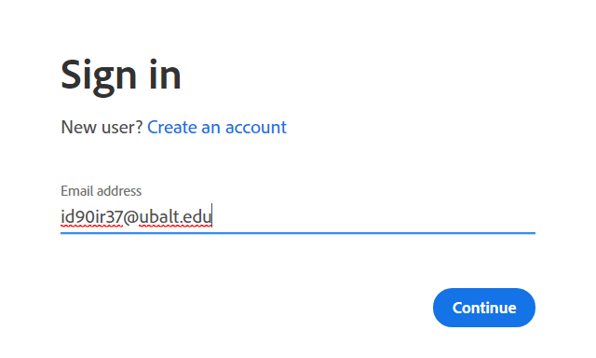

- After clicking on continue. Log in to the UB single sign-on
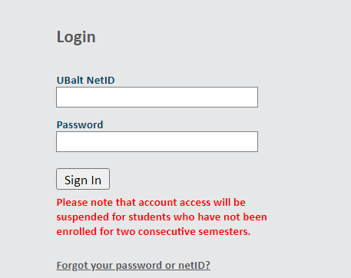

- Under “All Apps” find Acrobat DC and click on “install”. The app will begin to install. 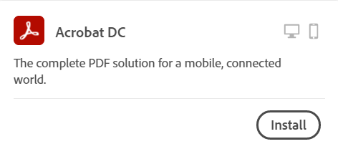

- Open Acrobat DC and sign in using your UB netid.

Please reach out to the call center with any issues callcenter@ubat.edu or 410-837-6262

