University of Baltimore – University Faculty Senate
Meeting Minutes: October 1, 2014
Attendance
Present: Jose Anderson (Law), John Bates (CAS), Sam Brown (CPA), Richard Bucher (Adjunct Faculty), Dan Gerlowski (MSB – UFS President), Stephanie Gibson (CAS), Cassandra Havard (Law), Catherine Johnson (Library – UFS vice president), Stan Kemp (CAS), Heather Pfeifer (CPA), Dennis Pitta (MSB), Kurt Schmoke (UB President), Julie Simon (CAS- CUSF), Colin Starger (Law), J.C. Weiss (MSB), Joseph Wood (UB Provost), Margaret Gillingham (CPA- alternate)
Absent: Patria Julnes (CPA- CUSF), George Julnes (CPA)

Guests, included: Laura Bryan, Michael Driscoll, Catherine Anderson, Christine Spencer; Kristen Tull, Susan Schubert, Elizabeth Gammon, Paul Monodis, Murray Dalziel, Miriam King, Michael Driscoll.

Meeting called to order at approximately 12:01 p.m.
- Agenda altered to include “approval of agenda” and “approval of prior meeting notes.” and CUSF report at end of meeting
- Amended agenda and September minutes approved unanimously
- President Schmoke

  - Has learned a lot and gained a lot of perspective on freshmen, should continue to admit freshmen but policy should be adjusted according to data
  - Recognizes that great strides have been made in freshman programs over the last seven years
  - Continues to develop a plan to emphasize programs that students are successful in and that fit with our upper division and graduate programs, all within the “knowledge that works” theme of UB.
  - Has instructed Miriam King to re-double effort at recruiting at community colleges as there is ample growth for us in this area, and will continue visiting all community colleges in the state.
  - Drop in transfers from community colleges has paralleled increases in allocation to freshmen enrollment
  - Looking for faculty to faculty outreach as one strategy for us to grow according to our uniqueness and our strengths.
  - UB has a new arrangement with “The Varsity” to promote near campus housing for our students next Fall.
  - Suggested an admission deadline of April 1.
  - Estimates with new admission policy there will 150 freshman this fall.
  - We will study the prospects for growth with a committee structure like SET, with committees in schools and a steering committee. On the steering committee I would like to see a UFS representative.
- Provost Wood
  - Investiture of President Schmoke 4/14/15 – should be an opportunity for UB to showcase its strong points and broadcast what we do
  - Strategic Enrollment team (SET) Committee idea is for schools to be more active in the strategic planning process.
  - Presented the UFS with a hard copy of the most recent report to Middle States. Will make electronic copies available.
  - We have a university wide assessment committee chaired by Catherine Anderson, Associate Provost.
  - Motion was made to move up the discussion of the bridge program
  - Motion passed unanimously
  - Summer bridge report on students whose admission is contingent on completing bridge programs
  - The people that are teaching in the bridge program make the decision on whether to move that person into matriculation
  - The idea was offered to allow Dean Bryant, Miriam King, and the Provost Office to present a complete picture of our freshman program including the role of the bridge programs. The Provost agreed to identify the bridge students over the current and past few years to the UFS Data Analysis Group (DAG) for a better understanding of their success patterns relative to all other students.
- Discussion of Freshman Admission Policy
  - Gerlowski asked UFS for a motion allowing the gavel to be passed to Johnson and to permit Gerlowski and Daniel Page to present findings and answer questions.
  - Gerlowski remarked that the UFS/DAG was working hard, was enjoying access to data, and part of a broader working group including representatives from EMSA, OIR, OTS, and the Provost Office. Katie Kaufman (EMSA) and Tom Renfro (OTS) were found particularly helpful. The muscle from the different parts of the university is necessary to understand the data and the analysis.
  - First item was to identify two groups of freshman. The MHEC freshman are those recognized by components of legislative statute and are defined in such a way so as to make inter-institutional comparisons easier and to facilitate reporting to state agencies. A broader definition, EMSA freshman includes all students who go through the freshman admission process and are subject to our academic policies and procedures, contribute to headcount, generate revenue, and aid logistical aspects of university planning. The MHEC freshman are about 75-80% of the EMSA freshman.
  - Based on the review of both a statistically based, logistic analysis, and also drill down, pivot based analysis, a set of freshman admission guidelines were proposed for Fall 2015. Given the graphical nature of the material provided by EMSA describing the current admission policy, the UFS proposal featured adopting those guidelines with a minimum SAT cut off of 780. Gerlowski explained the construct and Page explained the institutional meaning and setting. Page answered a variety of questions. A motion was made to approve the revised admission guidelines as explained by Gerlowski and demonstrated on the attached diagram with the understanding that it would be spelled out in clearer terms. The motion passed unanimously. The final graphic is attached to these minutes.
  - The UFS entertained a motion to accept a proposal made by Miriam King to move to an admission deadline of June 1 (email sent to Gerlowski). The June 1 deadline was the result of student success and admission dates for all freshman. This was in contrast to an earlier deadline proposed by President Kurt Schmoke. The King letter brought by Gerlowski in the form of a motion was amended to reflect President Schmoke’s dates after a discussion. The motion supporting an April 1 admission deadline for Fall, freshman admissions and a December 16 deadline for Spring, freshman admissions with the possibility of adding students to a waitlist for further and careful examination after that point passed unanimously.
- A discussion was held about the BOR faculty awards. Four names were put forward: Wendy Gerzog (law- scholarship), , Bridal Pearson (CPA- collaboration) , Dionne Koller (law- teaching), and Lisa Stickney (MSB- teaching) A brief discussion of the background and qualifications of each was held. It was pointed out that only one name could be put forward per category. The UFS was somewhat concerned because of its timing for the awards was very near the deadline and feared the prospect of a constrained, rushed choice. The Provost suggested that we could, this year, forward four names to the President and the Executive Committee could sort out the issues more efficiently than the UFS. The UFS agreed and made a motion to accept the Provost’s offer, thus four names will be forward immediately to President Schmoke and the Provost.
- A motion from the APC was received and discussed regarding the establishment of a faculty approved mid-term grading policy. After considerable discussion the UFS concluded that the motion was not in accordance with preferences previously expressed by the UFS and the motion was not approved (5 for, 7 against). A second motion was approved and is attached to these meeting notes.
- The UFS did encourage the UFS/APC to investigate the policy proposal regarding a needed change to our credit for prior learning policy. Expected report back in a month or two.
Meeting adjourned at approximately 205 pm

UFS Follow Up / To Do List
- Invite Miriam to November 5 UFS meeting to discuss faculty involvement in recruitment.
- Consider inviting Laura Bryan, Joe Wood, and Miriam King to UFS to learn about the full structure of the freshman program including: developmental support updates, curricula changes, assessment strategies, implementation of admission standards, and the role of the bridge programs.
- UFS Executive Committee consider doing A. and B. together at a meeting time that is not November 5, as Miriam King will be out of town on that day. Probably best to hold it outside of a UFS meeting as well.
- Request access to electronic copy of Middle States report
- Ask provost for data (identification) about bridge students, so they can be tracked/compared to other students.
- Communicate (to provost and president) the approved motions about the admissions standards and admissions deadlines.
- Communicate (to provost and deans) the approved motions midterm grades.

Attachment 1: Graphic Depiction of Admission Guidelines, Freshman Fall 2015

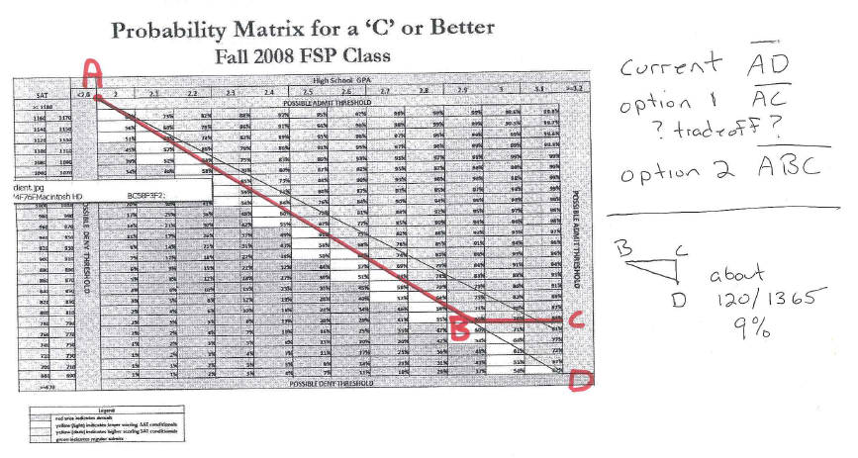

Attachment 2:
Motion made by Jack Bates that:
“The University of Baltimore adopt a standard Mid-term grade for undergraduate students. The Mid-term of a fifteen (15) week undergraduate semester will be designated as the eighth (8th) week of the semester. Therefore Mid- term grades will be due the eighth (8th) week of the semester by all full- time and adjunct faculty. Faculty will report the student’s progress as Satisfactory, Unsatisfactory, or FA (failing due to excessive absences). The Mid- term grade progress will be reported in PeopleSoft since this is the official University grade reporting mechanism.”

