Learning Outcomes Assessment Handbook

University of Baltimore AY 2015-16

Updated November 2019

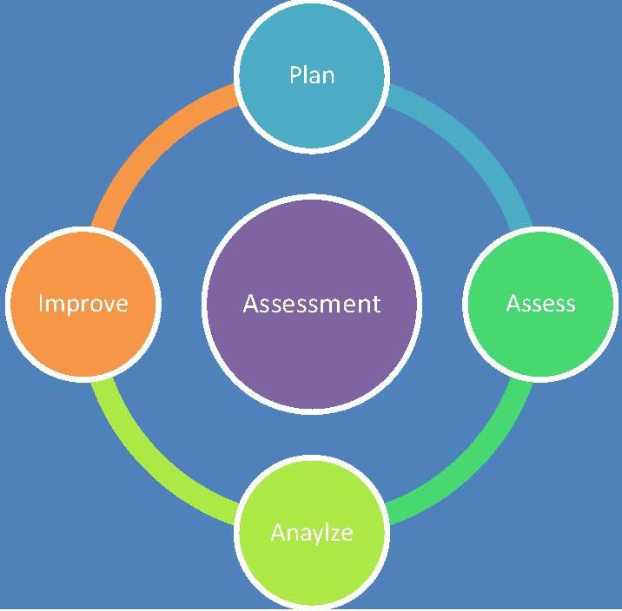

Prepared by Vice Provost in conjunction with Assessment Fellows, Associate Deans, and Assistant Provost for Student Assessment, Advising, and Retention

Table of Contents
- Assessment for Effective Teaching 3
- Support for Assessment 4
- Cycle of Assessment 7
- Designing Effective Assessment Plans 8
  - Identifying student learning outcomes 8
  - Writing student learning outcomes 9
  - Curriculum mapping 11
  - Measuring student learning outcomes 12
  - Reviewing assessment findings 14
  - Creating an action plan 15
  - Following up with Status report 15
- Taskstream 15
- What to Assess 15
- Institutional Timelines 16
- Other Resources 16
  - Writing a mission statement 16
  - More on direct and indirect measures 17
  - Evidence-based changes 19
- Additional Resources 20
- Glossary of Commonly Used Assessment Terms 20

ASSESSMENT HANDBOOK
This Assessment Handbook was developed during the 2015-16 academic year and is updated periodically to provide guidance to faculty and staff. It includes information about the process, structure, and timelines for assessment and helps ensure that all units are following the same timelines and compliance requirements. UB has been building a more centralized culture of assessment through collaborations between the Provost’s Office, Deans, and Executive Team and also has streamlined the process for requesting data to be used in assessment and analysis. In addition to this resource, forms and other resources are available on the University of Baltimore Assessment of Student Learning webpage. If you have questions, contact the Assistant Provost for Academic Affairs, Policies, and Programs at (410) 837-5243 or ccaraco@ubalt.edu.

Assessment for Effective Teaching

Two important conclusions may be reached about the best college teachers from What the Best College Teachers Do (Bain, 2004):

- They begin with questions about student learning outcomes rather than about what the teacher will do.
- They have some systematic program to assess their own efforts and to make appropriate changes. They assess their students based on the primary learning outcomes rather than on arbitrary standards.

Writes Bain (2004), “People tend to learn most effectively (in ways that make a sustained, substantial, and positive influence on the way they think, act, or feel) when

- they are trying to solve problems (intellectual, physical, artistic, practical, abstract, etc.) or create something new that they find intriguing, beautiful, and/or important;
- they are able to do so in a challenging yet supportive environment in which they can feel a sense of control over their own education;
- they can work collaboratively with other learners to grapple with the problems;
- they believe that their work will be considered fairly and honestly; and
- they can try, fail, and receive feedback from expert learners in advance of and separate from any summative judgment of their efforts.”

Students perform best when they have a clear understanding of what is expected of them and how they can best meet those expectations. Learning outcomes are formal statements that articulate what students are able to do, know, and think at the end of the course or as a result of instruction. Here is an effective format for including learning outcomes on a syllabus:

By the end of this course, successful students should be able to:

  - Explain why …
  - Evaluate the costs and benefits of …

  - Create an original …
  - Suggest solutions to …
  - Identify problems in …
  - Present an argument for/against …

Regular assessment of the degree to which our students are attaining the learning outcomes provides us with evidence of the strengths and weaknesses of our curriculum and our methods of delivering it. Of course, the regional agency that accredits the University of Baltimore, Middle States Commission on Higher Education (MSCHE), requires its member institutions to assess student learning outcomes. However, the ultimate reasons for the assessment of student learning outcomes must be to make our curriculum stronger, to make us more effective teachers, and to help our students learn more effectively.

Support and Structure for Assessment
Led by the Vice Provost in collaboration with the Office of the President, all administrative units and the University Faculty and Staff Senates work collaboratively to enhance student learning, success and overall effective functioning of the institution. Guided by the institution’s Key Performance indicators (KPI’s), the Maryland Performance Accountability Program (MPAR) indicators, data from the Integrated Postsecondary Education Data Systems (IPEDS) and annual financial audits, the university collectively assesses progress and makes recommended changes. Efforts are guided by a Core Assessment Team (CAT), which provides bi-annual updates and recommendations for action to the Executive Team. Figure 1 illustrates the relationship among assessment groups and Table 1 outlines responsibilities.

ACAT
Co-Chairs

Figure 1: Assessment Structure
Core Assessment Team

ADCAT

Assistant Provost
Faculty Assessment Fellow
Designated School Assessment Coordinator/
Report to Associate Deans Four Colleges -SLO's

Academic Programs Plans
Student Learning Outcomes
School and Program Accreditation
Advisory and Policy and Planning for
Key Performance Indicators in Support of Strategic Plan Strategic Planning and Budgeting Committee
Resources and Data
Unit Level Strategic Planning
Feedback on IE and assessment processes
Vice Provost
Designated Division Coordinator
Report to Division VP
A & F, Student Affairs, Four Colleges (unit effectiveness) Provost Office, Library, OTS, Enrollment Management and Marketing, Human Resources, Facilities Management and Capital Planning

Some administrative units have SLOs and will also submit reports on SLOs in TaskStream and will be reviewed by ACAT.

Table 1:
ACAT and ADCAT Responsibilities

Academic Core Assessment Team (ACAT) | Administrative Unit Core Assessment Team (ADCAT))
Primary ACAT Responsibilities  - Curricular SLO Assessment Plan Oversight  - Academic Unit Effectiveness Plan Oversight  - School/Program Accreditation Oversight  Academic Assessment Cycles Annual  - Curricular SLO Assessment Report Approval  - Academic Unit Effectiveness Report Approval  Cyclical  - Depending on relevant accreditation bodies (varies)  - Seven-year USM Program Reviews | Primary ADCAT Responsibilities  - Co-Curricular SLO Assessment Plan Oversight  - Administrative Unit Effectiveness Plan Oversight  - Administrative Unit Accreditation Oversight  Administrative Assessment Cycles Annual  - College updates of Strategic Plans  - Co-Curricular SLO Assessment Report Approval  Cyclical  - Depending on relevant accreditation bodies (varies) and Strategic Plan  - Five-year Program Reviews

The two teams converge into a central team, the Core Assessment Team (CAT), which meets as a group twice per year to review assessment plans and processes and review assessment results. Thus, CAT consists of the members of both the Academic Core Assessment Team (ACAT) and the Administrative Unit (ADCAT). The CAT is led by the Vice Provost with support also from members of The Office of the Provost. A faculty and a staff member selected by the respective governing bodies are also members of CAT, who share with their constituencies’ information from the review of assessment plans, processes and results. The CAT reviews policies and practices to support program review for academic programs, co-curricular programs, and administrative units and to ensure all unit and college level strategic plans align with the University Strategic Plan.

As a whole, the CAT will:
- Strengthen the quality of student learning outcomes
- Ensure that all university plans are aligned with Strategic Plan and Budgeting Process
- Strengthen the use of data in programmatic and operational decision-making in order to enhance programs and processes
- Provide forums for the continuous sharing and using of data on all levels
- Provide faculty and staff ongoing opportunities to enhance planning and assessment skills
- Develop a university community that strives for continuous improvement.
- Review annually the program review action plans and consider opportunities for collaboration across the University

- Review, evaluate and modify as needed the academic and administrative unit review guidelines and processes
- Report bi-annually to the Executive Team

Professional development opportunities are available for faculty and staff involved in assessment. Faculty may request 1:1 assistance with Taskstream, the University’s assessment management software, or to discuss assessment more generally. There are also periodic specialized opportunities through the Center for Excellence in Learning, Teaching and Technology (CELTT), as well as annual events at the beginning and middle of the year. Faculty may also deepen their understanding of assessment through work with school-specific committees, assessment days, or participating in General Education Council.

Assessment Management Software

In accordance with the standards for conducting and documenting assessment by the Middle States Commission on Higher Education, the University of Baltimore has expanded its assessment efforts to have all academic programs within the University use the assessment management software Taskstream. Taskstream helps manage assessment processes related to accreditation, planning and quality improvement processes for many colleges and universities. Faculty, department chairs, deans, and administrators should meet regularly to discuss the results and strategies for improvement documented on Taskstream. See the later section in this handbook dedicated to Taskstream.
We currently use Taskstream to collect and manage data in the following areas for each academic program and various administrative units:
- Mission/Purpose [Purpose]
- Program Student Learning Outcomes or Unit Goals
  - Measures
  - Targets
- Assessment Findings
- Action Plans [i.e. improvement steps to be taken based on analysis of assessment findings]
- Status Report [on the improvement steps]

Mission and outcomes (whether program SLOs or outcomes for a unit) are generally stable over a 3-year period, which is a common timeline for an assessment cycle. But what is happening in terms of each SLO varies by year. One outcome (e.g., one SLO) might be measured for the first time in the cycle, but another SLO may be at a later stage (e.g. assessment findings are being gathered and analyzed.

Taskstream

The elements of an assessment cycle have particular nomenclature in Taskstream:

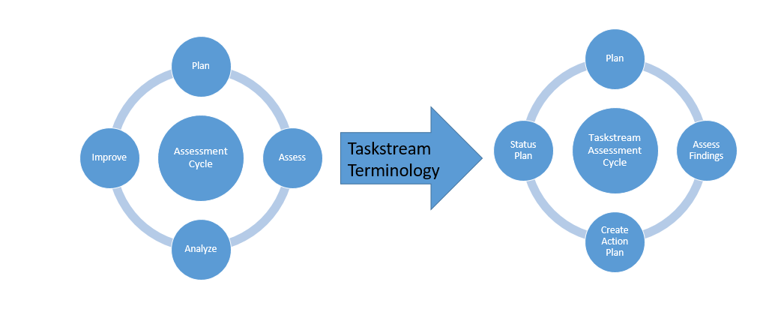

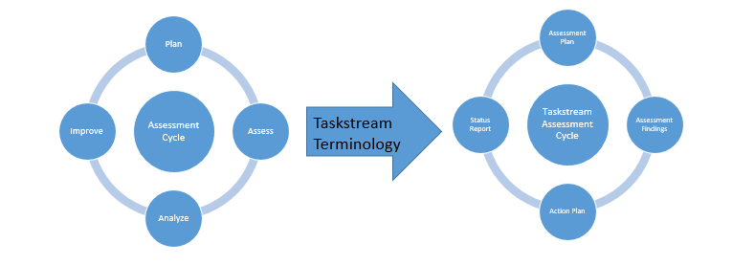
Figure 1: Taskstream uses the terminology above (R.) in presenting the assessment cycle. The assessment “plan” describes what specific activities be assessed for each program slo. “Assessment findings” archives the results of assessment activities completed that year; the analysis of those findings provides the basis for an “action plan to improve student learning or the assessment process.” The “status report” is where you record how the improvement strategy called for in the action plan is progressing. For each learning outcome, this full cycle occurs in either 2 or 3 academic years.

We also generate various assessment, audit, and other reports from the system. The data are reviewed periodically by the core assessment teams. This ensures that University of Baltimore is continually monitoring, assessing, and improving all programs the University offers.
Figure 2: Taskstream uses the terminology above (R.) in presenting the assessment cycle. The assessment “plan” describes what specific activities will assess each program student learning outcome. “Assessment findings” archives the results of assessment activities will assess each program student learning outcome. “Assessment findings” archives the results of assessment activities; the analysis of those findings results in an “action plan.” The “status report” is where you record how the improvement strategy called for in the action plan is progressing; you might be doing another assessment or you may be implementing a change that you will review in the next assessment cycle. The next review results in a new assessment plan that responds to the loop closed by assessing and adapting for improved student learning. For each learning outcome, this full cycle occurs in either 2 or 3 academic years.

We use Taskstream almost exclusively for assessing learning outcomes. Some administrative units also post their assessment plans and results in Taskstream. Access to Taskstream is provided at a variety of levels. Individuals need a password and ID to access Taskstream that is specific to University of Baltimore.

The Cycle of Assessment

Whether one is assessing learning outcomes for an academic or co-curricular program or for a single course, it is important to remember that assessment is an iterative process, intended to provide useful feedback about what and how well students are learning. When developing the plan, it is essential to think through all four steps of the cycle. Assessment is an ongoing process of planning, doing, checking, and acting.

- Plan Set Learning Goals. Establish clear, measurable expected student learning outcomes (SLOs); decide and articulate what students should know and/or be able to do when they leave your program or class.
- Do Develop and implement assessment strategies. Ensure students have sufficient opportunities to achieve the outcomes. Design tests, assignments, reports, performances, or other activities that measure the types and qualities of learning expected.
- Check Review assessment data. Gather, evaluate, and discuss the results of the assessment instruments to see what evidence they provide about student learning.
- Act Create an action plan. Discuss the results and decide how to address any issues raised by the data to improve learning. Then determine if the action helped.

The assessment cycle is a process for continuously inquiring about how students, staff and faculty are doing. What are students learning? How are students learning? How is a particular service assisting our students? Is student learning supported or supplemented outside the classroom? Are current pedagogical strategies used by faculty effectively? Although all faculty and staff may use some components of the assessment cycle, use of all steps in this cycle results in continuously focusing on the possibility of using evidence to create better teaching and learning.

Relationships among Outcomes

When designing course, program, and general education outcomes you should always keep sight of the general institutional level goals. All student learning outcomes (SLOs) up and down the chain (i.e., from course learning outcomes to university-level learning outcomes) should coordinate conceptually. To do so, keep in mind the following steps:

- Begin with the broad institutional outcomes expected of all students
- Work backward to design academic program outcomes that coordinate conceptually with the institutional outcomes
- Design course outcomes that will lead to the achievement of both program and institutional outcomes
Note that when the program is delivered, students experience this sequence in reverse. Students first participate in experiences that address lesson outcomes. The learning that results from these experiences accumulates as students proceed through the courses and other experiences in the program. A curriculum should be designed so that it provides a coherent set of experiences leading to the development of desired knowledge and skills – students show increasing levels of sophistication and integration of skills as they progress through the program.

In thinking about the increasing levels of sophistication and expertise, you might want to mirror the stepped levels of Bloom’s Taxonomy (1956, revised Anderson and Krathwohl, 2001). This classification scheme for cognitive outcomes provides many of the words that identify what we hope to achieve in our courses and arranges them according to six increasing degrees of cognitive complexity (See Table 2). The underlying assumption of the Taxonomy, which has been supported by considerable research, is that each higher-level outcome (such as the ability to apply methods to solve problems) necessarily includes all the outcome levels below it (in this case, knowledge and comprehension). Therefore, a student’s satisfactory demonstration of a high-level outcome precludes any necessity also to affirm the student’s satisfactory attainment of the lower-level outcomes nested within it. The list in Table 2 orders the six levels of Bloom’s Taxonomy from left (simplest) to right (more complex), with examples of verbs representing typical student learning outcomes below the label for each level. Beginning level courses should start at the lower levels of expertise, first introducing the basics – knowledge and comprehension. More advanced courses should move steadily upward through application and analysis. Finally, advanced undergraduate and graduate courses probably should be asking students to demonstrate synthesis and evaluation.

Alignment. A program’s curriculum should be aligned systematically with the program’s learning outcomes. Alignment involves clarifying the relationship between what students do in their courses and what faculty expect them to learn. Analyzing the alignment of a curriculum with program learning outcomes allows program directors to identify gaps which can lead to curricular changes that improve student learning opportunities. The same activity can go on at the institutional level.

Curriculum mapping. Mapping shows you where in your curriculum your courses are addressing each program learning outcome. Students should be provided several learning opportunities for each outcome, and your curriculum should include places where skills are introduced (I), practiced (P), and finally mastered (M). Constructing a map makes it possible to identify where within the curriculum these learning outcomes are addressed. In other words, it provides a means to determine whether your outcomes are aligned with the curriculum (See Curriculum Mapping, Section IV).

Designing Effective Assessment Plans

Identifying Student Learning Outcomes

As noted above, student learning outcomes are statements indicating the intended knowledge, skills, attitudes, behaviors, or values resulting from a learning activity. When first identifying what knowledge and skills should be included in the student learning outcomes for a course or program, it is important to keep a few parameters in mind.

- Limit the number. MSCHE and assessment experts recommend assessing no more than 4-6 program-level student learning outcomes within a multiyear cycle. As some outcomes are achieved, new outcomes can be identified. And as programs evolve in response to the changing needs of society and the workplace, new SLOs may be identified that could replace or subsume current SLOs.
- Limit the scope. It is important to operationalize student learning outcomes such that students can demonstrate their knowledge and skills. The demonstration may be a performance on a test, a paper, or some kind of project deliverable. It is important that learning outcomes can be measured individually, and assessment experts recommend using only one action verb per student learning outcome. However, two verbs can be used in some cases.
- Consider both program needs and broader institutional learning goals. It is important to focus on the knowledge, skills, and abilities needed by students at a particular level (e.g., baccalaureate, master’s) and in a particular program of study as well as the contribution the program is making to the broader UB learning goals.
- Focus on evidence-based revisions. Once you’ve shown evidence of ability to achieve basic learning outcomes, develop more focused outcomes to identify areas where you can revise and improve. The goal of assessment is provide feedback to the program so it can improve student learning. Considering past learning outcomes and the program’s success in achieving those outcomes may suggest ways of focusing new outcomes to provide more information to the program. Programs should hypothesize about areas of weakness and develop outcomes to confirm or deny expectations and identify ways of fixing those weaknesses. Effectively constructed outcomes can help support arguments for additional university support.

Writing Student Learning Outcomes

What are learning outcomes?

Learning outcomes are statements of what is expected that a student will be able to DO as a result of a learning activity. These statements are typically expressed as knowledge, skills, attitudes, behaviors, or values. The key word is DO and the key need in drafting learning outcomes is to use action verbs that are measurable (e.g., “understanding” is not measurable whereas “create a document that …” is measurable).

Keying outcomes to the course level

Learning outcomes for different level courses are usually keyed to the hierarchy of Bloom’s taxonomy. First articulated in 1956, the designations of the levels were updated in 2001. Lower level courses will be looking simply for knowledge or remembering, while the most advanced courses might be looking for synthesis or creativity. Between them are comprehension (understanding), application, analysis, and evaluation. It’s important that a course’s level in the curriculum coordinate with the appropriate cognitive level. Below is a list of action verbs commonly associated with the various levels of the taxonomy. They not meant to be exhaustive, but are intended to initiate reflection and discussion about program-level student learning outcomes.

Table 2:

Action Verbs Associated with Levels of Bloom’s Taxonomy, Revised

Knowledge  (Remember) | Comprehension  (Understand) | Application  (Apply) | Analysis  (Analyze) | Evaluation (Evaluate) | Synthesis  (Create)
define | describe | apply | analyze | appraise | arrange
list | discuss | Calculate | appraise | assess | assemble
name | explain | demonstrate | classify | choose | collect
recall | express | dramatize | contrast | contrast | compose
record | depict | employ | debate | defend | construct
relate | locate | illustrate | diagram | estimate | create
underline | paraphrase | interpret | differentiate | evaluate | design
label | recognize | operate | distinguish | judge | formulate
quote | report | practice | examine | justify | integrate
locate | restate | schedule | experiment | measure | manage
match | review | sketch | question | rate | organize
cite | summarize | solve | test | revise | plan
reproduce | translate | use |  | score | prepare
identify |  |  |  | select | propose
state

Why use learning outcomes?

Learning outcomes help instructors be precise. They can

- help students learn more effectively. Students know where they stand and the curriculum is made more open to them.
- make it clear what students can hope to gain from following a particular course or lecture.
- help instructors to design their materials more effectively by acting as a template.
- help instructors select the appropriate teaching strategy.
- help instructors more precisely tell their colleagues what a particular activity is designed to achieve.
- assist in setting examinations based on the materials delivered.
- ensure that appropriate assessment strategies are employed.

Learning outcomes are particularly important where materials and learning activities are produced by many people in order to be used by others, such as general education or university- wide writing courses. By stating what you expect students to be able to do, you can help colleagues better judge an assignment’s appropriateness to its circumstances and consider how to change it to meet their own local needs.
A learning objective should include an action verb that identifies an observable action students take in response to overarching student learning goals.

A summary of the guidelines to keep in mind when developing student learning outcomes for your program is as follows:

- Focus on outcomes that are essential and respond to program needs and institutional learning goals.
- Include in clear and definite terms the knowledge, abilities, values, attitudes, and habits of mind a student who graduates from your program is expected to have.
- Confirm that it is possible to collect accurate and reliable data for the outcomes (i.e., is measurable).
- Consider available resources when developing outcomes.
- Include more than one measure that can be used to demonstrate that the students in a particular program have achieved the expected outcomes of the program.
- Address how the students’ experience in the program contributed to their knowledge, abilities, values and attitudes.
- State the outcome so that assessments of the outcome can be used to identify areas to improve.

What comes next?

Once you have written your learning outcomes, the next logical step is to design an assessment method to test whether students have achieved the outcomes. Only after the learning outcome is designed can one really say what forms of learning materials / activities are needed to assist students to do well on the assessment. Clearly, your suggested examination questions should attempt to test whether or not the intended outcomes you specified have been achieved.

Curriculum Mapping

All curricula – including thoughtful reflection on what individual courses contain – should be developed within the context of the program learning outcomes. In turn, programs should broadly reflect the goals and mission of the college and university.

Curriculum mapping helps identify which courses are responsible for particular outcomes. It also provides a way for faculty to be certain that the curriculum offers the courses in a rational sequence. The curriculum should be organized so that knowledge and skills for each program learning outcome are first Introduced, then Practiced, and finally Mastered (entered in Taskstream as I, P, or M).

Think about the following as you map your curriculum:

- Are key program goals introduced, practiced, and mastered at varying levels of courses?
- Does the program offer appropriate redundancy in learning opportunities?
- Do course learning outcomes coordinate with program learning outcomes?
- Are there opportunities for students to organize, synthesize, and integrate what they are learning across the curriculum?
- Are courses appropriately preparing students for careers or graduate school?

Think about the following as you create your curriculum map:

- What conclusions can you draw about priorities, emphasis, and learning?
- What knowledge/skill is taught in each course? Are certain elements over-covered, under- covered?
- Would co-curriculars enrich any of your areas?

Use the curriculum mapping feature in Taskstream. To help map out elements before entering them into Taskstream, use this curriculum mapping worksheet.
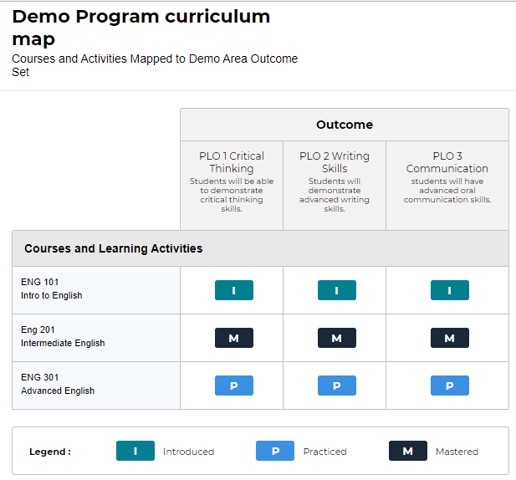

After mapping, review your curriculum to make sure there is a coherent plan of study. A program is not a collection of courses, but s meant to provide a coherent program of study to meet SLO’s.

Measuring Student Learning Outcomes

Departments/programs should address the following questions when considering how to measure student learning:

- Who will be measured? Departments/programs do not need to measure each student each year. Random samples of students can be used. Some departments assess students in a senior capstone course. Assessing students in selected courses is also possible. Students should be assessed after they have been exposed to the content matter described in the learning outcomes. Often, assessment occurs during the last semester or two of the student’s career, but assessment can take place at any time. If using a pre-test/post-test measurement design, students should be assessed before and after completion of learning outcome content.
- When? Data about student learning should be gathered at least annually.
- By whom? Departments should specify that a particular person or committee be charged with assessment duties. When using embedded assessment (i.e., assessment measure is part of the regular course assignments), course instructors can be charged with gathering data. Assessment is most useful when results are analyzed, discussed, and implemented by as wide a group as possible.
- How? The table below describes some of the various assessment measures that can be used. Multiple measures are not necessary for each outcome, but the program should use more than a single measure throughout its assessment plan

Measure | Description | Advantages | Disadvantages
Portfolio Review | An evaluator or evaluators evaluate a collection of student work. Uses rubric. | Evaluates longitudinal work of students | - Time-consuming  - Requires diligence  - Difficult to score
Objective Exam | Use of a multiple- choice/true-false exam to measure student learning; may include pre-test/post- test design. | - Tests actual knowledge.  - Can be used to measure improvement. | - Difficult or expensive to design.  - Difficult to test all students.
Embedded Assessment | Use of an in-class graded or ungraded activity or assignment as a way of measuring student learning. Uses rubric. | - Unobtrusive  - Easily administered and scored | - Limited in scope
Student Interviews | Asking students direct questions about their learning and experiences in the program. May use a rubric. | - Can probe knowledge and affective responses | - Difficult to score  - Time-consuming  - Possibility for bias in student answers
Surveys | Asking questions of faculty, employers or alums about student learning. | - Easy to administer  - Easy to score | - Difficult to determine causality  - Difficult to design valid instruments  - Possibility for bias in the answers
Indirect Measures | Other measures including scores on placement tests, national awards and honors, etc. | - Compares your students to national averages and other schools | - Not directly tied to student learning outcomes  - Comparisons may not be available

Academic program quality depends on gathering appropriate data about or evidence of student learning. Middle States requires that program-level assessment include at least two measures of assessment, one of which must be a direct measure of student learning.

- Direct measures provide evidence that actual learning has occurred and is in the form of a product or performance (e.g., exams, projects, or performances graded with rubrics).
- Indirect measures are signs that students are probably learning, but exactly what or how much they are learning can be less clear. (e.g., number of hours students study, course evaluations, student satisfaction surveys).

Examples of direct and indirect assessment measures, along with additional information on them, can be found at the end of this handbook under Other Resources, “More on Direct and Indirect Measures.”

You must select assessment measures that can provide actual evidence about the learning outcomes you are attempting to evaluate. Before you begin your assessment you should decide on what is a minimally acceptable performance standard. With your colleagues it is best to articulate what constitutes unacceptable, acceptable, and exemplary performance for each assessment measure. These standards can vary, as minimally accepted work is often connected to what the student is expected to do when she becomes a graduate. You would probably expect nursing students, for instance, to know how to draw blood 100% of the time, whereas English students probably would have a little more leeway in minimal expectations for interpretations of Shakespeare.

Think about the following as you compose your learning outcomes:

- What assessment measures can you easily put in place without disrupting a faculty member’s classroom activities or a student’s work?
- What evaluation tools does the program already have in place, what knowledge or skills are they evaluating, and do they provide useful information about the program goals?
- Are you using both direct and indirect measures? Every outcome must be evaluated by at least one direct measure. Remember – direct measures can include a wide variety of possibilities.
- What do you not know now about your outcomes that you wish you did know? How can you design a measure that addresses that question?

Reviewing Assessment Findings

Understanding what your assessment data are telling you can sometimes be difficult. It’s important that the measures you are using directly address the outcomes you are trying to assess. To make sure your data are valid they should be relevant, accurate, and representative. If your measures yield these types of data they will probably be useful to you in making further curricular decisions.

Once you have a good data set you can proceed to interpreting the evidence you’ve collected. Consider what the data are telling you about how well your students are achieving the learning outcomes you’ve set. Do your findings seem to make sense? If not, try to figure out where the glitch is occurring. Collected evidence should indicate to you where students are having difficulties and where there might be problem areas in the curricular information you thought your program was delivering. Once you’ve been able to see all the data together you will be able to make decisions about what additional information you need to move forward, including both better assessment methodologies and program/curricular improvements.

An essential activity at this step is to share the data with others in your program. All review and decisions about programmatic revisions should be done cooperatively with faculty who teach in the program.

Creating an Action Plan

Data collection matters little unless the data are shared at the program and/or institutional levels and used to improve learning, planning, and teaching. The data needs to be used to reevaluate and/or revise the curriculum or individual courses to be sure that program learning outcomes are being achieved. Using the evidence to plan a more responsive curriculum or to address missed learning opportunities is the point of assessment. Improving student learning, or as some accrediting agencies say “closing the loop,” is the proper objective of assessment.

How will you use the evidence? Program faculty should be a part of any discussion about the evidence gathered using assessment. Once the data are gathered (and program directors have entered them into Taskstream), a programmatic conversation should help direct any actions taken in response to what the evidence shows. If a change in course material or curriculum is indicated these actions should be entered in your action plan and addressed. Other possible actions could be offering evidence that new equipment or software purchase is required to improve student learning; new faculty hires are necessary; pre- or co-requisites are needed. It is always important to indicate who is responsible for implementing any changes and to include a timeline for the implementation.

Following up with Status Report

The Status Report tab in Taskstream is where you should write comments that follow up on your action plan. For example, if you’ve identified curriculum that needs to be revised, what stage is that in? If you’ve identified new resources that are needed, are they being obtained?

Once the actions you’ve recommended are actually achieved, you review the results alongside the curriculum map. Does it need revision? Do SLOs need revision? Review the program structure and goals to develop the next assessment plan. In short, they become part of your next assessment cycle.

Taskstream training materials are available for all those who are entering assessment data into Taskstream for their program. Taskstream training is ongoing, and materials as well as one-on-one training sessions can be requested at any time from the Provost’s Office.

What to Assess
UB asks that each program assess at least two program student learning outcomes each academic year. All program learning outcomes must be assessed at least once within a three-year period. It is up to you whether you do one each semester, or two in one semester. Middle States likes to see each program learning outcome assessed through two assessment methods, one of which must be direct. Depending on how each college decides to collect reports, Program Directors will either turn forms in to their Associate Dean for entry into Taskstream or enter their data themselves into Taskstream by the dates in the timeline. Do not wait until the last minute to do all your assessment work as this is a process and takes time.

Institutional Assessment Timeline
All academic programs are expected to conduct assessments of at least two program SLOs every academic year. A complete SLO assessment report (including assessment findings and action plans) for data collected regarding those two or more SLOs must be entered into TaskStream and submitted for official review no later than COB of the school’s/college’s specific due date.

A status report describing and discussing progress achieved, problems encountered, and potential effects of each action plan must be entered into TaskStream and submitted for official review no later than COB of the school’s/college’s specific due date..

Examples:

- Findings and action plans for AY 2015-16 assessments must be submitted by October 21, 2016; status reports on those action plans must be submitted by February 17, 2017.
- Findings and action plans for AY 2016-17 assessments must be submitted by October 20, 2017; status reports on those action plans must be submitted by February 16, 2018.

Other Resources

Writing a Mission Statement

The foundation for an assessment planning process is a shared, clearly articulated mission statement. Aligned mission statements are mutually supportive. A mission statement is a brief (90 words, maximum) statement that identifies the purpose of your program, who is served, and how they are served. A mission statement is clear and concise. Program level mission statements should be aligned with schools or divisions as well as the university mission.

General Program Mission Statement Template

The mission of the degree program is to
[Primary purpose]
for

[Stakeholders] opportunities ] .
by __[Primary functions, including examples of student learning

Sample Mission Statement

The mission of the Biology B.S. degree program is to prepare students for employment in various biology-related areas and/or for advanced degrees in biology and other related fields. The program curriculum provides students with instruction in the fundamental concepts, knowledge, and laboratory/field techniques of the life sciences, and offers hands-on learning opportunities ranging from small-group problem solving exercises to practice in formal laboratory methods to the conducting of field-based research projects in the greater Baltimore area.

Checklist for a Mission Statement

- Is the statement clear and concise (ideally no more than 90 words)?
- Is it distinctive (i.e., setting your program apart from those offered elsewhere)?
- Does it clearly state the purpose of the program?
- Does it indicate the primary stakeholders?
- Does it support the missions of the school/division, the college, and the university?
- Does it reflect the program’s priorities and values?

(Based on material from the University of Central Florida, UCF Academic Program Assessment Handbook,” 2008.)

More on Direct and Indirect Measures

Assessment takes many forms. Direct and indirect evidence of student learning offer insight into the outcomes of the students’ educational experiences. Both are helpful in providing evidence of student learning. Similarly both quantitative and qualitative evidence add value to the assessment process. Below is what MSCHE has to say about the value of formative and summative assessment.

“Formative assessment is ongoing assessment that is intended to improve an individual student’s performance, student learning outcomes at the course or program level, or overall institutional effectiveness. By its nature, formative assessment is used internally, primarily by those responsible for teaching a course or developing a program.

Ideally, formative assessment allows a professor, professional staff member, or program director to act quickly to adjust the contents or approach of a course or program. For example a faculty member might revise his or her next unit after reviewing students’ performance on an examination at the end of the first unit rather than simply forging ahead with the pre-designated contents of the courses.

In contrast, summative assessment occurs at the end of a unit, course, or program. The purposes of this type of assessment are to determine whether or not overall goals have been achieved and to provide information on performance for an individual student or statistics about a course or program for internal or external accountability purposes.
Grades are the most common form of summative assessment.”

(MSCHE, Student Learning Assessment, 2003)

Sample direct and indirect measures at the course and program level:

 | Direct Measure | Indirect Measure
Course Level | - Course and homework  - Examination & quizzes  - Standardized tests  - Term papers & reports  - Presentations  - Research projects  - Class discussion  - Case study analysis  - Rubric  - Artistic performance | - Course evaluations  - Hours of service learning  - Student hours doing homework  - Number of student hours at out-of-class cultural events
Program Level | - Capstone projects  - Pass rates or scores on licensure, certification  - Student publication  - Internship supervisor ratings | - Focus group interviews  - Course enrollment info  - Job placement  - Dept. or program review  - Alumni surveys  - Student perception survey

Suggested direct and indirect measures:

Direct Measures:

- In-house pre-test and post-test for mastery of knowledge
- Performance assessment (e.g. rubrics or other standardized instrument that measures)
- Major project assessment by independent raters (according to criteria or rubric)
- Common test formats (e.g. completion, essay, matching, multiple-choice, true-false)
- Authentic Test
- Classroom Assessment Techniques (Angelo and Cross, 1993)
- Community Service and other Field Experience
- Capstone Experiences (e.g. papers, senior theses)
- Homework Assignments
- In-class Presentations
- In-class Writing Assignment
- Poster presentations and student research conferences
- Exhibitions and productions
- Competence Interviews
- Portfolios
- Embedded assignments

“What differentiates embedded assessments from other class activities is that they are designed to collect information on specific program learning objectives. In addition, results are pooled across courses and instructors to indicate program accomplishments, not just the learning of students in specific course sections” (Allen, 2004).

Indirect Measures:
- Job placement of graduating seniors
- Employer surveys and questionnaires
- Student graduation/retention rates
- Exit interviews
- Survey measuring satisfaction with learning that occurred
- Student program evaluations
- Focus group discussions
- Alumni surveys reporting satisfaction with program
- Analysis of student grade distribution
- Peer review of program
- Analysis of records, documents regarding program/clientele
- Community perception of program effectiveness
- Benchmarking
- Degree of increase or decrease of specifically targeted behaviors
- Reflective essays
- Interviews

Evidence-based Changes

Whatever it is that one learns though the assessment process, one must use this evidence to do something. Nothing is worth assessing if you don’t use the results. Thus, the assessment steps here must be acted upon and repeated:

- identifying what you want students to do, or for your program to accomplish,
- designing ways in which this learning opportunity happens,
- gathering evidence – both direct and indirect,
- analyzing the results,
- making sense of the results,
- doing something with what you learned, and
- starting again at step one

Some entities call this “continuous improvement.” It is simply worth noting that repeating the steps is beneficial to helpful review.

Additional Resources
Links to the materials below can be found on the Institutional Effectiveness webpage under Assessment, “Assessment Handbook.” These useful tools include sample worksheets and guidelines for planning assessments.
- Bloom’s taxonomy of action verbs for SLOs
- Assessment Plan worksheet (Use this worksheet to plan your annual program assessments prior to entering the information into Taskstream.)
- Assessment Report worksheet (Use this worksheet to plan your annual program report prior to entering the information into Taskstream.)
- Curriculum Mapping worksheet (Use this worksheet for curriculum mapping prior to entering the information into Taskstream.)
- Dos and Don’ts of writing SLOs
- Course Embedded Assessment
- AAC&U VALUE Rubrics (often used to assess cross-disciplinary intellectual and practical skills)
  - Inquiry and analysis
  - Critical thinking
  - Creative thinking
  - Written communication
  - Oral communication
  - Reading
  - Quantitative literacy
  - Information literacy
  - Teamwork
  - Problem solving
  - Civic engagement – local and global
  - Intercultural knowledge and competence
  - Ethical reasoning
  - Foundations and skills for lifelong learning
  - Global learning
  - Integrative learning

Glossary of Commonly Used Assessment Terms

Action plan:
What you plan (or hope) to do as a result of your assessment plan findings. Your action plan can be as expansive as a complete curriculum overhaul or as small as a tweak to a section of a course. It might include needing new equipment or additional faculty.

Assessment findings (assessment results):
What is learned about the efficacy of a course or a program with respect to students’ attainment of particular learning outcomes?

Assessment plan:
An outline of a program’s student learning outcomes, assessment methods used to collect evidence related to the attainment of each outcome, and the intervals at which the evidence is collected and reviewed.

Benchmark:
A point of reference for measurement; a standard of achievement against which to evaluate or judge one’s own performance. A program can use its own past performance data as a baseline benchmark against which to compare future data/performance. Additionally, data from another (comparable, exemplary) program can be used as a target benchmark.

Bloom’s Taxonomy of Cognitive Objectives, revised:
Six levels arranged in order of increasing complexity (1=low, 6=high)):

- Knowledge (remember) Recalling or remembering information without necessarily understanding it. Includes behaviors such as describing, listing, identifying, and labeling.
- Comprehension (understand) Understanding learned material. Includes behaviors such as explaining, discussing, and interpreting.
- Application (apply) The ability to put ideas and concepts to work in solving problems. It includes behaviors such as demonstrating, showing, and making use of information.
- Analysis (analyze) Breaking down information into its component parts to see interrelationships and ideas. Related behaviors include differentiating, comparing, and categorizing.
- Evaluation (evaluate) Judging the value of evidence based on definite criteria. Behaviors related to evaluation include: concluding, criticizing, prioritizing, and recommending.
- Synthesis (create) The ability to put parts together to form something original. It involves using creativity to compose or design something new.

Course goals (sometimes called course objectives):
Describe what a course strives to provide its students. Course goals/objectives focus on the inputs (course components, activities, assignments, etc.) that are intended to facilitate student learning.

Curriculum map:
Evaluation of curriculum in relation to intended learning outcomes and goals. Good mapping ensures that students are receiving appropriate instruction at appropriate points in their progression through a curriculum and enables the program/department to identify gaps in the curriculum and provide an overview of program accomplishments.

Curriculum mapping indicators:
Each program outcome should appear in multiple courses with one of three levels of concentration indicated as follows.
- Introduced (I): The points (generally specific courses) in a curriculum at which students are introduced to particular program learning outcomes. Outcomes may be introduced in more than one course, and more than one outcome may be introduced in a given course.
- Practiced (P): The points (generally specific courses) in a curriculum at which students practice particular program learning outcomes that previously have been introduced. Students should have the opportunity to practice outcomes in more than one course.
- Mastered (M): The points (generally specific courses) in a curriculum at which students should be able to demonstrate mastery of particular program learning outcomes. Students may have the opportunity to demonstrate mastery of outcomes in more than one course.

Direct assessments:
Directly evaluate student work (e.g., exams, papers, projects, musical performances, art exhibitions, etc.) by requiring students to display their knowledge and skills in direct response to a set of guidelines or assignments.

Formative assessments:
Conducted during the life of a major, course, or academic program with the purpose of providing feedback that can be used to modify, shape, or improve the major, course, or academic program.

Goals (in general):
Very broad statements noting what universities and programs hope their students will be able to achieve (e.g. “To establish a foundation for lifelong learning, personal development and social responsibility”). These statements may not be measurable in themselves (e.g. understanding/appreciation/development/etc.), but they provide guidance for program development and the identification of measurable student learning outcomes.

Indirect assessments:
Primarily reflective in nature and include self-reporting by students and alumni of their opinions and impressions of a program, course, or other educational experience, and their opinions on the value of their education in the development of their careers.

Learning outcomes:
Observable, measurable ways in which students should be able to demonstrate their understanding/appreciation/development/etc. after successfully completing a course or a program of study (e.g., “Students will be able to evaluate the implications of accepted ethical standards and current legal thought on the behavior of xxx professionals in the workplace.”). SLOs focus solely on the output from learning opportunities – student knowledge, behavior, and habits of mind.
(NOTE: Learning outcomes are known by many names: Student Learning Outcomes, SLOs, Program Learning Outcomes, and Course Learning Outcomes.)

Measure:
Methods and instruments used to collect evidence of the extent to which students demonstrate the desired behaviors.

Mission statement:
A brief (90 words, maximum) statement that identifies the purpose of a program, department, or other institutional unit, who is served, and how they are served. A mission statement is clear, concise, and contributes to assessment. Program level mission statements should be aligned with schools or divisions as well as with the university mission.

Rubric:
Written and shared set of standards for consistent judgment of a performance/product/ assignment/etc., containing specific characteristics that are arranged in levels indicating the degree to which performance standards have been met.

Standards:
Programmatically agreed upon values used to measure the quality of student performance, instructional methods, curriculum, etc.

Status Report:
In your next reporting period, comments on where you are with regard to your action plan.

Summative assessments:
Conducted after a major, course, or academic program has concluded to make comparisons with a pre-determined, targeted standard of performance.

Target (criterion):
Desired level of student performance on a particular learning outcome, stated explicitly in an assessment report, and set before assessment of course or program learning outcomes is conducted.

References
Allen, M.J. (2004). Assessing Academic Programs in Higher Education. Bolton, MA: Anker Publishing.

Anderson, L.W. & Karthwohl, D. R. (2001) A Taxonomy for Learning, Teaching, and Assessing: A Revision of Bloom's Taxonomy of Educational Objectives. New York: Longman.

Angelo, T.A & Cross, K.P. (1993). Classroom Assessment Techniques: A Handbook for College Teachers, 2nd Ed., San Francisco, CA: Jossey-Bass, Inc.

Bloom, B.S. (1956). Taxonomy of Educational Objectives: The Classification of Educational Goals. Handbook I: Cognitive Domain. White Plains, N.Y.: Longman.

