University of Baltimore Institutional Effectiveness Plan
- Introduction and Purpose
The University of Baltimore is committed to continuous self-examination to demonstrate its accountability, effectiveness, and efficiency in advancing student learning and success. Building on that longstanding commitment, this Institutional Effectiveness (IE) Plan advances a mature, evidence-driven culture of assessment and improvement anchored in measures of student success and operational effectiveness. The plan codifies innovation, cross-silo communication and is infused with disaggregated and contextualized data.
- Alignment with Mission, Strategic Planning, and Accreditation
Institutional effectiveness at UBalt is integrated with strategic planning, resource alignment, and assessment of educational effectiveness. Consistent with the prior plan, the IE framework encompasses the institutional assessment planning process derived from strategic goals, learning outcomes assessment, academic program review, administrative assessment, national and internally developed surveys. The IE Plan is responsive to MSCHE expectations. Assessment evidence algins with institutional planning artifacts, including KPIs and scorecards. UBalt’s robust shared governance culture, reinforced by university-wide forums and webinars by administration leadership, enables inclusive planning and transparent communication about progress toward institutional goals.
- Strategic Planning
The current strategic plan was implemented in 2018 and represented a shift to “re-imagine” the institution’s focus. As the University prepared for its centennial, the strategic plan strove to build upon the institution’s first 100-year legacy and leverage its strengths to forge a bold future. The new plan was ambitious and articulated shared goals:
- Position UBalt as the region’s premier professional, career-focused university.
- Strengthen student success,
- Solidify UBalt’s commitment to community engagement and service,
- Organize for long-term financial stability,
- Achieve excellence in research, scholarship and creative activity, and
- Strengthen UBalt’s commitment to diversity, equity and inclusion.
In March 2023, UBalt President Kurt Schmoke received approval from the University System of Maryland to extend the existing strategic plan through 2026. This extension comports with the strategic plan’s continued institutional relevancy and is in alignment with the direction outlined by UBalt leadership.
The strategies articulated in the strategic plan continue to drive the institution forward. In 2025, UBalt created goals for the Maryland State Managing for Results (MfR) report and Performance Accountability Report (PAR) using metrics aligned to these strategic plan goals.
The strategic planning process has been initiated with the formation of the committee of cross-campus stakeholders, with an expected launch in March 2026.

- Framework of Assessment: Core Assessment Team
The Core Assessment Team, (CAT) helps guide assessment at UBalt and communicates results to the greater UBalt community. The CAT is comprised of 2 parts: ADCat and ACat. ADCat or the Administrative Core Assessment Team is co-chaired by the Assistant Provost for Institutional Effectiveness and the Assessment & Technology Coordinator. Membership includes representatives from student affairs, all nonacademic units and a Staff senate representative. ACat or the Academic Core Assessment Team is co-chaired by the Associate Provost for Academic programs and CELTT. ACat includes representatives from each of the associate deans, a UFS representative and the Assessment & Technology Coordinator.
The Core Assessment Team has six goals.
- Strengthen the quality of student learning outcomes
- Strengthen the use of evidence to enhance programs and to make programmatic decisions
- Provide forums for continually using and sharing data
- Provide ongoing opportunities to enhance assessment skills for all faculty and staff
- Develop an academic community that strives for evidence-based improvement
- Capitalize on UBalt’s capacity to provide students with distinctive programs
Core Assessment Team Membership
The CAT is comprised of the: Administrative Core Assessment Team (ADCat) and Academic Core Assessment Team (ACat).
Administrative Core Assessment Team (ADCat) membership | Academic Core Assessment Team (ACat) membership
- Assistant Provost for Institutional Effectiveness (co-chair)  - Assessment and Technology Coordinator (co-chair)  - Divisional Liaisons (appointed by Divisional VP's) | - Associate Provost Academic Programs (co-chair)  - Director of Teaching and Learning Excellence (co-chair)  - CAS Associate Dean  - MSB Associate Dean  - LAW Associate Dean  - CPA Associate Dean  - Assessment & Technology Coordinator

Primary Responsibilities
ADCat ACat

- Facilitate continuous review process in administrative units  - Help ensure that administrative assessment is linked to the strategic plan and to the assessment of the University learning goals  - Members provide support within their divisions in developing assessment plans, reporting findings and action plans | - Curricular SOL Assessment Plans (Advisory)  - General Education/Graduation Requirements assessment  - Accreditation (regional & program specific)  - USM program review

The Core Assessment Team Communication Structure
Units within the ADCAT and the ACAT develop annual reports. The Core Assessment Team shares the report in a forum with the senior leadership, university shared governance and the university community of faculty, staff and students. Through this annual exercise, the university is made aware of the assessment activities, how they are tied to accreditation standards, and how they advance the strategic plan of the university, college/school or division. Senior leadership may identify a risk in the annual report and work with the Enterprise Risk Council to address. Both the assessment and the report communication processes are supported by the Office of Institutional Effectiveness.
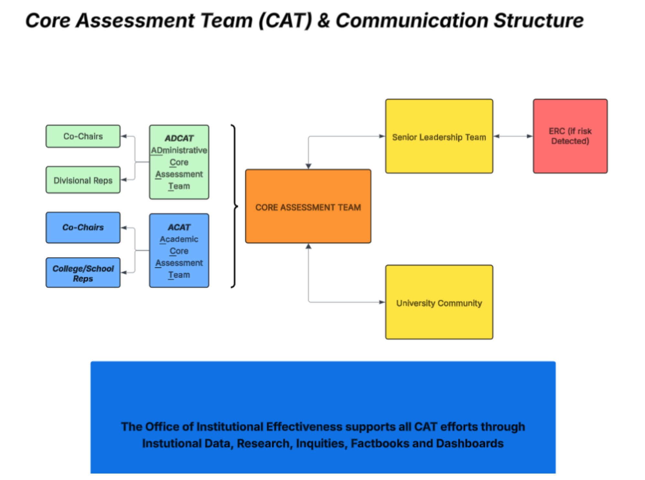

- Academic Core Assessment Team (ACAT)

Academic Program Assessment
In accordance with the standards for conducting and documenting assessments by the Middle States Commission on Higher Education, the University of Baltimore ensures that assessment processes, findings and interventions are housed centrally within SharePoint sites under appropriate security. SharePoint is used to collect and manage data in the following areas for each academic program and various administrative units:
- Mission
- Program Student Learning Outcomes
- Curriculum Map
- Assessment Cycle
- Assessment Findings with Action Plan
- Closing the loop
Mission and outcomes (whether program SLOs or outcomes for a unit) are generally stable over a 3-year period. Assessment activities of SLO’s vary by year. One outcome (e.g., one SLO) might be measured for the first time in the cycle, while another SLO may be applying the intervention designed in the prior assessment cycle. All program SLOs should be reviewed every two years. The data are reviewed periodically by the core assessment teams (ACAT or ADCAT). This ensures that University of Baltimore is continually monitoring, assessing, and improving all programs the University offers.

Program SLO Assessment follows the diagram below.
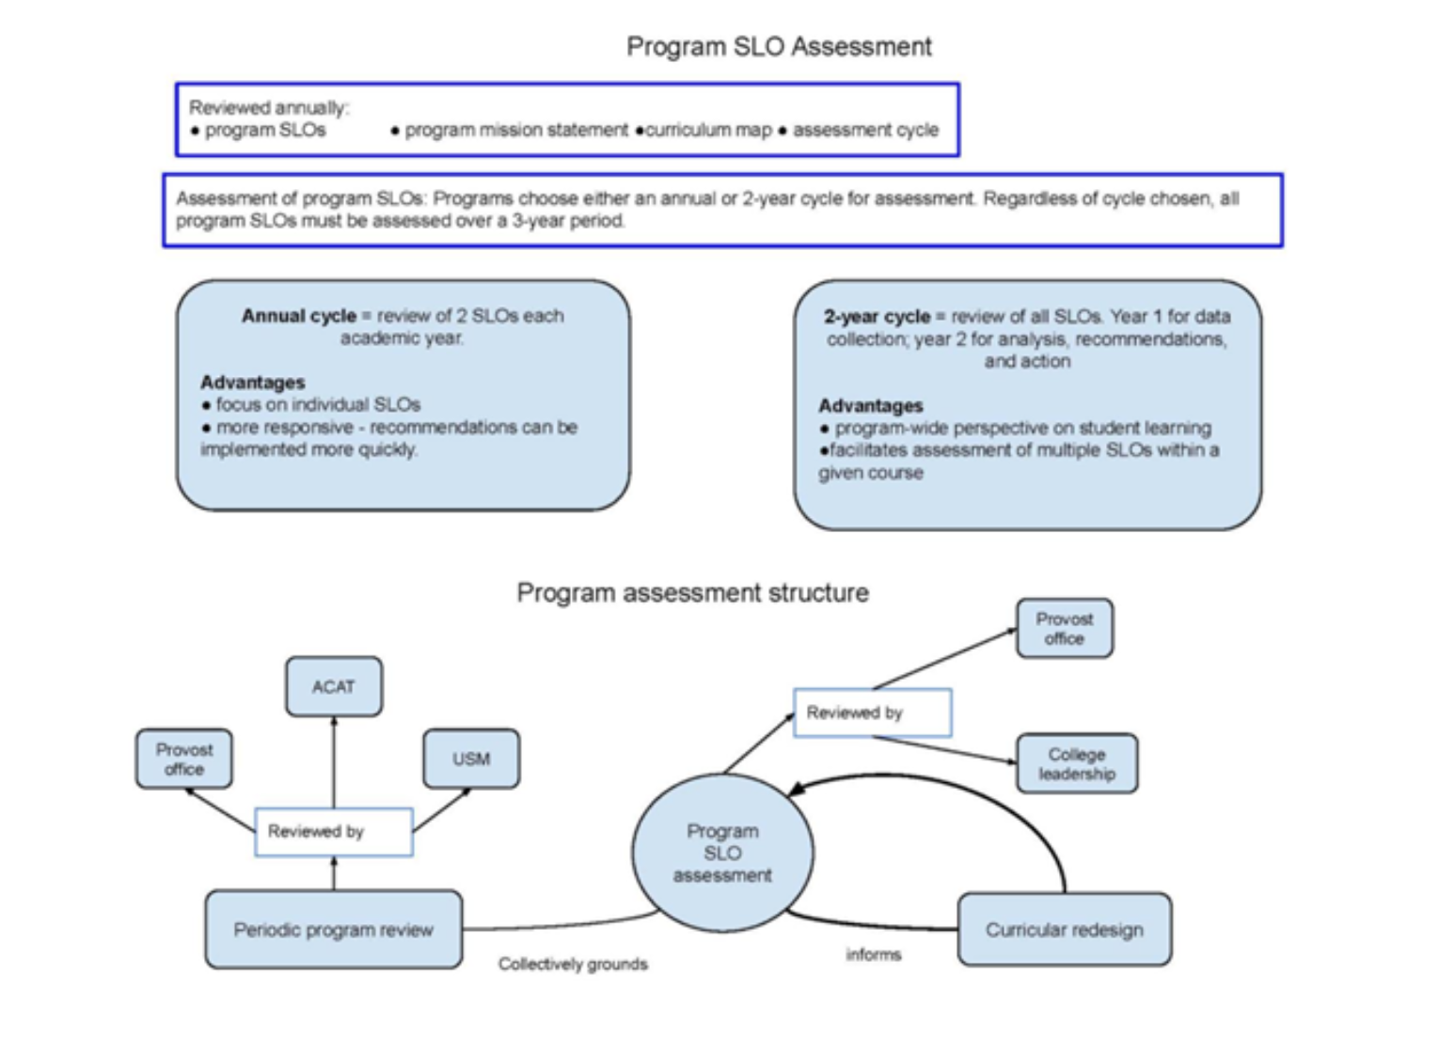

Assessment for Effective Teaching
Students perform best when they have a clear understanding of what is expected of them and how they can best meet those expectations. Learning outcomes are formal statements that articulate what students should know and be able to do at the end of the course or as a result of instruction. Each academic program at UBalt has a guiding set of student learning outcomes (SLOs). These should be periodically reviewed and updated by faculty. Program-level SLOs inform learning outcomes for each course. These should be communicated clearly to students in the syllabus. Here is an effective format for including learning outcomes on a syllabus:
By the end of this course, successful students should be able to:
- Explain why …
- Evaluate the costs and benefits of …
- Create an original …
- Suggest solutions to …
- Identify problems in …
- Present an argument for/against …
Regular assessment of the degree to which our students are attaining learning outcomes provides us with evidence of the strengths and weaknesses of our curriculum and our methods of delivering it. Of course, the regional agency that accredits the University of Baltimore, Middle States Commission on Higher Education (MSCHE), requires its member institutions to assess student learning outcomes. However, the ultimate reasons for the assessment of student learning outcomes must be to make our curriculum stronger, to make us more effective teachers, and to help our students learn more effectively.

- The Administrative Core Assessment Team (ADCAT)
UBalt is committed to continuous improvement in our administrative units' work to advance the institutional mission in support of the strategic plan. The Administrative Core Assessment Team (ADCAT) is a vital component of UBalt's institutional effectiveness framework, working in parallel with the Academic Assessment Team (ACAT) to ensure comprehensive institutional assessment. Each UBalt administrative unit completes its assessment through the support of the Administrative Core Assessment Team, a collaborative community of practice for assessment liaisons from each division.
In accordance with the standards for conducting and documenting assessments by the Middle States Commission on Higher Education, the University of Baltimore ensures that assessment processes, findings and interventions are housed centrally within SharePoint sites under appropriate security. SharePoint is used to collect and manage data in the following areas for each of the administrative units:
- Mission
- Goals
- Map to Strategic Plan
- Assessment Cycle
- Assessment Findings with Action Plan
- Closing the loop
Mission and outcomes (whether program SLOs or unit goals) are generally stable over a 3-year period. Assessment activities for outcomes vary by year. One outcome (e.g., one goal) might be measured for the first time in the cycle, while another may be implementing an intervention designed in the prior assessment cycle. All unit goals should be reviewed on a regular cycle. The data are reviewed periodically by the core assessment teams (ACAT and ADCAT). This ensures that the University of Baltimore is continually monitoring, assessing, and improving the institution.

Effective Assessment Practices: The Administrative Assessment Liaison
To assist each unit with recording their assessment, we have developed the role of Administrative Assessment Liaison to serve as the crucial bridge between the ADministrative Core Assessment Team (ADCAT) and individual administrative units within each division, ensuring effective assessment practices and continuous improvement.
Expected Outcomes:
- Enhanced assessment of culture within administrative units
- Improved quality and consistency of assessment practices
- Better alignment between unit and institutional goals
- More effective use of assessment results for improvement
- Strengthened institutional effectiveness

Key Responsibilities:
- Communication and Coordination
- Maintain regular communication between the core assessment team and administrative units
- Disseminate assessment-related updates, deadlines, and requirements
- Serve as the primary point of contact for assessment-related questions
- Assessment Planning Support
- Guide units in developing meaningful administrative outcomes
- Assist in creating appropriate assessment methods and metrics
- Review assessment plans for alignment with divisional and institutional goals
- Help units establish realistic timelines for assessment activities
- Data Collection and Management
- Provide guidance on data collection methodologies
- Ensure proper documentation of assessment activities
- Assist units in organizing and storing assessment data – with SharePoint editors
- Maintain confidentiality and security of sensitive information
- Analysis and Reporting
- Support units in analyzing assessment results
- Help units develop action plans based on assessment results
- Review assessment reports for completeness and clarity
- Help units identify trends and areas for improvement
- Ensure timely submission of assessment documentation
- Compile division-level assessment summaries
- Professional Development within ADCAT
- Participate in assessment-related training and workshops
- Share best practices with administrative units
- Stay current with assessment trends and requirements
- Continuous Improvement
- Track progress on improvement initiatives
- Document success stories and lessons learned
- Facilitate the sharing of effective practices across units
- Institutional Support
- Contribute to institutional assessment reports
- Support strategic planning initiatives
- Advocate for resources needed for assessment activities

The Assessment Documentation Log facilitates the summary of administrative assessment activities of each unit. The log also documents the alignment of these activities to the university strategic plan and the MSCHE standards.
- General Education
General Education is the foundation of university education. The courses in the General Education program are designed to provide students with opportunities to develop core knowledge and dispositions across many disciplines and academic areas of study. By helping to foster lifelong learning and curiosity, General Education enriches students’ education at UBalt and their personal, professional, and civic lives.
General education courses embody the mission of the program and meet the student learning outcomes in their designated area. Within UBalt, the General Education Program components are Field of Inquiry, Core Competencies, and Signature Experiences.
One of the main components of any General Education Program in Maryland is that it introduces students to new areas of inquiry, and the theories and methods used in those fields. At UBalt the thrust of the “Fields of Inquiry” components collectively achieves that goal for students. These include Arts & Humanities, Biological & Physical Science, Mathematics, Social & Behavioral Sciences, Basic Composition.
A second component of any General Education Program in Maryland is that it empowers students with certain skills needed to successfully be a lifelong learner. At UBalt the thrust of the “Core Competencies” components collectively achieve that goal for students. These include Oral Communication, Technological Fluency, information Literacy, Global Awareness, Diverse Perspectives, and Ethics.
A third component of any general Education Program in Maryland is that it promotes student success in their chosen fields in a way that is consistent with that's institution's mission. At UBalt the thrust of the "Signature Experiences" components collectively achieves that goal for students.

A faculty member who is interested in having a course become part of the General Education (GE) or Graduation Requirements (GR) should submit the request form directly to the General Education Council after the course has been approved by their department and undergraduate curriculum committees or other appropriate bodies within the school or college. The deadlines for submitting forms to GEC are announced by GEC each semester and generally occur around Week 8 of the semester. The general procedure for the certification of courses is outlined below:
- A faculty member completes the approval form for the domain under which they wish to be considered and assembles appropriate documentation. The proposal goes to the department and curriculum committee or other appropriate offices and the dean.
- The paperwork is submitted to the GEC at least one week prior to the next regular meeting.
- The GEC Chair reviews the paperwork and if it is complete, forwards the paperwork to the Council members.
- The Council reviews and if sufficient information is present, votes on the certification request as part of the next regular meeting.
- The Chair notifies appropriate parties of the results and forwards to campus Curriculum Review Committee for recommendation to Provost and for Provost final approval and updates to relevant documents/web pages.
The General Education Council reviews a selection of courses each semester to evaluate how well they meet Student Learning Outcome (SLO) requirements. These reviews focus on courses taught during the previous semester and rely on materials submitted by faculty to determine alignment with the approved General Education area.
Faculty are required to provide:
- All student artifacts from the course (no need to anonymize)
- The course syllabus (it should include current GE area descriptions and SLOs)
- Assignment prompts for each assessment of the GE SLOs, with explanations of how each aligns with the SLOs (reviewers may be outside the discipline and rely heavily on this information)
- Any additional support files (optional)
The GEC randomly selects at least five submitted artifacts for assessment.

Possible outcomes:
- Approved: Course meets assessment standards for the assigned General Education area. No further SLO assessment is required for three years unless there is a substantive course change.
- Not Approved: Course will be reassessed the next time it is offered. Two consecutive “Not Approved” determinations may result in decertification from the General Education Program, which could require students to complete additional coursework.

- Surveys and Evidence Strategy
Survey Cycle
UBalt will undertake a rigorous process for self-evaluation using nationally normed instruments and instruments developed and reviewed internally. UBalt conducts a coordinated cycle of such surveys. Customized questions are added to instruments such as NSSE, to explore issues that influence momentum and financial readiness and allow for disaggregation of data to understand distinct subpopulations of our campus community. Findings are discussed and disseminated through academic and administrative leadership offices, shared governance and appropriate workgroups enabling timely adjustments to pedagogy and services. All instruments, response rates, analyses, and action plans are archived in the accreditation repository, with actions targeted for initiation within 90 days of results dissemination. Assessments of those interventions are cataloged within the ACAT and ADCAT units.
Year-One Focus: Data Empowerment Group
To democratize data and build shared understanding, OIE, Enrollment Management, Administration and Finance, and the Office of Technology Services jointly lead the Data Empowerment Group. The group will deliver the campus Data Glossary and Data Owner Registry, an inventory of UBalt reports released externally and an inventory of campuswide business intelligence products. The group will produce “Institutional Data 101” and “Institutional Data 201” webinars that help faculty and staff read dashboards, interpret trends, and act ethically on UBalt’s data. The “Ask-OIE” intake portal provides clear service levels for analytics and assessment requests, while quarterly “Data Stories” synthesize insights into accessible narratives for campus constituents. Access to dashboards follows role-based, FERPA-aligned permissions with change logs and standard refresh cadences to maintain trust and consistency.

By year’s end, UBalt will complete an annual IE report, integrate artifacts into the accreditation repository, and identify next-stage enhancements to analytics and business processes.

- Reporting/Planning for the Future

All of the assessments mentioned above are reported on a regular basis, and information is disseminated to appropriate parties. Institutional Assessment is process that is collaborative, continuous and evolving. We will monitor our progress against the institutional success measures, adjusting as needed.

