Search for a course
(This tutorial teaches you how to search for a course through self service.)
Navigate to the MyUB Homepage by going to the following link: https://myubalt.ubalt.edu. Enter your Network ID and Password.
From the MyUB Portal, select “My Student Center” from the “Most-Used Tools” column.
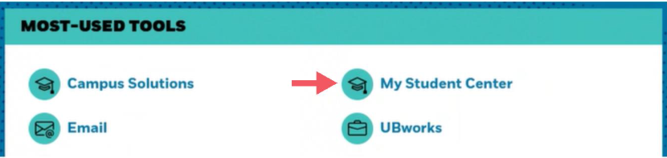
Click the icon that says “Search” under the “Academics” section of your Student Center page.
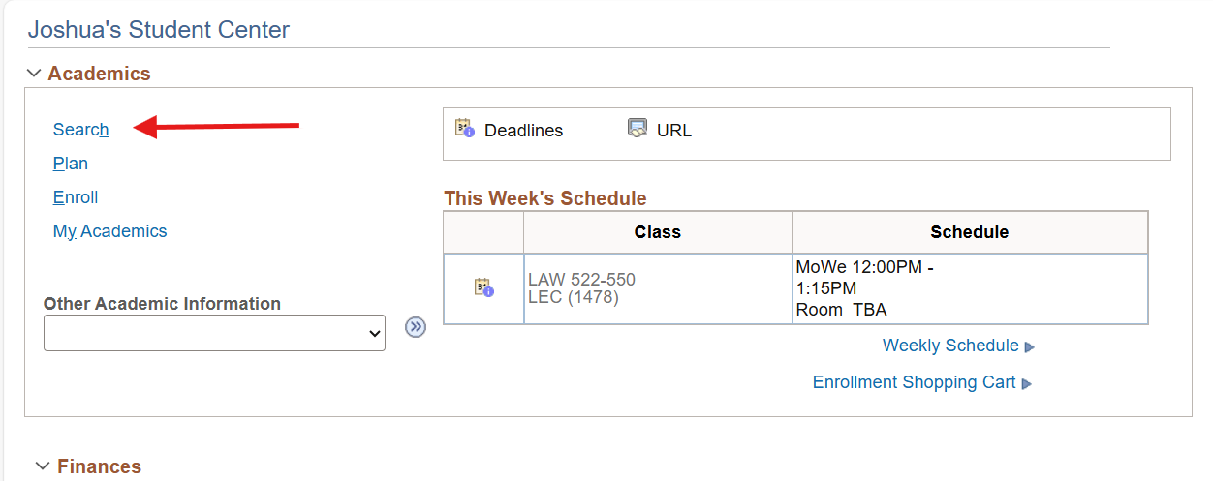

Under Search Criteria, you have the options to change term, subject, course career, or even fine-tune with the Additional Search Criteria option to search for credit value, class location, etc. Click the “Search” button once you have entered your parameters.
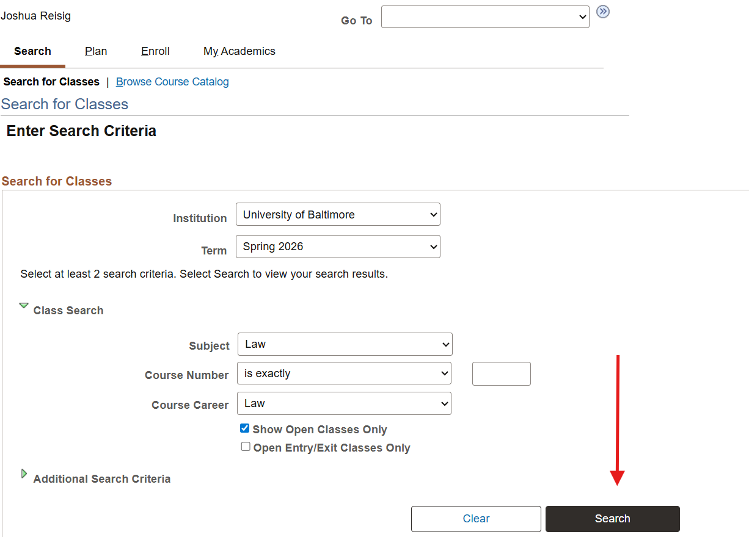

The results will be displayed as a result of your search.

