Curriculum Mapping: Linking Program Outcomes to Specific Courses in the Curriculum

Curriculum mapping identifies where within the curriculum program goals are addressed and student learning outcomes are achieved. It is important to note that curriculum maps can change based on curriculum changes to ensure they are still in alignment with the program learning goals (AKA program student learning outcomes). They should therefore be reviewed annually. The spreadsheet below provides a mechanism for you to link program goals and student learning outcomes to specific courses within the curriculum. Please refer to the sample curriculum map.

Instructions:
- List program learning outcomes (horizontally).
- Under courses (vertically), list all the courses that students are required or encouraged to take. Be sure to include internships and capstone courses.
- Within the body of the chart, indicate where goals are introduced, practiced, or mastered (I, P, M). Not every course will incorporate every goal.

Courses | Program Learning Outcomes
Key
I = Introduced
P = Practiced
M = Mastered

Sample Curriculum Map (From TaskStream)

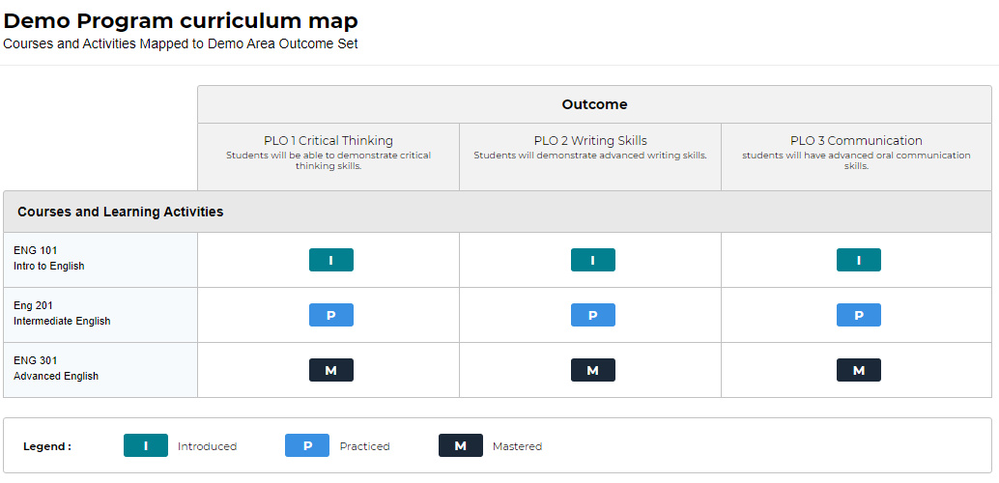

Entering Curriculum Map into Taskstream

Now that you have created your curriculum map, you need to input the information into Taskstream.
- Click on your “Academic Program Assessment Workspace” link
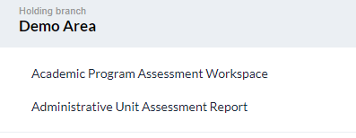
- On the left hand of the screen click “Curriculum Map”
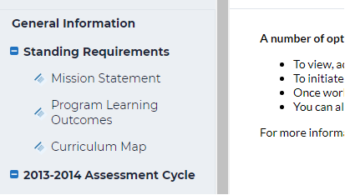

- On the upper right hand corner of the screen, click the Green “CHECK OUT” button
- To create a new map, click “Create New Curriculum Map” 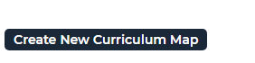

- Give your map a title (e.g. BA English Curriulum Map)
- Add a brief description if you like (e.g. “updated September 2019”)
- Choose which set of goals you would like to align the courses with
(you can view the goals before selecting them)
  - First you should select the program “goals”. In TaskStream, “goals” here means student learning outcomes. You also have the option of mapping to the UB undergraduate goals or specialized accreditation standards (e.g. NASPAA, AACSB, etc.)
- The following message will appear one you select your outcome set:
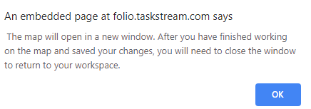

Click OK
You are now ready to add your courses
- Click the plus sign next to “Course and Learning Activities”
- A new window will open
- Course /Activity ID should be the course number (e.g. CSOS 150)
- Course/Activity Title is the name of the course
- Description –copy the course description if you like
- Link – you can provide a link to the online course description
- Click Create
- Repeat this process for all your courses

Adapted from: Diamond, R.M. (1998). Designing & Assessing Courses & Curricula. San Francisco: Jossey-Bass.

