Purchasing Card Processing
Users Verify Transactions
- Navigation: Main Menu > Purchasing > Procurement Cards > Reconcile > Reconcile Statements
- Users will not have to search for their transactions. The page should open displaying current transactions.
- Status of all transactions will be “Staged”. Users should change dropdown to “Verified” for each undisputed transaction.
- Users then click the “Billing” tab and update the Description for each transaction.
- Click “Save”.
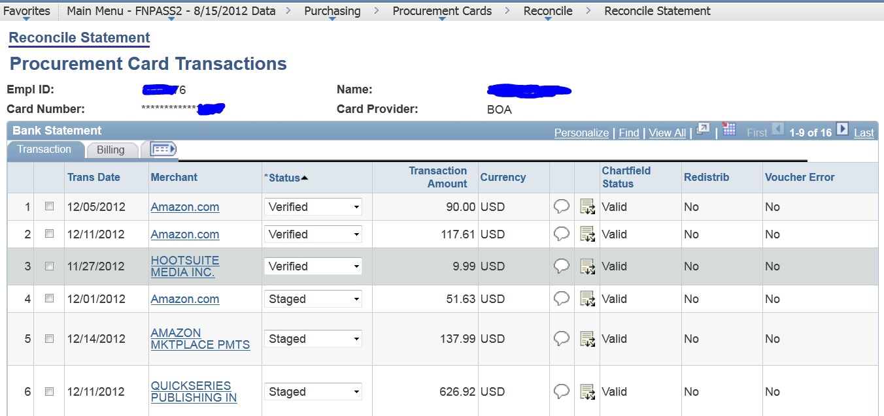
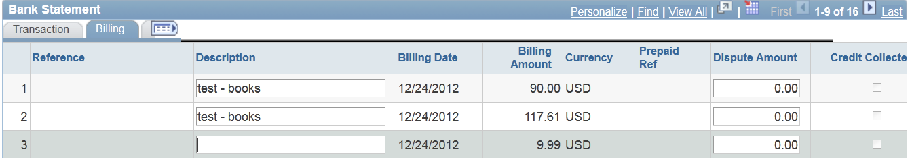

Reviewers Approve Transactions
- Navigation: Main Menu > Purchasing > Procurement Cards > Reconcile > Reconcile Statements
- Reviewers will see a search screen.
- Fields that must be populated to search:
  - Role Name: Purchasing Card Reviewer
  - Card Issuer: Bank of America (if this field is not populated, reviewer will receive an error)
  - Optional – Name – reviewers can search for a specific user by last name, first name
- Click Search
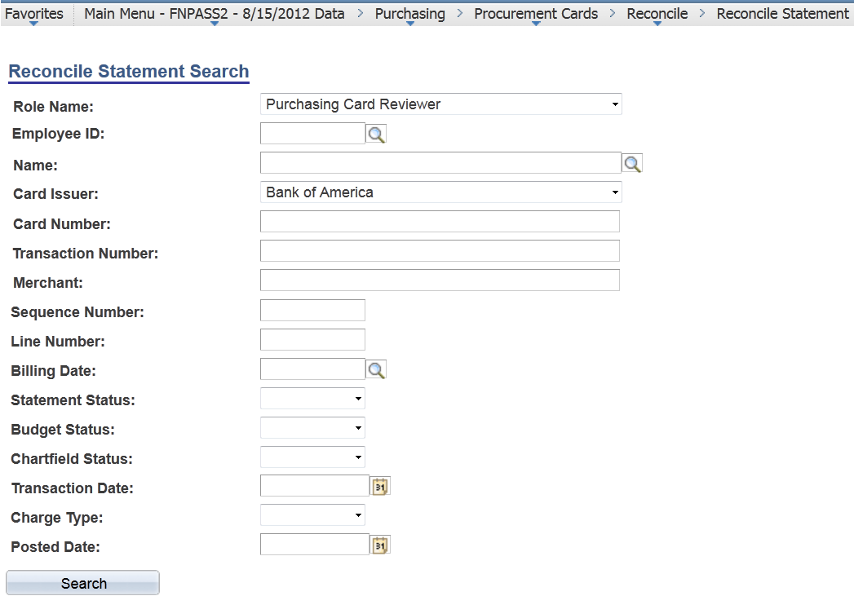

- Reconcile Statement page displays for all users that the Reviewer needs to approve
- Reviewer changes dropdown to “Dept Approved”. If Users did not previously Verify transactions and add a description, Reviewer will also need to add descriptions.
- To change the distribution of a line, click the distribution icon on the specific line 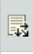
- Enter the distribution on the distribution page. Click OK.
- Click Save when all changes and approvals are complete.
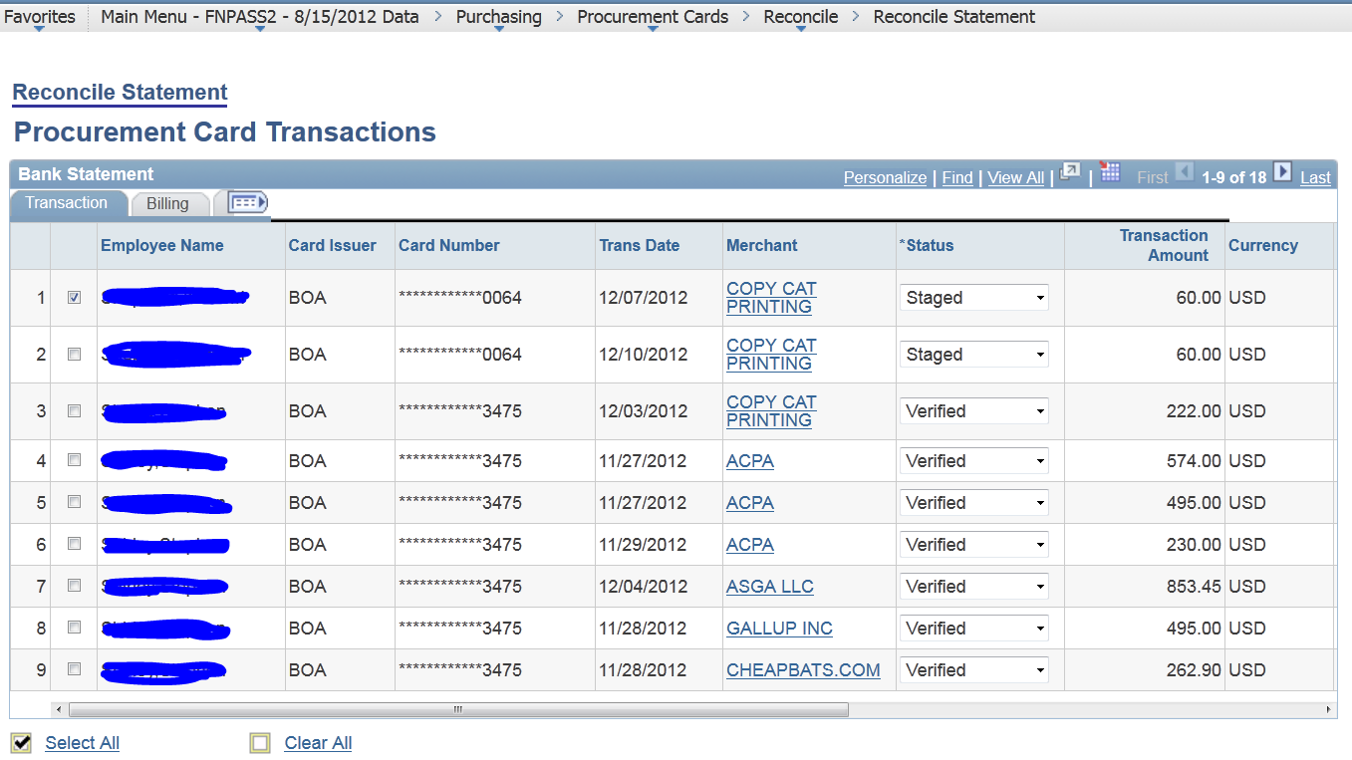
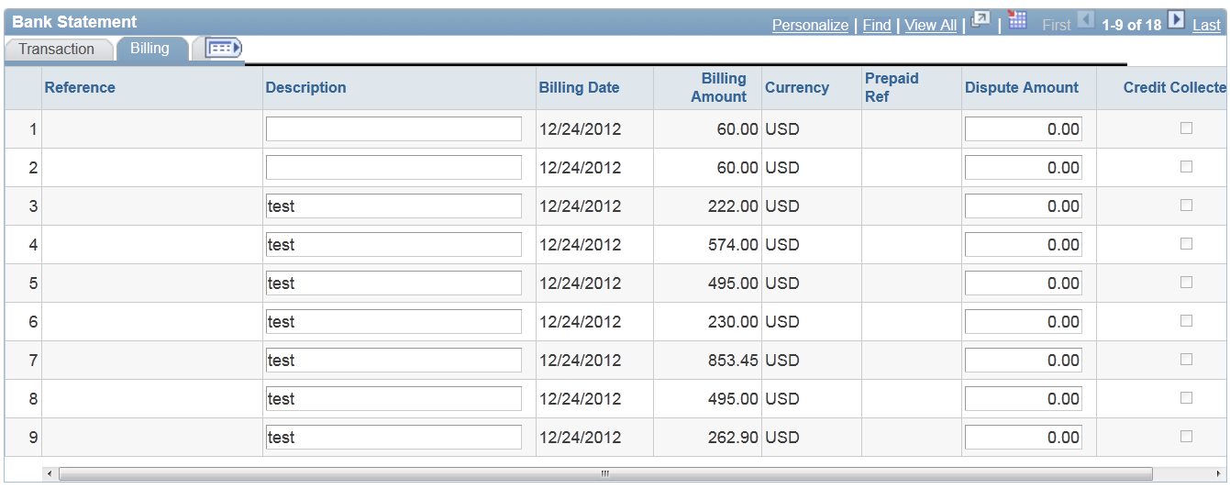
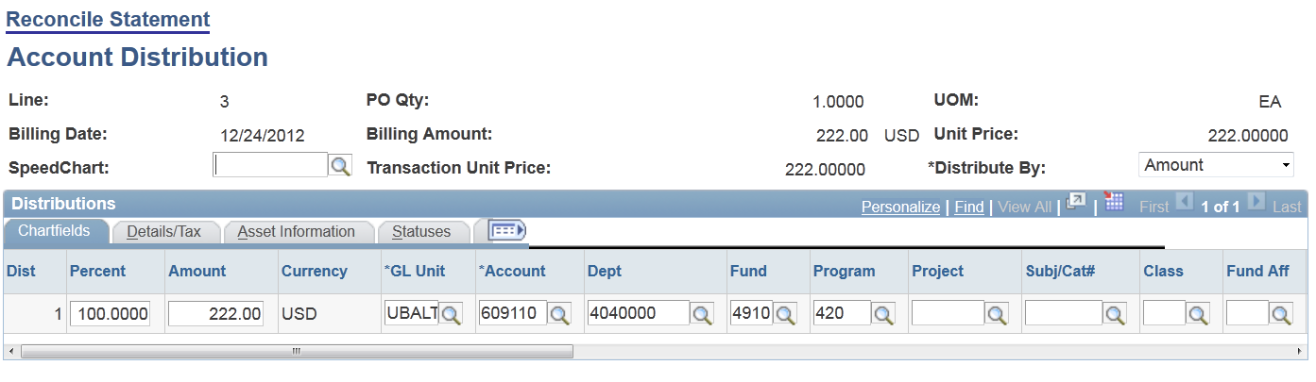
UB Approve Transactions
- Only Purchasing Card Administrators can UB Approve
- Navigation: Main Menu > Purchasing > Procurement Cards > Reconcile > Reconcile Statements
- Administrators will see a search screen.
- Fields that must be populated to search:
  - Role Name: Purchasing Card Administrator
  - Card Issuer: Bank of America (if this field is not populated, reviewer will receive an error)
- (Note: to find previous statements, you will have to change Statement Status to “Closed”. By default this search only shows open transactions.)
- Click Search
- Change fields transactions to UB Approved individually, or use Select All button to check all transactions at once and the click “Approve” button—this will Approve all transactions. Click Save.
- Note if transactions do not have descriptions, you will have to enter them on the Billing tab before saving.
- Make a note of the Billing Date to provide to Accounts Payable so they can continue their steps.
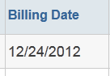
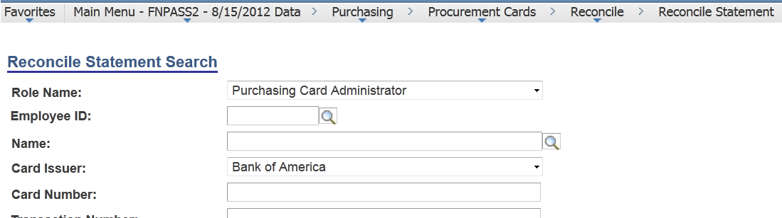
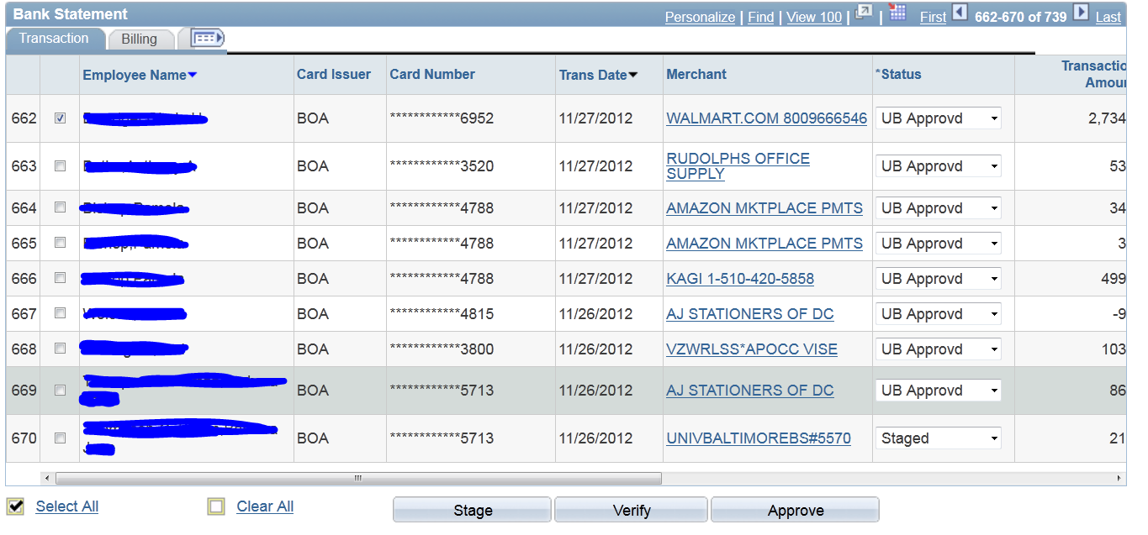

Custom UB Approval Process
- This process must be run prior to creating journal. It ensures all transactions have been approved and contain a description.
- Run query UB_PROCARD_APPROVAL_VERIFY to check for transaction status.
- Navigation: Main Menu > UB Menu > UB PCard Approval Process
- Create or select Run Control.
- Enter Billing Date obtained from Purchasing department.
- Click Run. Make sure UB PCard Approval Process is checked. Click OK.
- Go to Process Monitor to make sure process runs to Success.
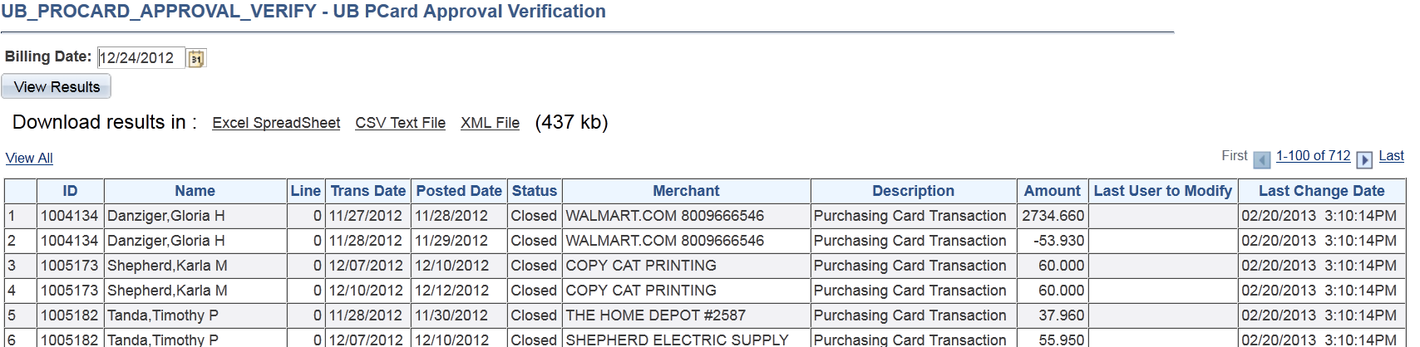
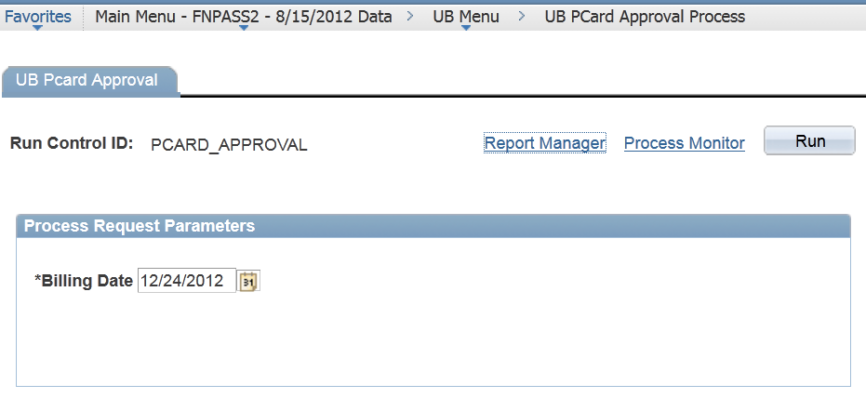
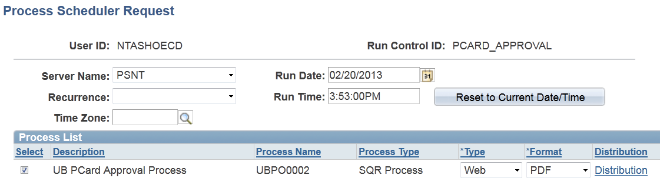
Create Staging Rows for P-Card Journal
- Navigation: Main Menu > UB Menu > UB Menu PO > Process > UB PCard Run
- Create or select Run Control
- Click Run. Make sure UB PCard Process is checked. Click OK.
- Go to Process Monitor and make sure process runs to Success.
- Run query UB_PROCARD_ACCTG_LINE_STATUS to check for accounting lines that will be added to journal.
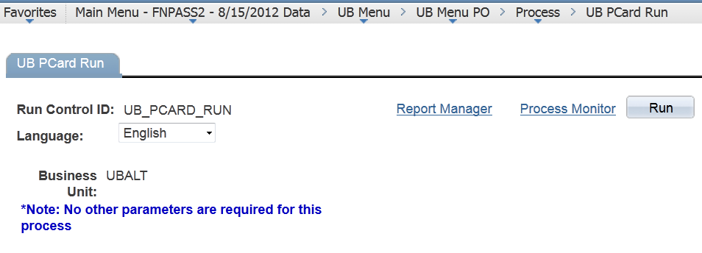
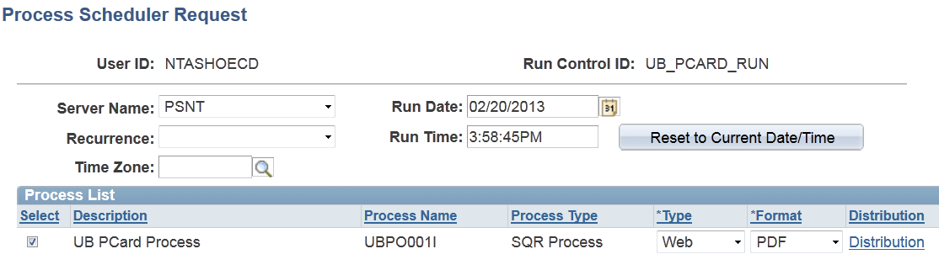
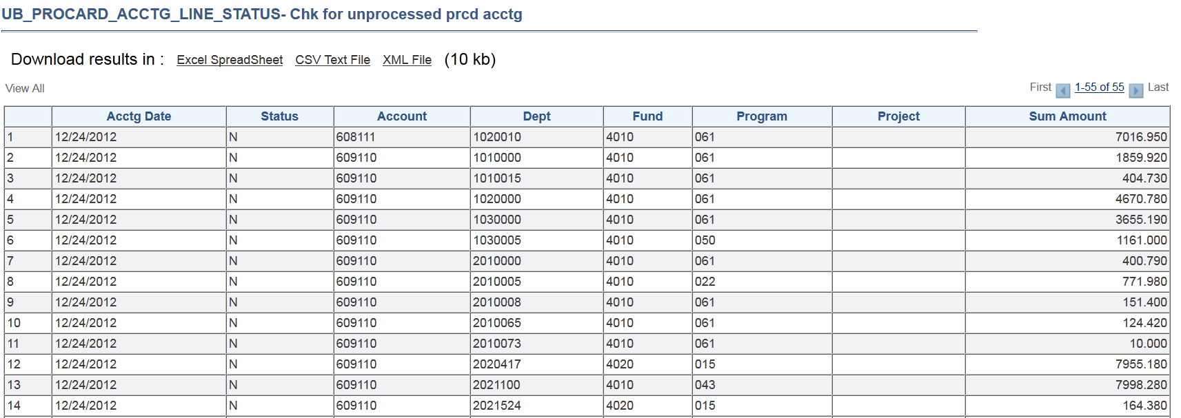
Update Journal Generator Template
- Navigation: Main Menu > General Ledger > Journals > Subsystem Journals > Journal Generator Template
- Select “PROCARD” Run Control if available. Otherwise, create new run control. Fields should be populated as seen below.
- Click “Correct History”.
- Change date to the billing date of the statement being processed and change Reference to reflect date.
- Click Save.
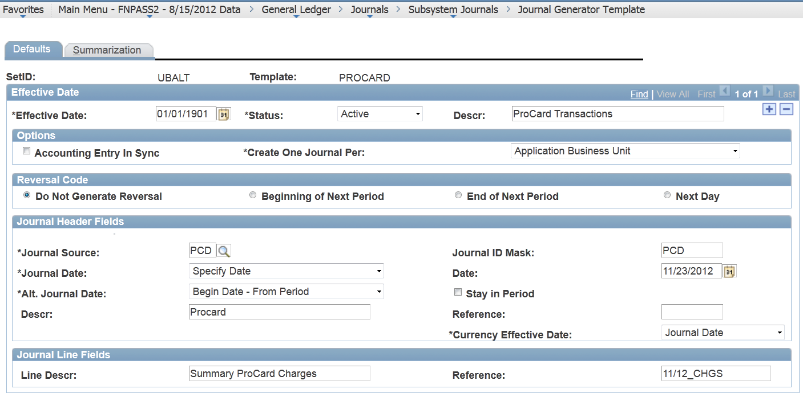

Generate Journal
- Navigation: Main Menu > General Ledger > Journals > Subsystem Journals > Generate Journals
- Select UB_PCARD_RUN Run Control if available. Otherwise create new run control and populate fields as seen below. From Date and To Date should be the Billing Date of the P-Card statement being processed.
- Click Run. Make sure FS_JGEN is checked. Click OK.
- Go to Process Monitor and make sure process runs to Success.
- Click Details, Message Log. Messages display number of journals generated.
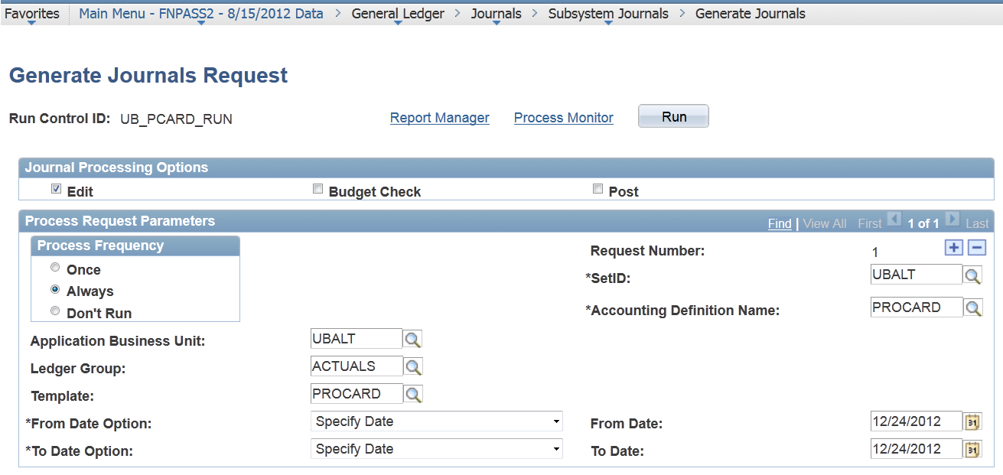
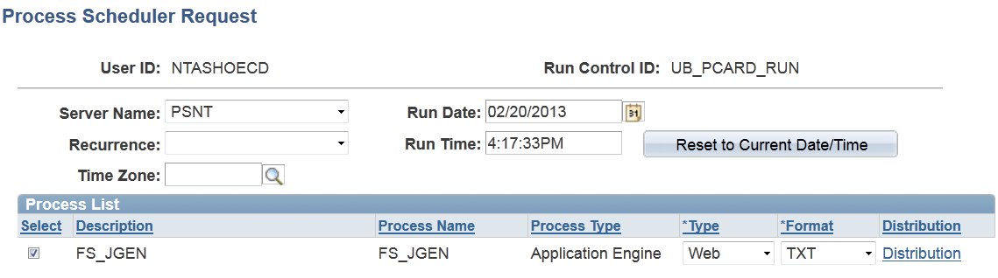
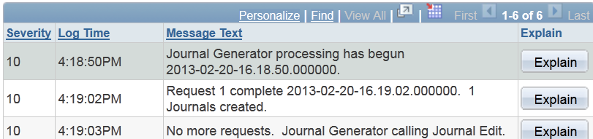
Check Journal
- Navigation: Main Menu > General Ledger > Journals > Journal Entry > Create/Update Journal Entry
- In Search Criteria, enter following and make sure other fields are clear:
  - Business Unit = UBALT
  - Journal ID begins with PCD
  - Journal Date = (billing date of P-Card)
- Click Search
- Process as other journals
