PeopleSoft Requisition Amount Approval

All PeopleSoft Requisitions must be approved and successfully budget checked before Procurement can convert the Requisition to a Purchase Order. The Requisition in an internal document which creates a pre-encumbrance in the financial system. The Purchase Order is the document sent to the vendor instructing them to ship the item(s) or perform the service(s).

After the Requisition has been created and saved, an authorized person must log into PeopleSoft and approve the Requisition (some individuals are authorized to create and approve their own Requisitions). Contact Procurement for more information on how to request approval authority.

Follow this process to approve a PeopleSoft Requisition:
Open the Requisition. Navigate to  Purchasing > Requisitions > Add/Update Requisitions > Find an Existing Value | 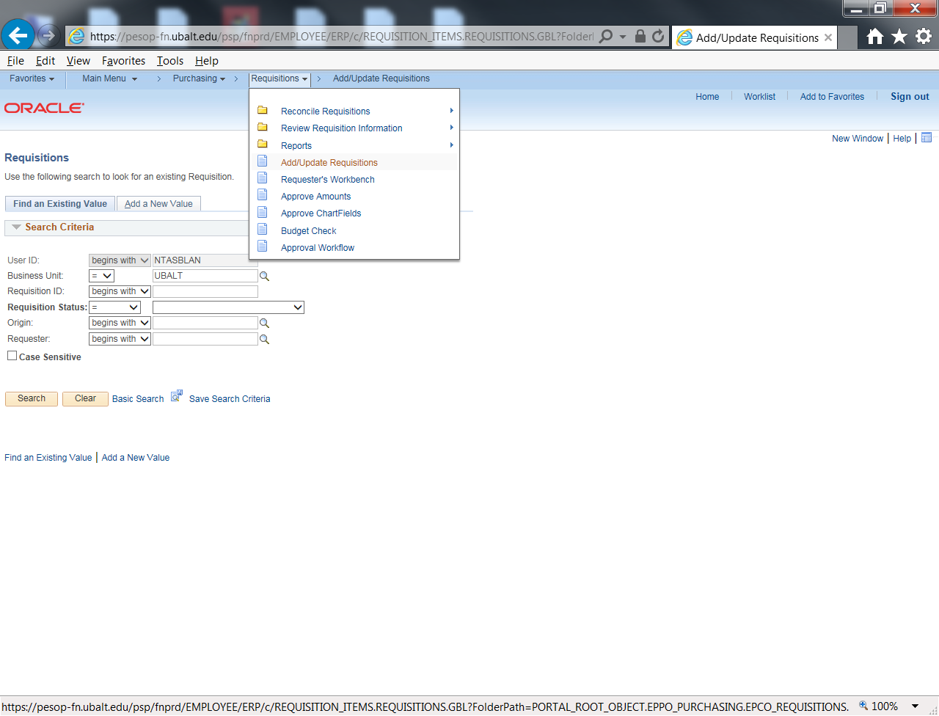
Enter the Requisition number in the field labeled “Requisition ID:” then click the Search button. If you do not know the number, just click search to be presented with a list of requisitions. | 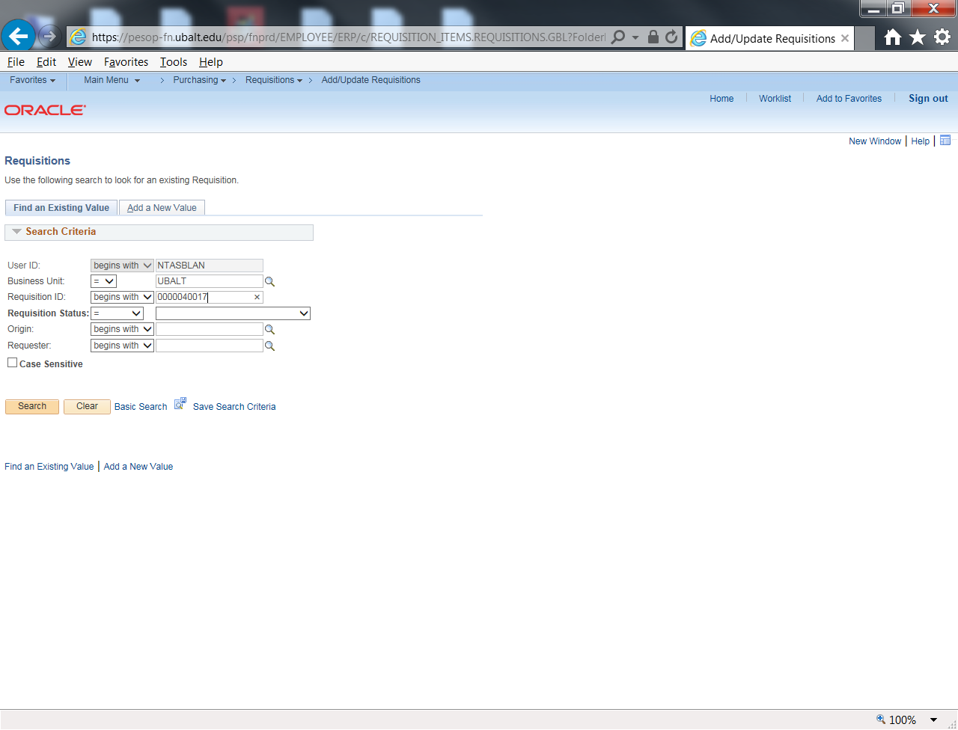
Review the requisition for completeness and accuracy, then navigate to  Purchasing > Requisitions > Approve Amounts | 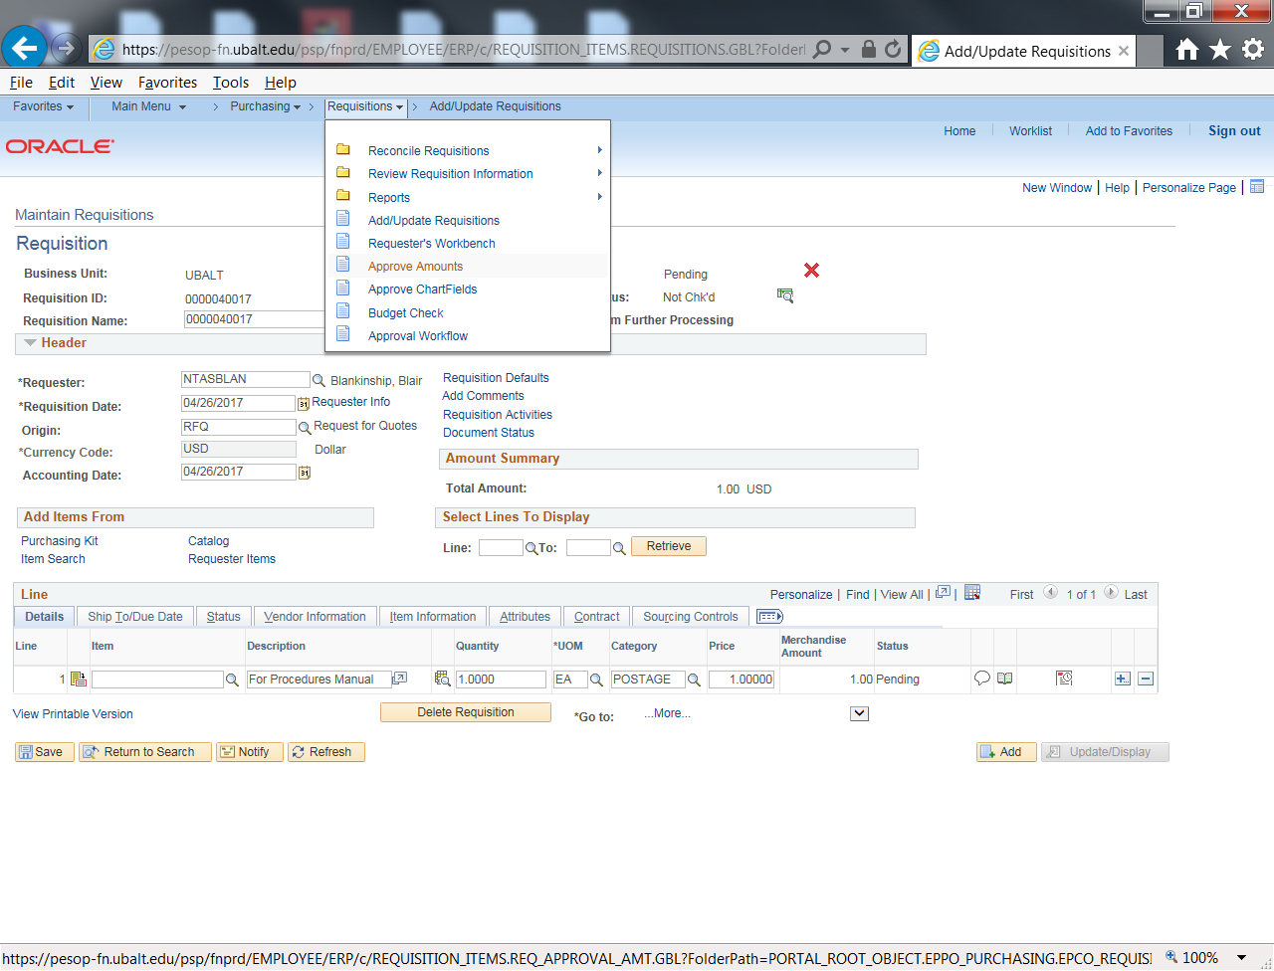
Click the small triangle to the left of the label “Line Details” to see the chartfield information. Review the chartfield info and the dollar amount. If the information is correct, click the Save button to approve the Requisition.  If the system responds with a dialog box telling you that the approval has been recorded and the transaction has been routed to others for approval, ask the next level approver to approve the Requisition.  If the Approval Status (top center of page) says “Complete”, the requisition has been approved.  The next step is to run the Budget Check process. | 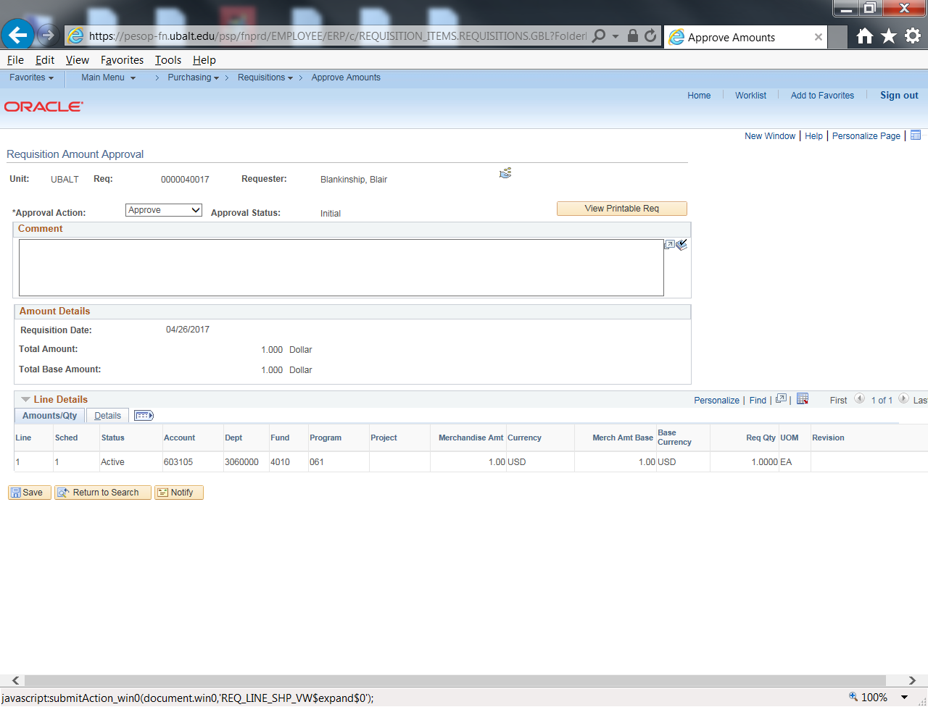
Reopen the Requisition. Navigate to
Purchasing > Requisitions > Add/Update Requisitions > Find an Existing Value.

Enter the Requisition number and click the Search button.

Note that the Status is Approved, and the Budget Status (upper right corner of the screen) says “Not Chk’d” (not checked). | 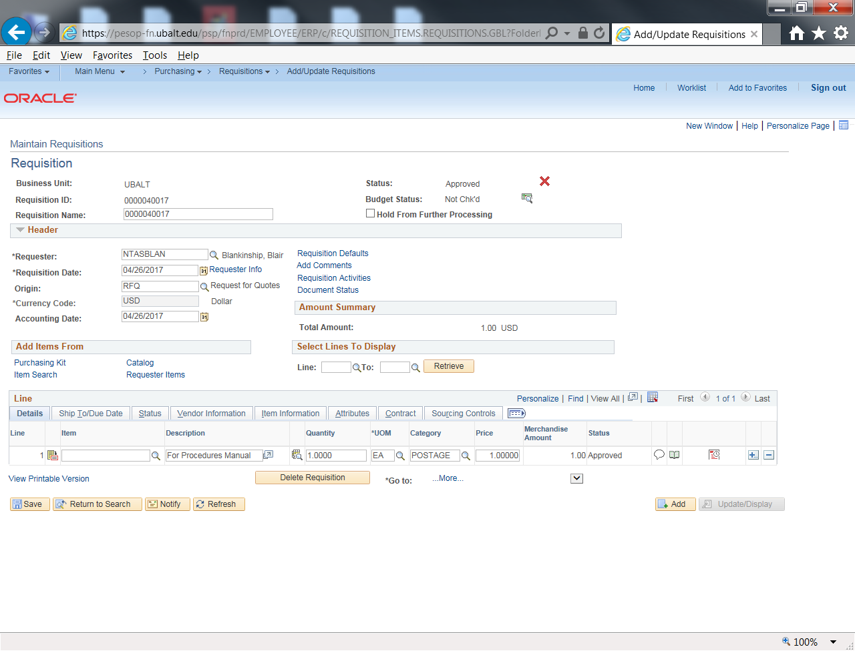
Click the small green icon (NOT the red X icon). If you hover the mouse pointer over the icon it will display “Budget Check” | 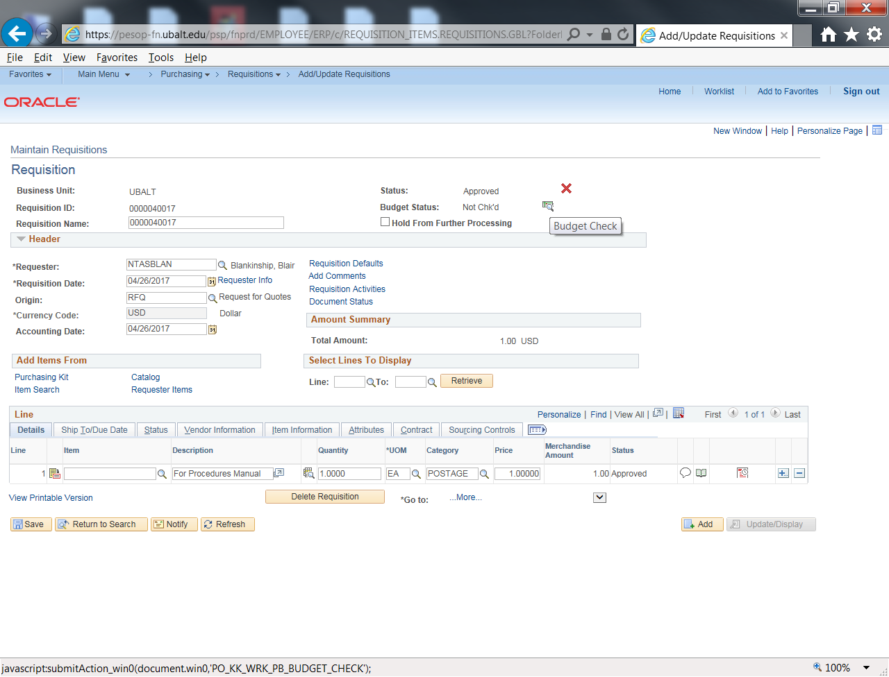
The message next to Budget Status should now say either “Valid” or “Error”.  If it says Valid, the Requisition has been successfully approved and budget checked. If it says Error, transfer sufficient funds into the Account and Department which funds the Requisition, then click the Budget Check icon again.  If the budget error persists, please contact the Budget Office for assistance. | 