

knowledge that works

PeopleSoft Purchasing Training

Create a Requisition

Create a Requisition

Introduction 3
Sign-In to PeopleSoft Finance 4
Navigation 7
vendor look-up 8
Description, Quantity, Category and Price 11
changing cartfield information 14
requisition approval 17
budget check 20
FAQ 22

CREATE A REQUISITION

Before describing the process of creating a requisition, it is important to review some information about how PeopleSoft creates, stores, and processes financial information like requisitions, purchase orders, and payment vouchers.

The development of the PeopleSoft Financials application has evolved over time. The current version (version 9.1.) includes many features to make the product extremely flexible. That flexibility has a price; complexity. There are features and design elements/structures that do not lend themselves to the higher education environment. PeopleSoft was designed so that it could be used in a manufacturing environment where it is common to have:
- A small number of suppliers that supply 90% of products required.
- That small number of suppliers makes regular, scheduled deliveries of materials or products each month. Regular monthly orders for 10,000 screws for example. PeopleSoft has been designed to work with each of these scenarios - none of which are currently used by UB.
- Automatic generation of requisitions and purchase orders to meet anticipated demand.
- Batch generation of purchase orders (all of the purchase orders generated in a day are printed in a large “batch” at night, or perhaps in three or four batches each day).
- A hierarchical approval structure where one manager may approve financial transactions (like requisitions) for large numbers of departments. The University environment, by contrast, typically has a very decentralized approval structure where many managers approve transactions for a small number of departments, generally a single department.

Navigation
To navigate from screen to screen or elements within a screen, use the tools and options on the pages themselves – DO NOT use the browser “back” button or “forward” button/arrow. Using the browsers buttons instead of the PeopleSoft buttons and/or links will confuse PeopleSoft.

How to Create a Requisition in PeopleSoft
The requisition screens include four important sections:
(1) the main window,
(2) “Requisition Defaults” (accessed by a hyper-link)
(3) a link used to “Add Comments” (also accessed by a hyper-link) and
(4) the “schedule” and “accounting distribution” or “distribution” which are accessed by two icons (one icon to access the “schedule” and one icon to access the “distribution” where you can change the account number, or department number.

To sign into Peoplesoft Finance, navigate to the My UB, and scroll down to the link:
- UB Finance On-Campus

That will take you to the PeopleSoft main log in page.

1. Be sure to enter your Network ID in the field labeled User ID – it MUST be entered in ALL CAPS.  Then enter your password. The password is case sensitive, so enter it exactly (not all caps). | 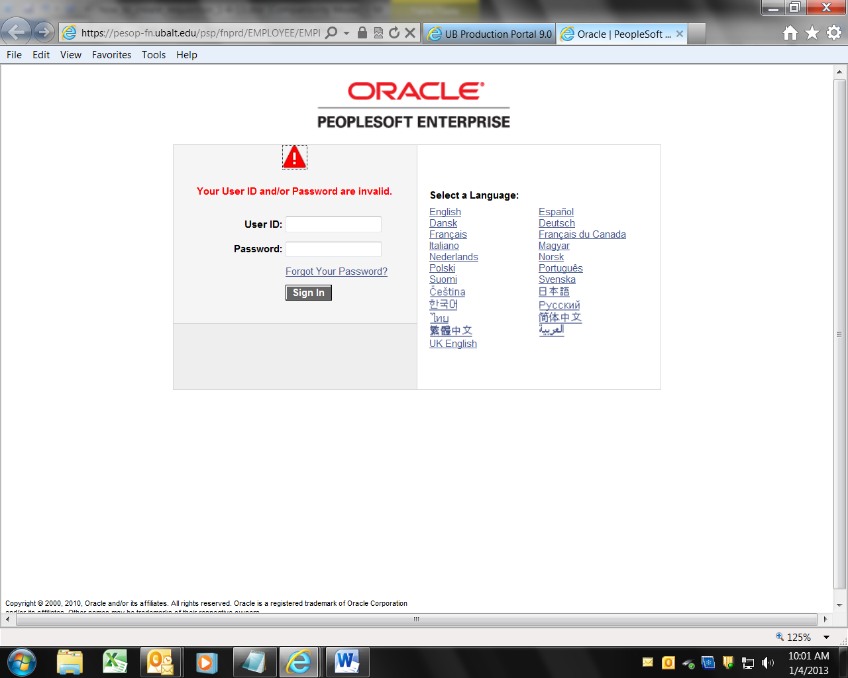
2. After you successfully log in you will see the main menu. The image to the right may include some option that you do not see. But you should see Purchasing.  To start the process of viewing or creating a requisition, click the word “Purchasing” in the main menu.  Note that you may not be able to access that menu again. The menu items will string out across the top of the page. | 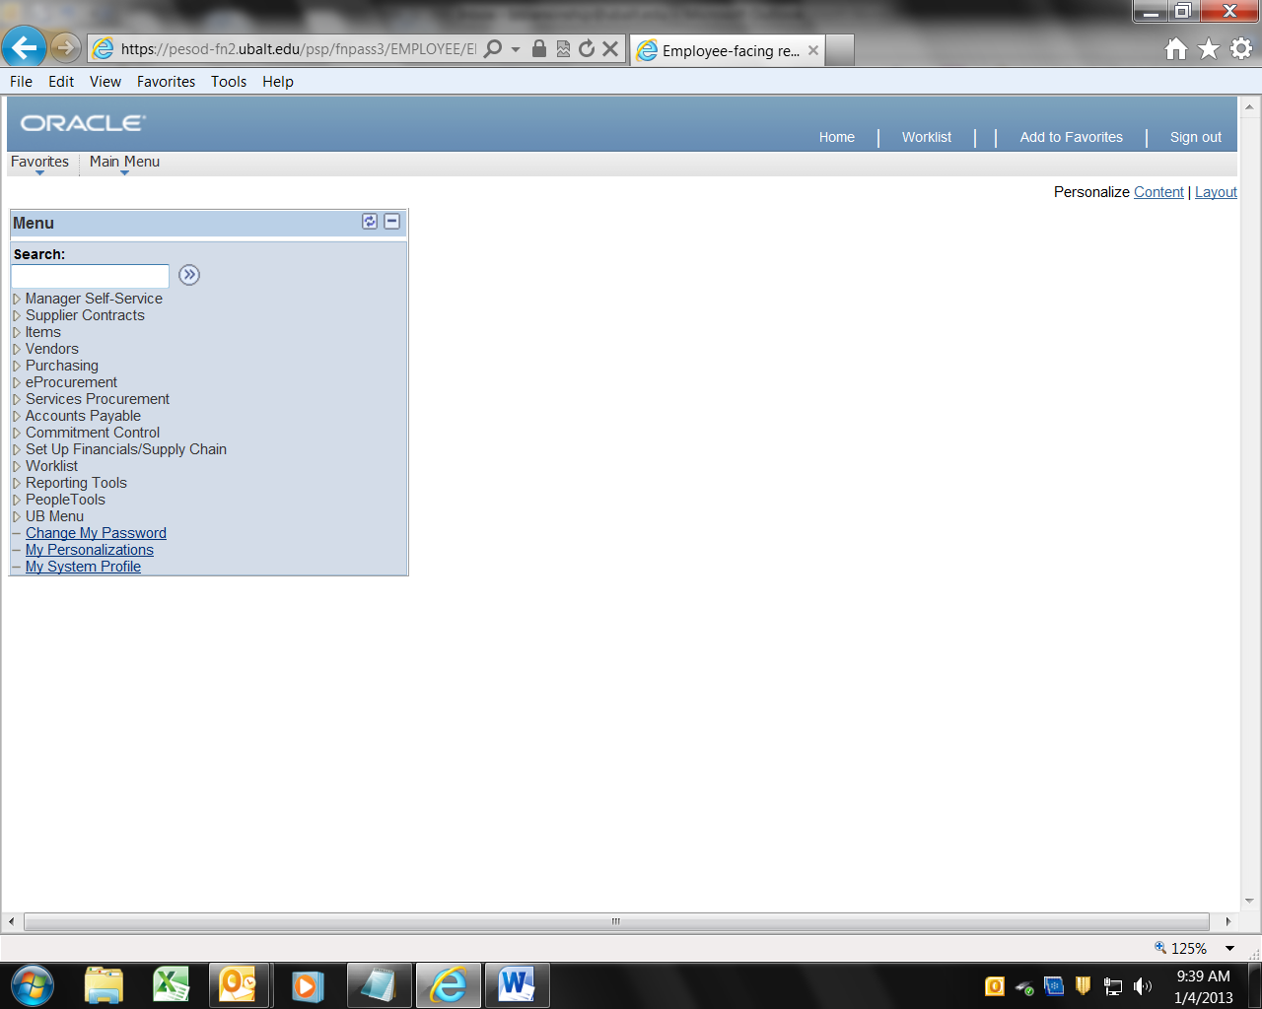
3. After you click Purchasing in the main menu, you will see the screen to the right. To add (create) a new Requisition, or view an existing Requisition, click “Add/Update a Requisition” | 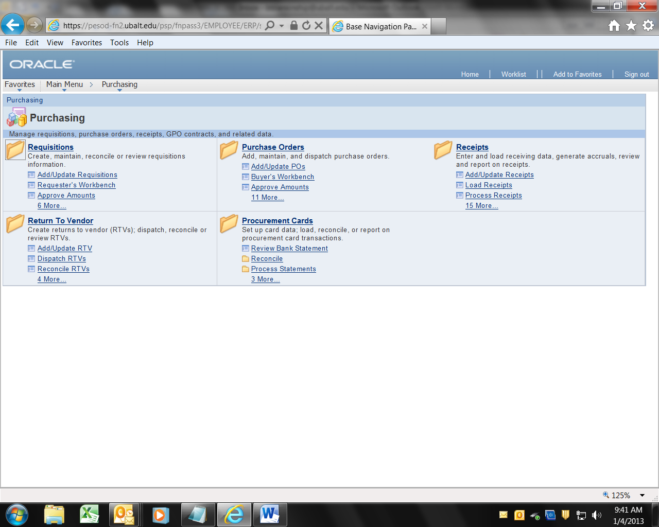
4. To add (create) a new Requisition click on the tab “Add a New Value”. Then click the button labeled “Add”.  To view an existing Requisition click on the tab “Find an Existing Value”. | 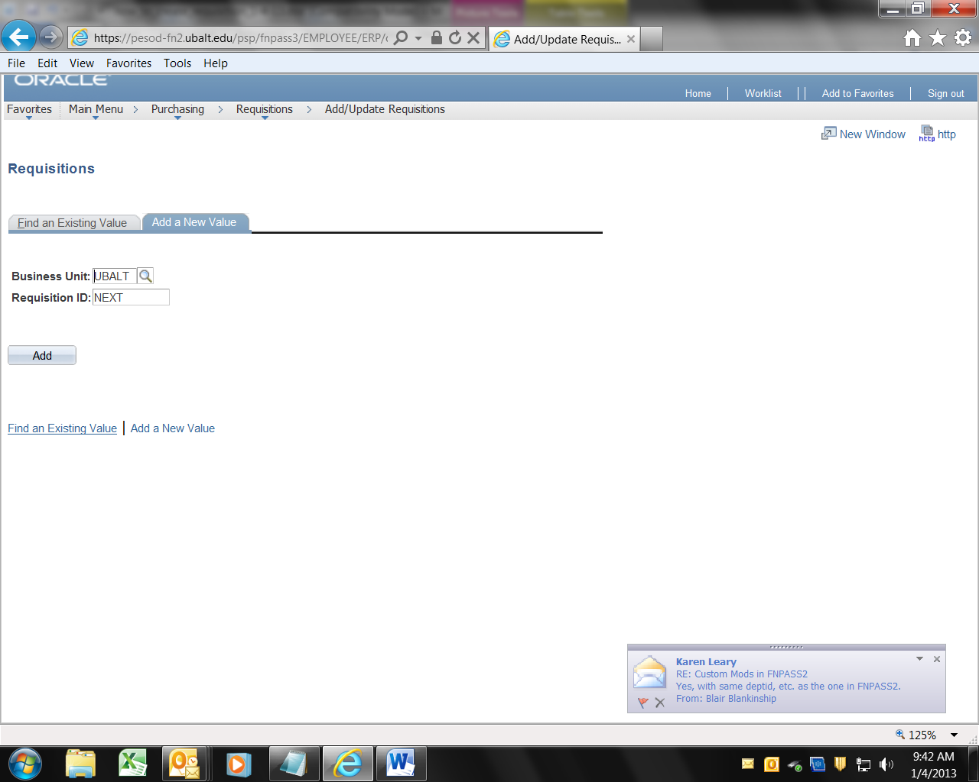
5. If you click Add, you will see the main menu panel. Note the following:  The menu items across the top  The hyperlink “Requisition Defaults”  The hyperlink “Add Comments”  The new field “Req. Name”  The Status (“Open” in this screen shot)  The Budget Status (“Not Checked” in this screen shot)  The field labeled “Description”  The field labeled “Quantity”  The field labeled “UOM”  The field labeled “Category”  The field labeled “Price” | 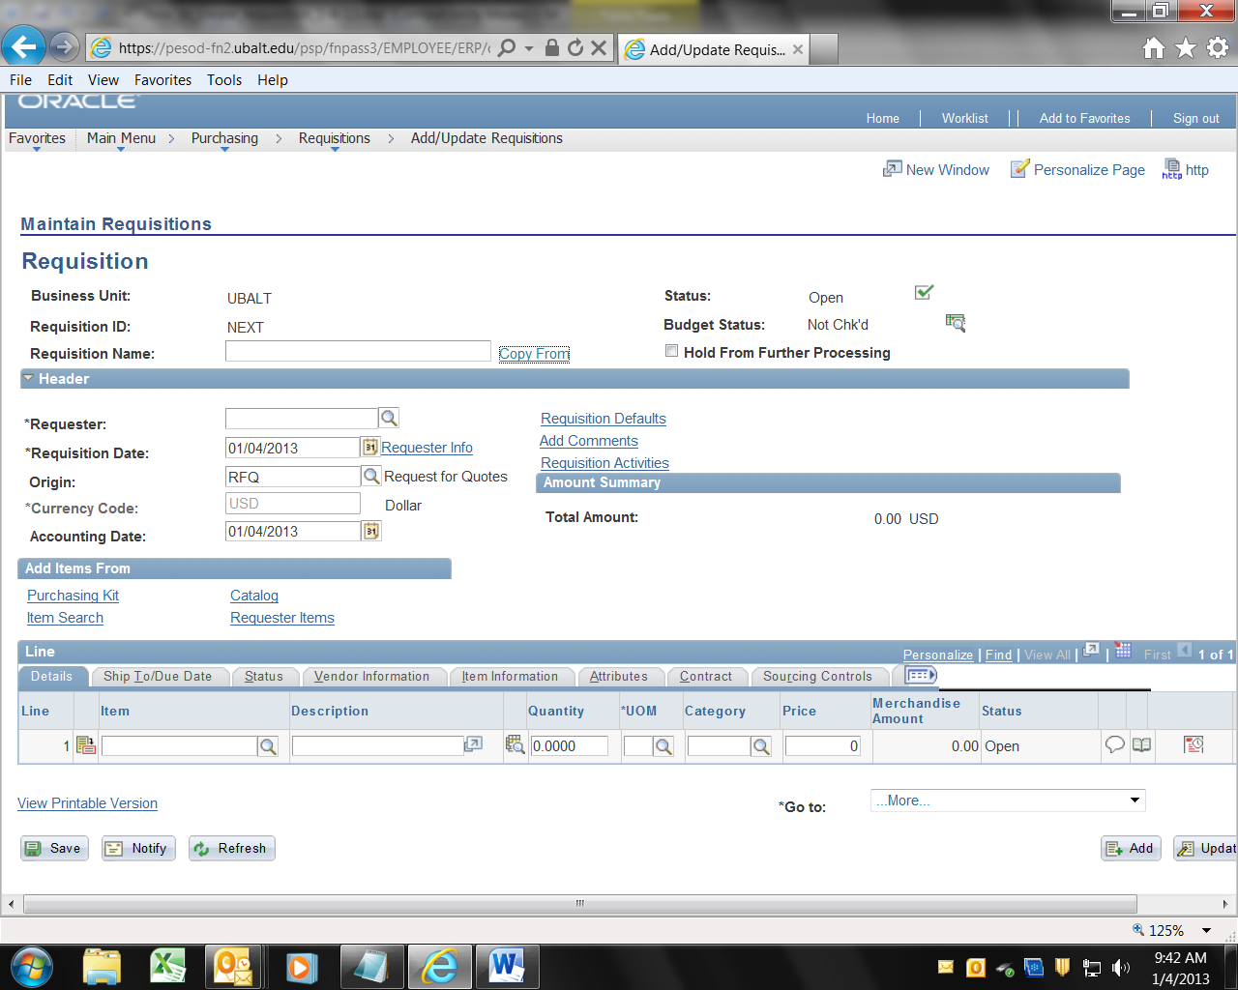

A requisition, can be saved before it has been approved and/or budget checked. PeopleSoft processes automatically update financial information using the data on documents like requisitions. Documents can be accessed by a large number of people. People can have authority to view requisitions, create requisitions and approve requisitions (or some combination of these authorities). People that only have authority to view requisitions sometimes see a different “view” of the information. The information is not displayed in the same format for all users.

To create a new Requisition:

Continued on next page

Create or Add a New Requisition Navigation

Purchasing → Requisitions → Add/Update a Requisitions
6. To add (create) a new Requisition click on the tab “Add a New Value”. Then click the button labeled “Add”.

7. You should see a Panel that displays the blank and default fields for a requisition.

Click the Link “Requisition Defaults”

8. You will ONLY ENTER THREE fields: (1) Buyer (optional), (2) Vendor, and (3) Due Date.  8.a. If you know to which Buyer the Req. will be assigned, click the magnifying glass icon to the right of the field labeled “Buyer” and select the Buyer. This field is optional.  8.b. Click the magnifying glass icon to the right of the field labeled “Vendor:” | 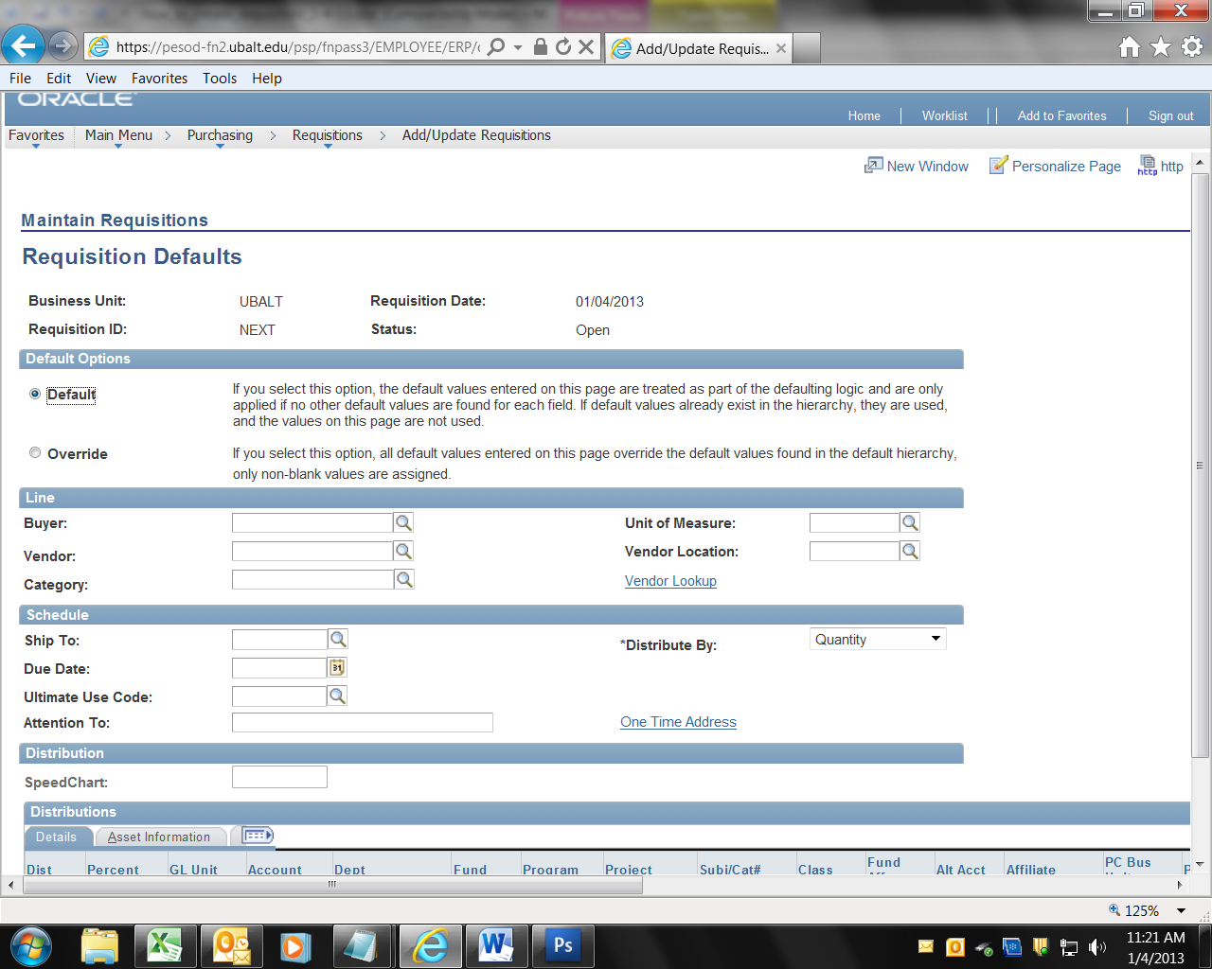
8.b. (continued) In the field labeled “Short Vendor Name” enter part of the vendor name. For example, enter “Dell”, then click the button labeled “Look up”  Pick the vendor from the list. If you try various combinations of the name and cannot find the vendor, see step 12. Below. | 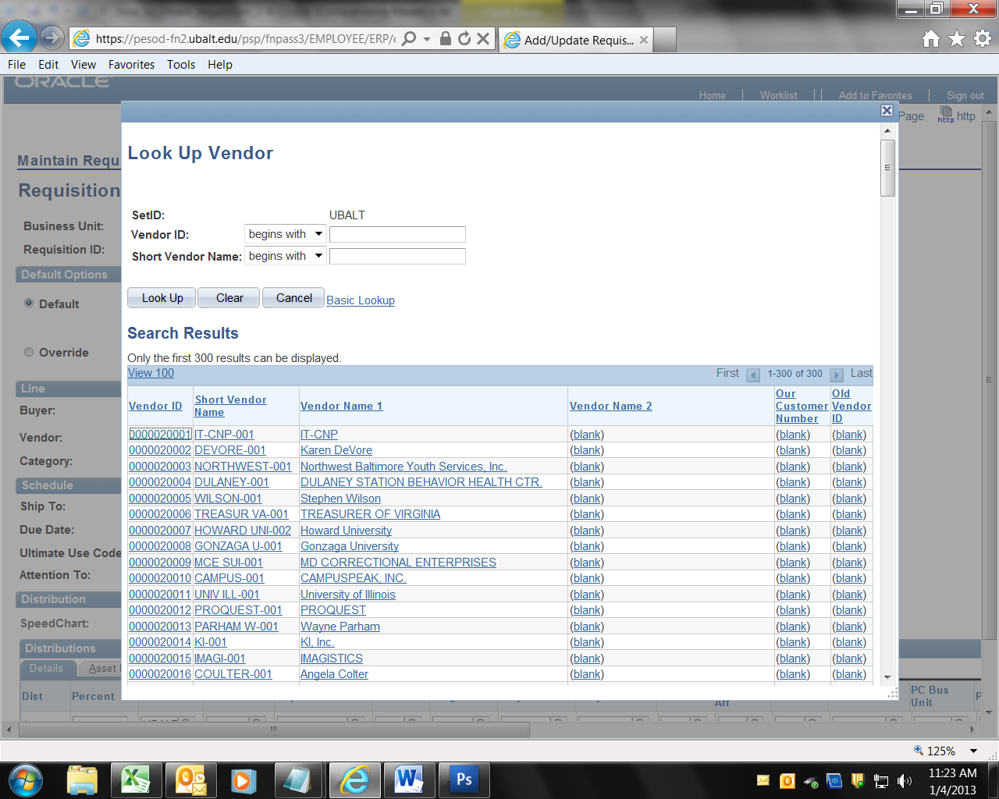
9. Due Date: Skip down to the field labeled Due Date. Click the calendar icon, and select the date when you need to have the product of service. Do not enter today’s date, enter the date when the product or service is needed.  ONLY ENTER THREE FIELDS: (1) Buyer (optional), (2) Vendor, and (3) Due Date. | 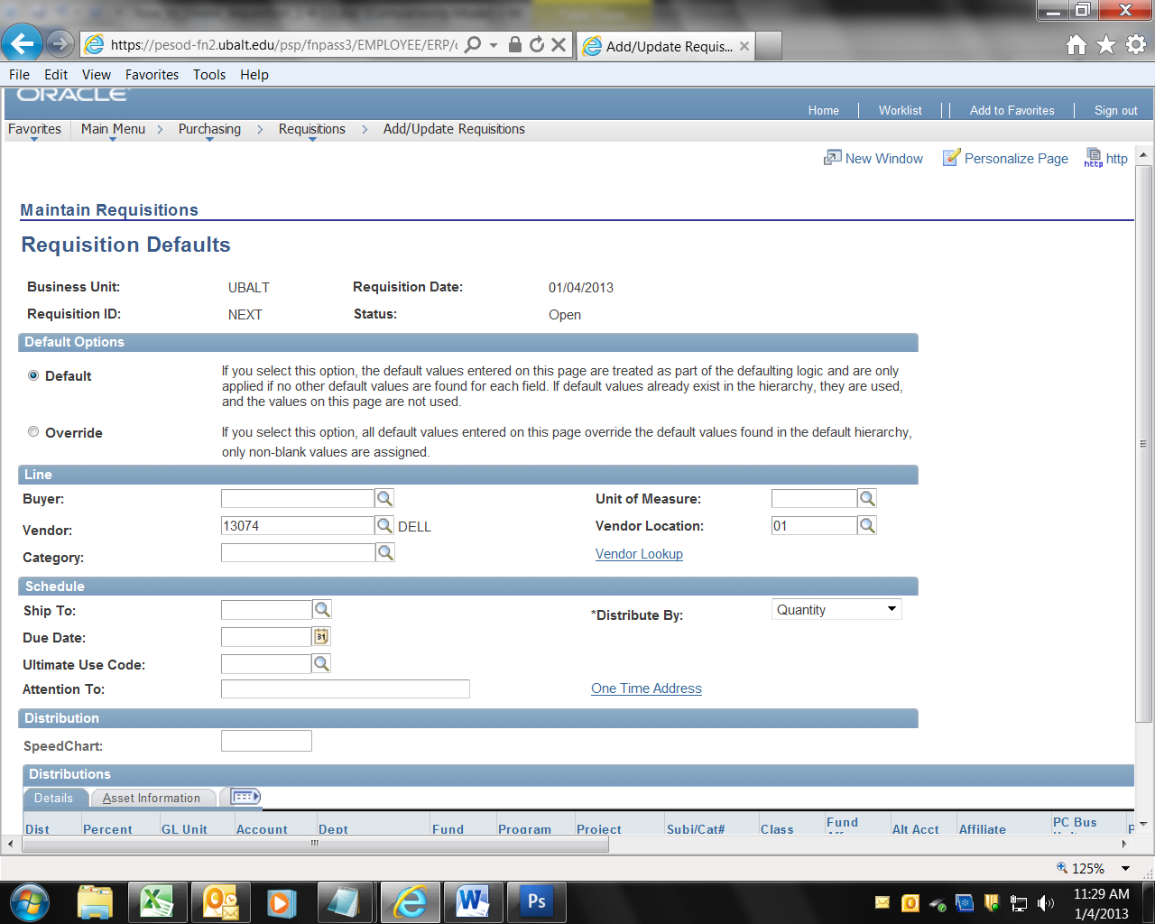
10. Click the button labeled OK in the lower left of the screen. | 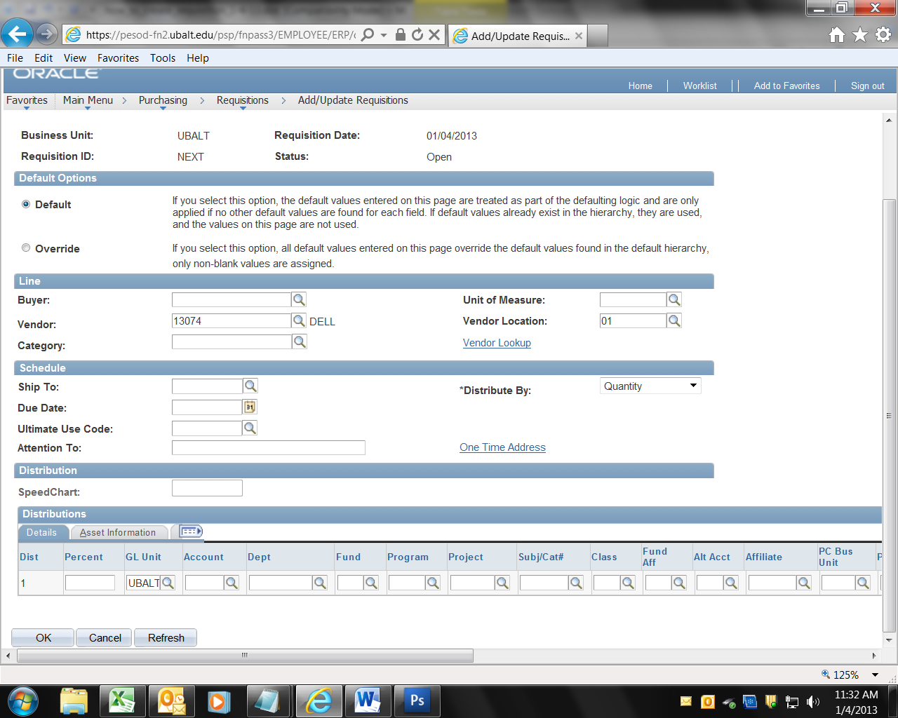
11. Requisition Name: You may enter a name for the Requisition in the field labeled “Requisition Name:” That field is optional. You can always find the Requisition by its number. | 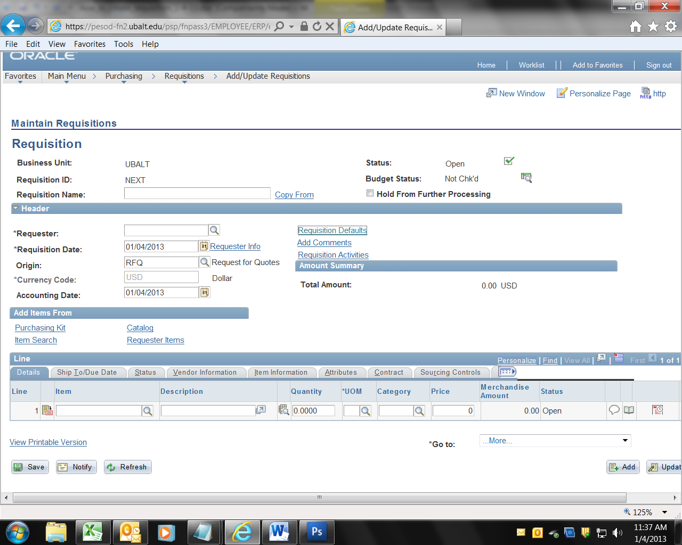
12.a. Comment Field (was Header Comments): If you could not find the vendor, click the hyper-link “Add Comments”
12.b. Enter the vendor’s name, address and tax ID number (it may be the FEIN, or Social Security number – it MUST be 9 digits). Enter the information in the large Comment field.  Click OK | 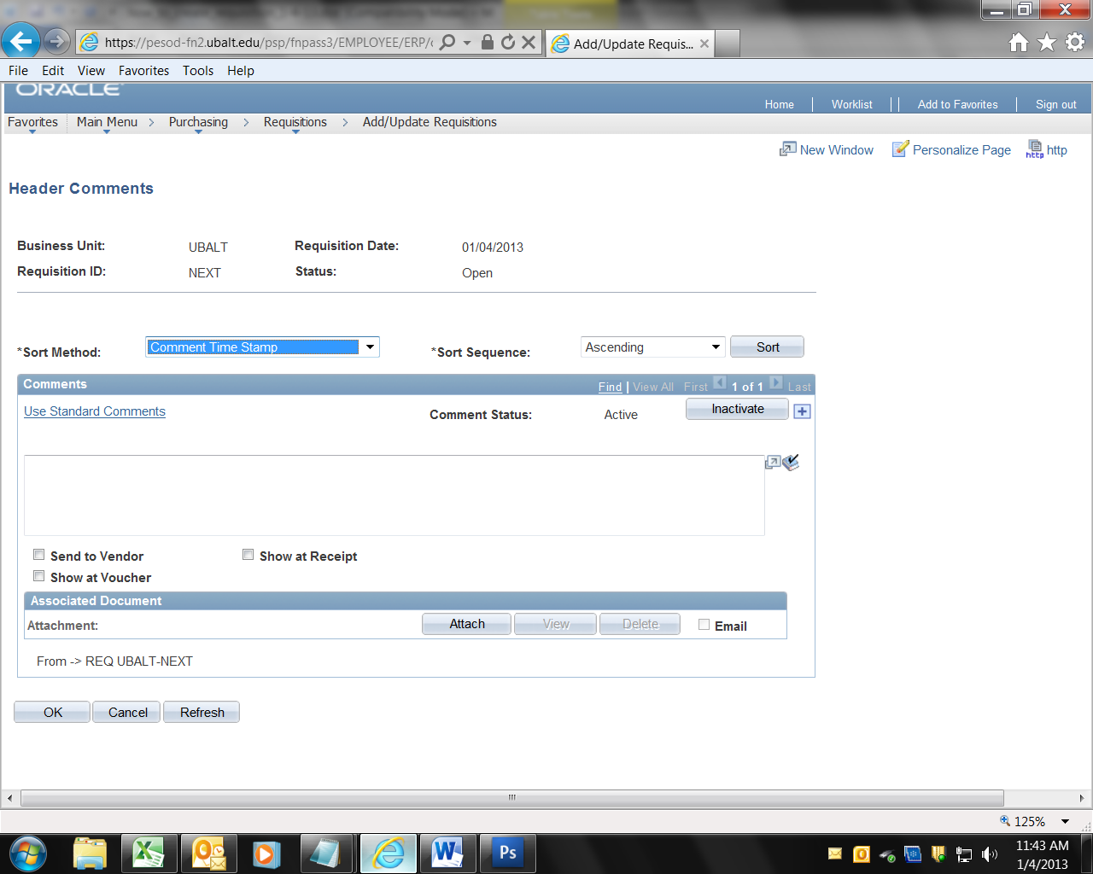
13.a. Description: Near the bottom of the page, enter the Description. Note that the description is limited to about 180 characters. Enter the who, what, where, when, why and how. Include the following in the Description field: Department Contract: Name 410-phone number.

If you need more space for description or comments, click the “speech balloon” icon (sometimes called speech bubble, dialogue balloon or word balloon) in the lower right side of the screen.

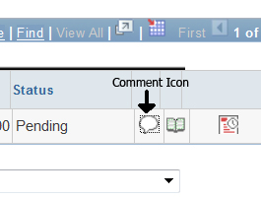

13.b. (was Line Comments): Enter text into the Line Comments field, then click OK. | 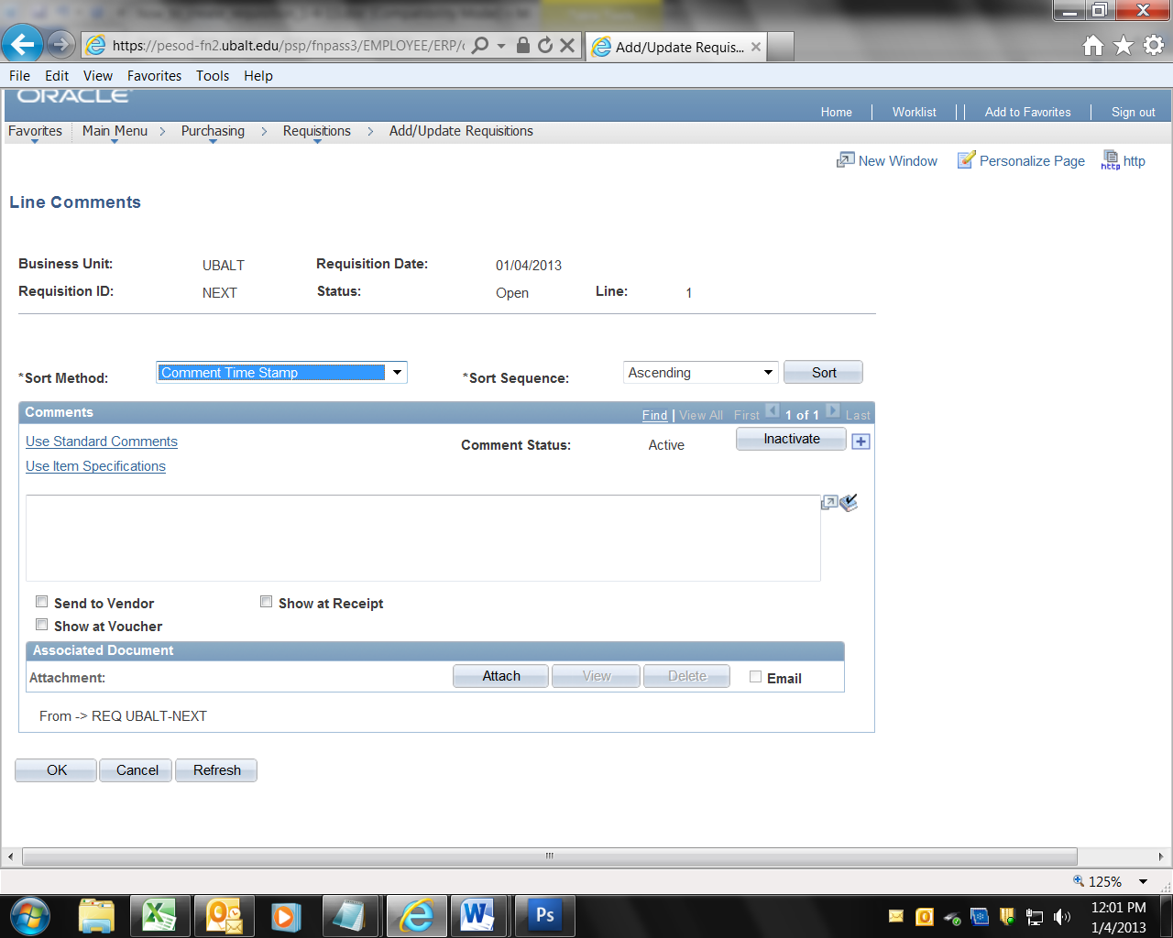
14. Quantity: Enter the quantity in the field labeled Quantity. | 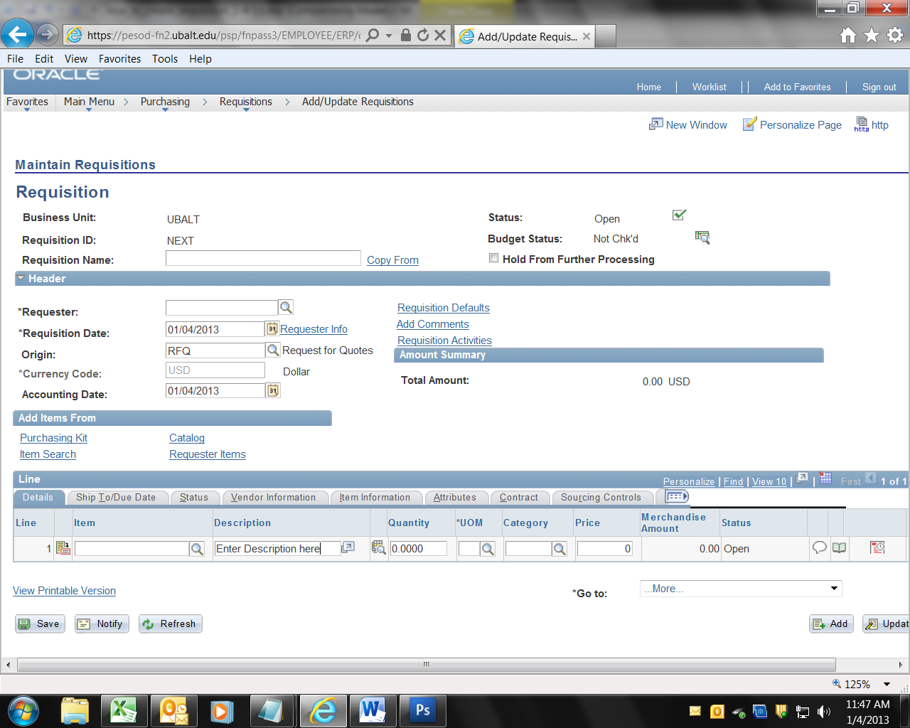
15. UoM: Enter the Unit of Measure (“UOM”). You can click the magnifying glass icon to get a list, but one of the following will almost always work:
Each: EA
Lot: LOT
Fee: FEE
16. Category: Click the magnifying glass icon to the right of the field labeled “Category”. In the field labeled “Description” enter a one or two word description of the item you are buying. For example, enter “Computer”, then click the button labeled “Look up”. Pick the Category from the list.

If you try various combinations of the name and cannot find the category, delete text in the Description field, and click look, up, then scroll through the list and pick the best match.
17. Price: Enter the price in the field labeled Price.  Note that the Requisition ID is initially set to “Next”.  Click Save.  Note that the Requisition ID has been assigned by the system. It is a 10 digit number with five leading zeros.  DO NOT enter information in any other field | 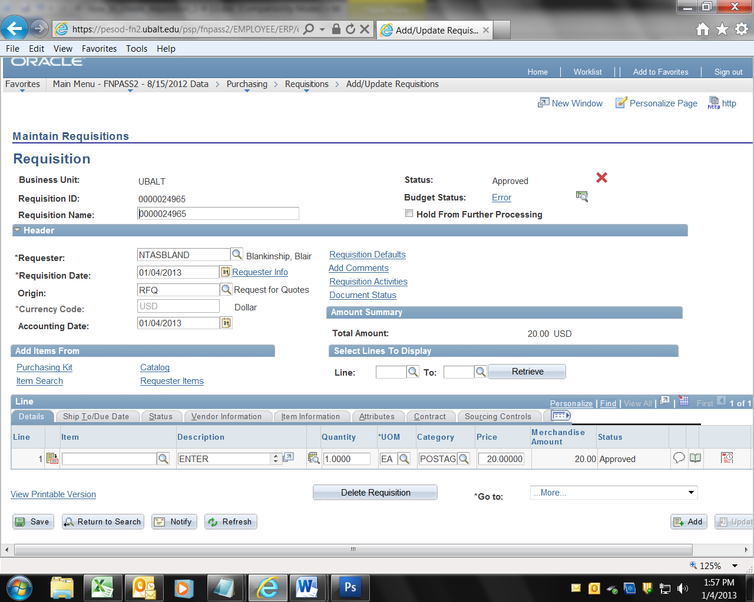
18.a. Accounting Chartfield Distribution: To correct or change the Accounting Distribution (Account, Department, Fund, Program and (sometimes) Project), Click the Schedule Icon.  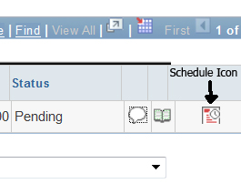 | 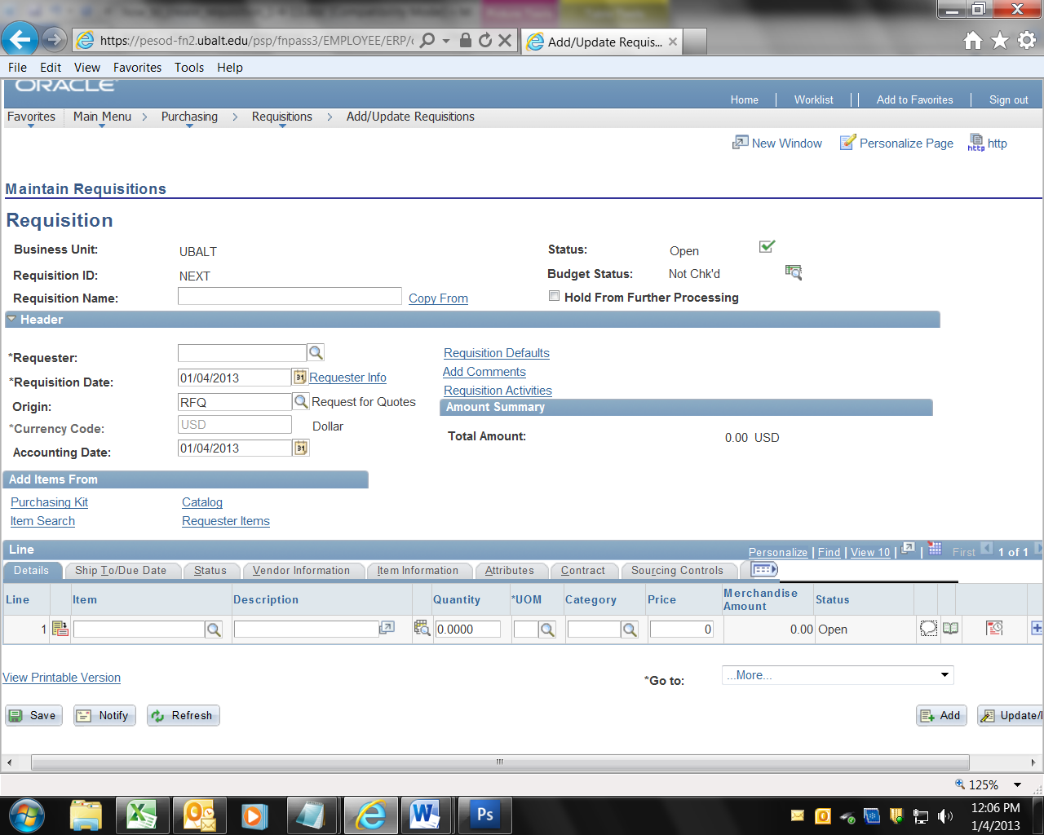
18.b. Now click the Distribution icon.  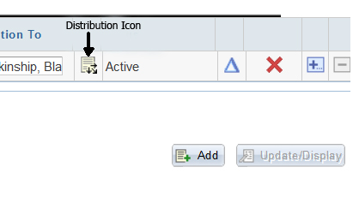 | 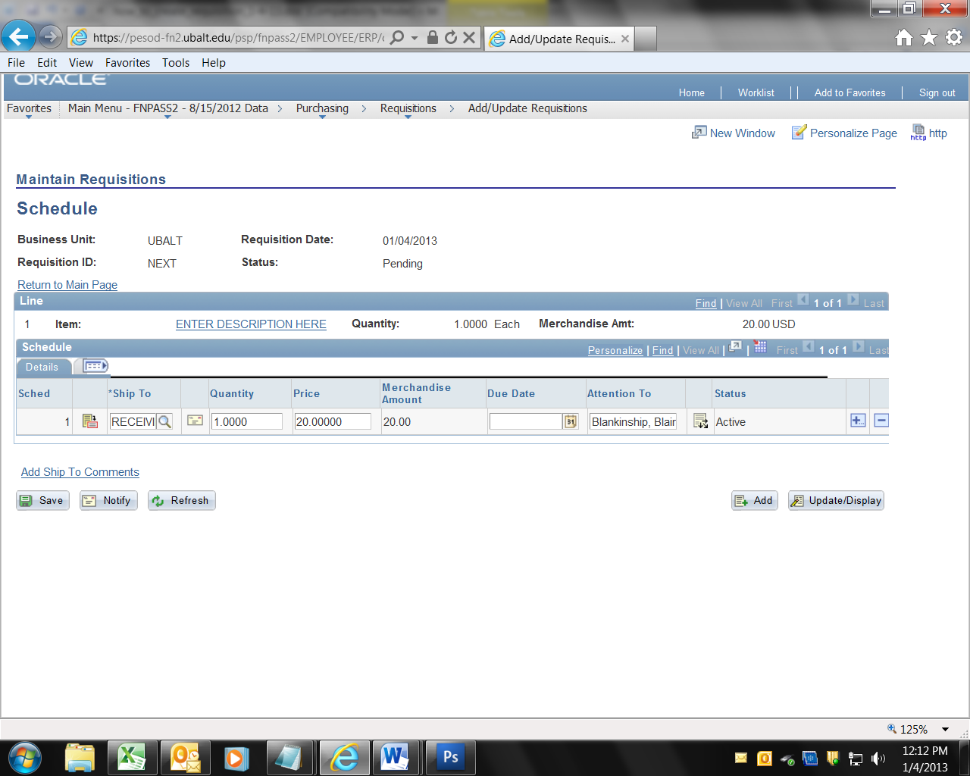
18.c. If you need to change the Account number, First you MUST delete the entry in the Alt Acct field. That MUST BE DONE FIRST. Then click in the Account field and enter the correct Account number.  Change the Department, Fund, Program and Project as necessary and then,  Click OK, | 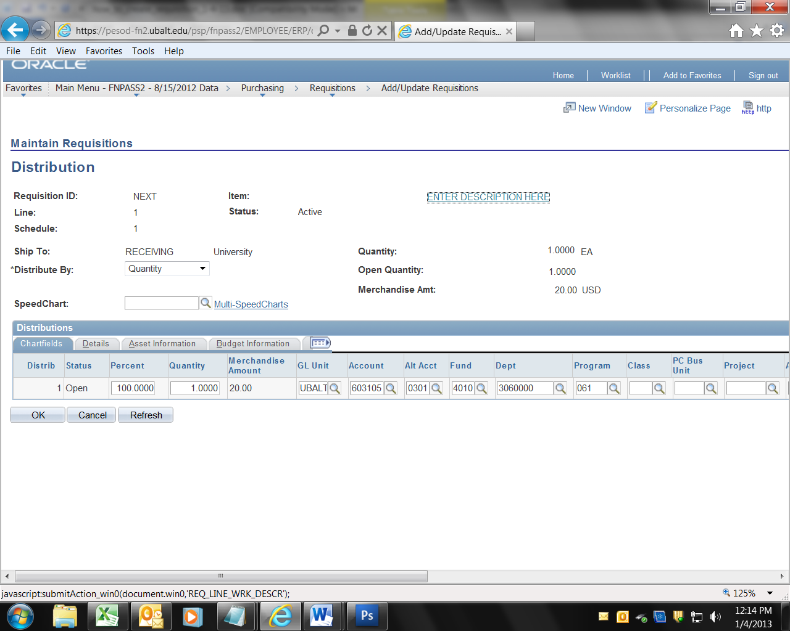
18.d. Click the hyperlink “Return to Main Page”. | 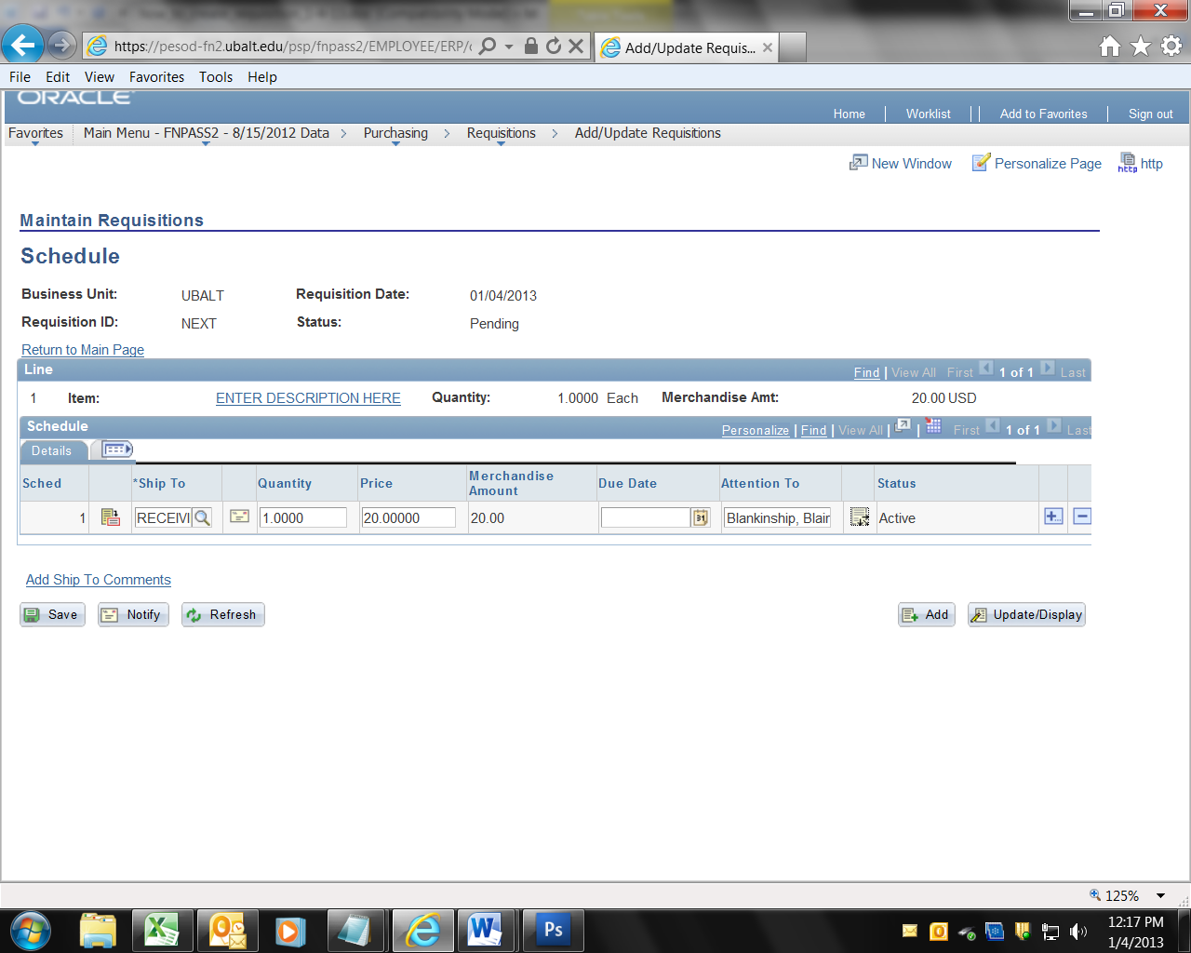
19. Click Save.  Note that the system has assigned a 10 digit Requisition ID (with 5 leading zeros).  Note that the Status is still “Pending” (approval), and that the Budget Status is “Not Chk’d”  You have created a UB Requisition using PeopleSoft! The next step is to have the Requisition approved for dollar amount. | 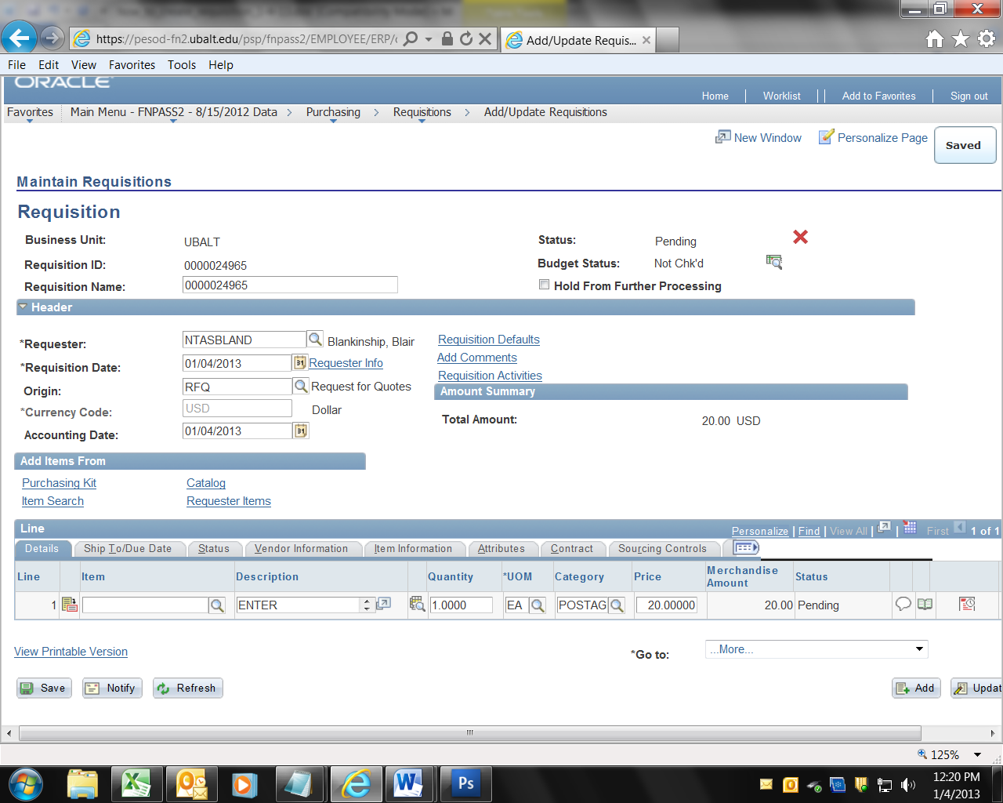
20. The next step in the process will be Requisition Approval. In order to “route” the requisition for approval, you should review and approve your own requisition. Once you have applied the amount approval, the requisition will be ready for the approver to approve it. | 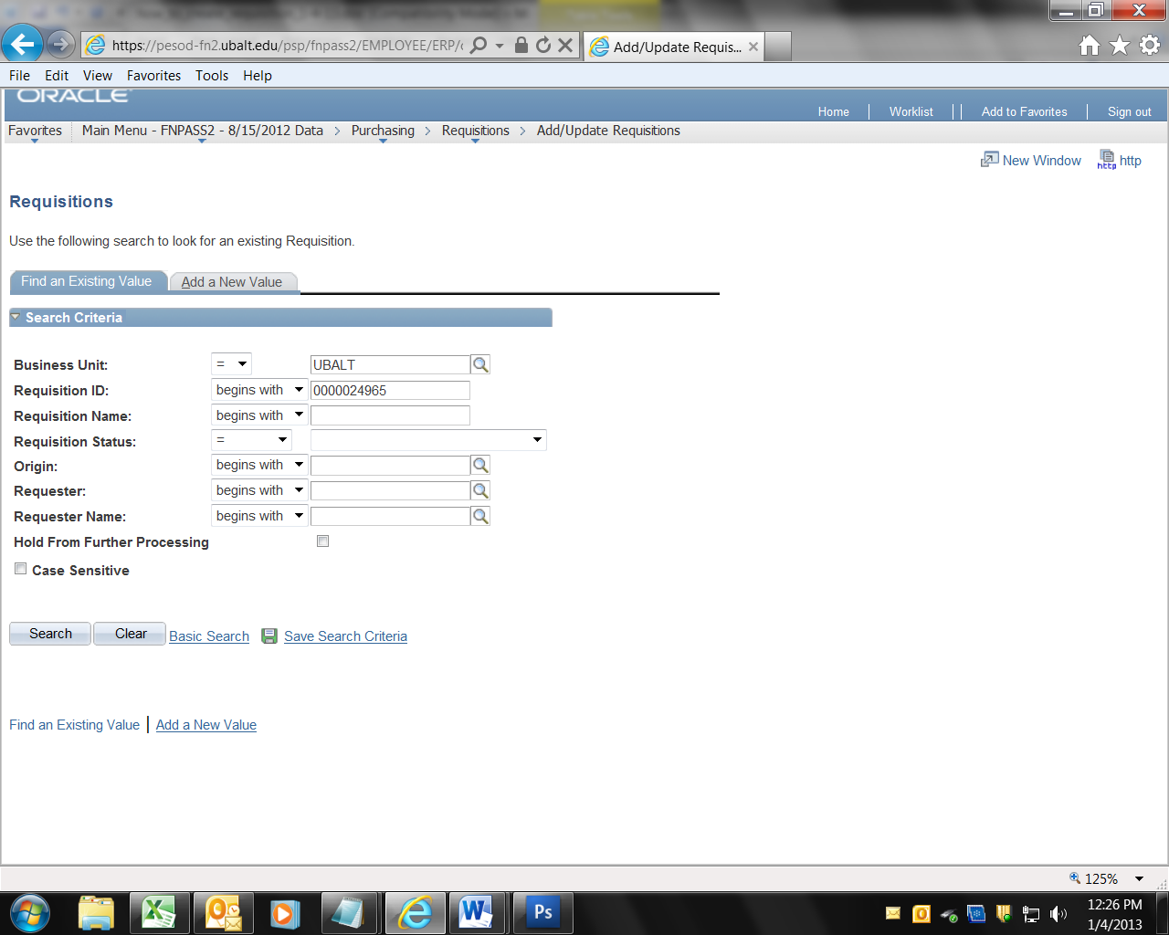

REQUISITION APPROVAL
Use this process to approve the dollar amount for the purpose entered in the Requisition Description field.

Continued on next page
21. Find the Requisition by navigating to Purchasing > Requisitions > Add/Update Requisitions.

Click on the tab “Find an Existing Value”

Enter the 10 digit Requisition number in the field labeled Requisition ID:

Then click the button labeled “Search”
22. Confirm that the Requisition is complete and accurate. | 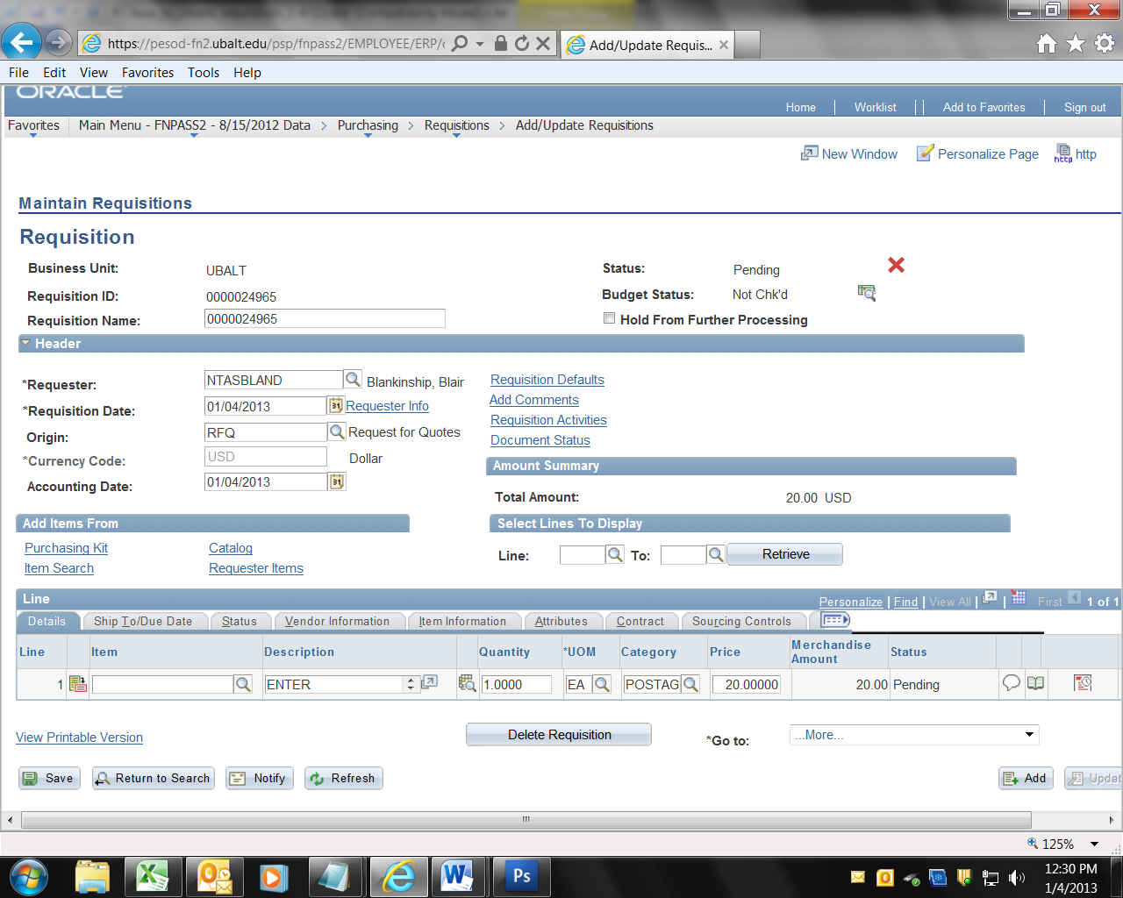
23. Navigate to the Approval screen by clicking on the menu option “Requisition” along the top of the screen, then select “Approve Amounts” | 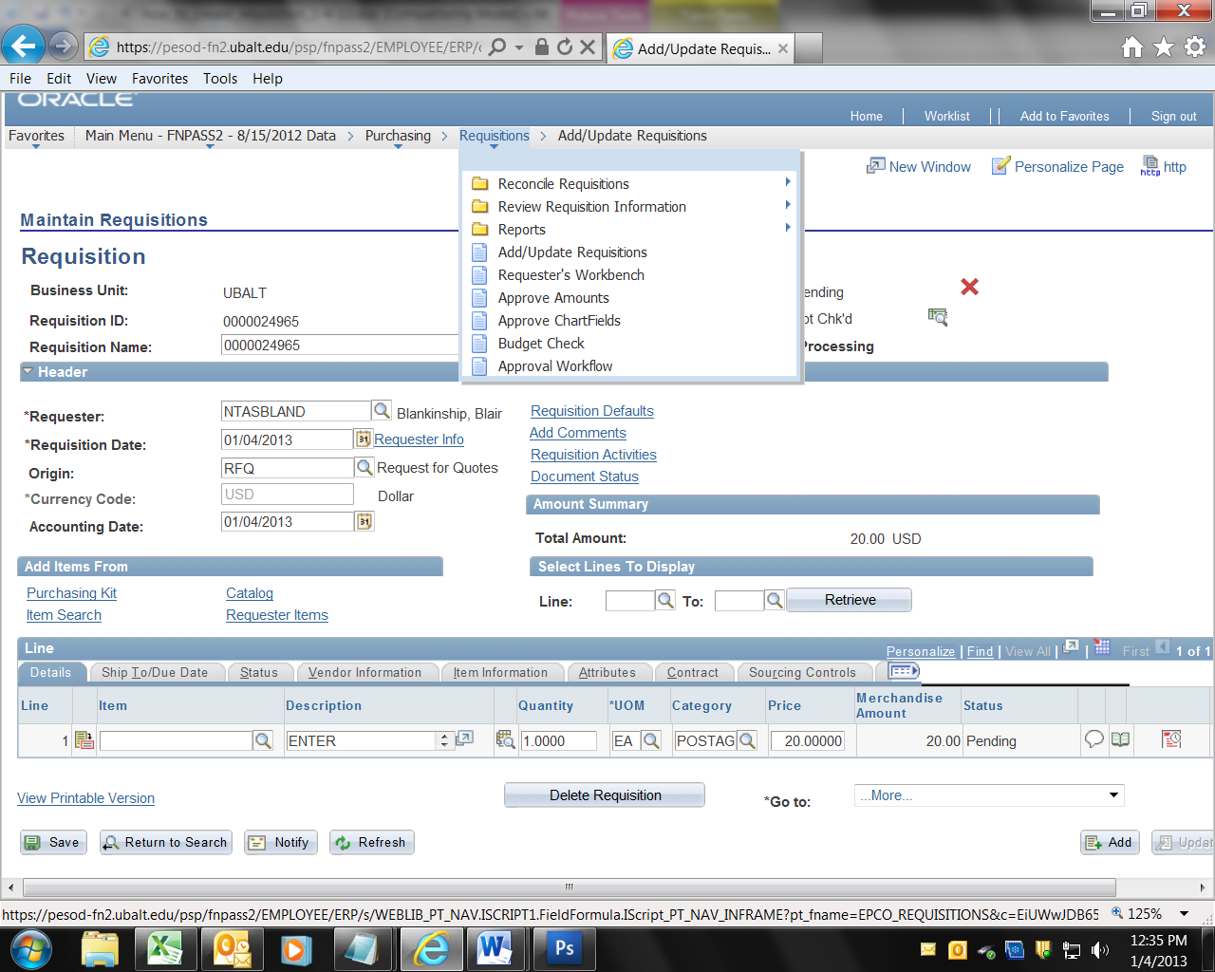
24. Confirm that the total dollar amount is correct. Note that the Approval Status is Initial.  To approve the Requisition, click the button labeled “Save”. | 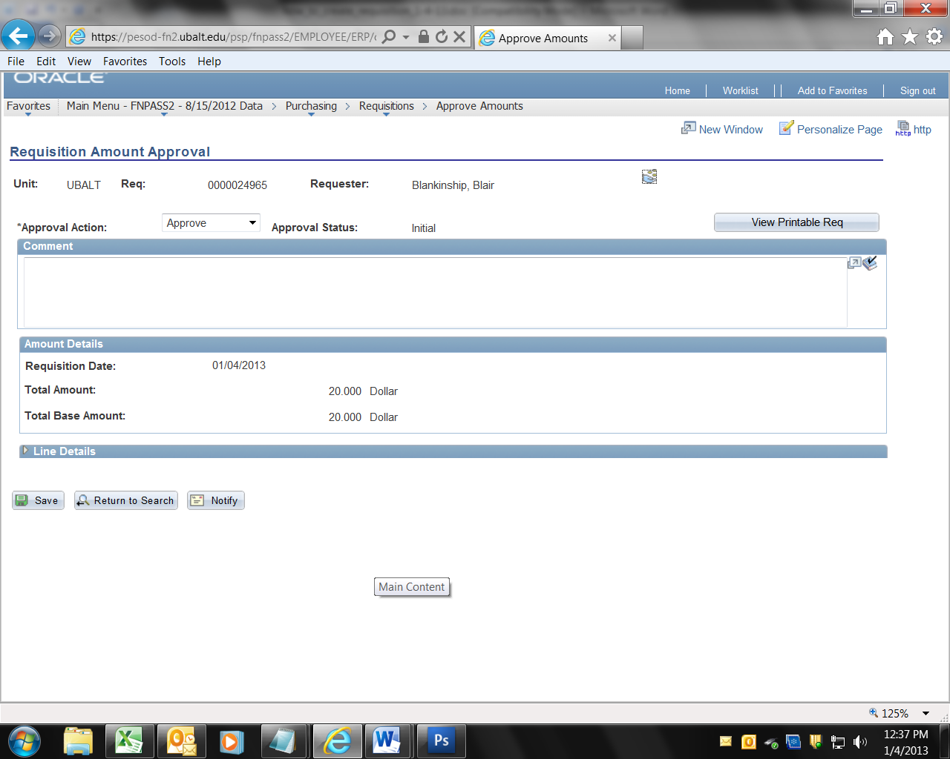
25. If you have authority to approve that dollar amount in that Department, the Approval Status will change to Complete. Meaning the Requisition has been approved.  If you do not have approval authority in that Department, or for that dollar amount, you will get a message that says, “Additional Approvals Required”. If you get that message, ask a person with approval authority to approve the Requisition. Note that there is no automated routing for the approval, you need to ask an approver to approve. | 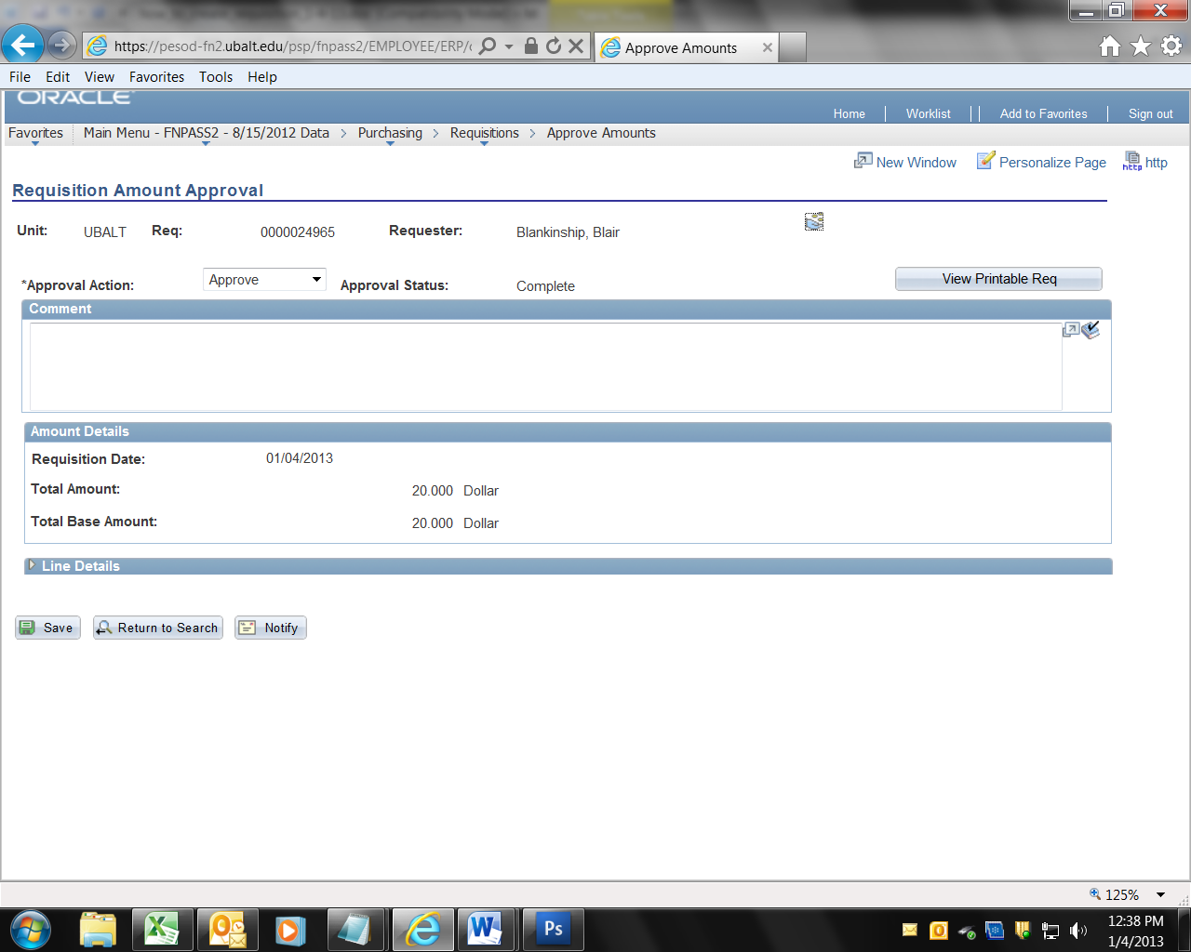
26. The final step is to budget check the Requisition.

BUDGET CHECK
During the Budget Check, PeopleSoft will compare the dollar amount on the Requisition to the dollar amount available in the Account and Department indicated on the Requisition accounting “Distribution”. If there are sufficient funds, the Budget Check will return “Valid” If not, it will return “Error”. If you get a budget error, you must transfer funds and click the Budget Check icon again, or delete the Requisition. Procurement cannot work on a Requisition until it has been successfully approved and budget checked.

Continued on next page
27. Find the Requisition by navigating to Purchasing > Requisitions > Add/Update Requisitions.

Click on the tab “Find an Existing Value”

Enter the Requisition number in the field labeled Requisition ID:

Then click the button labeled “Search”
28. Click the budget check icon (green bar paper with the magnifying glass under the red X in the upper right of the screen).  If you hover the curser over the icon it will identify it as the Budget Check  Note that the Budget Check process takes a minute or two. | 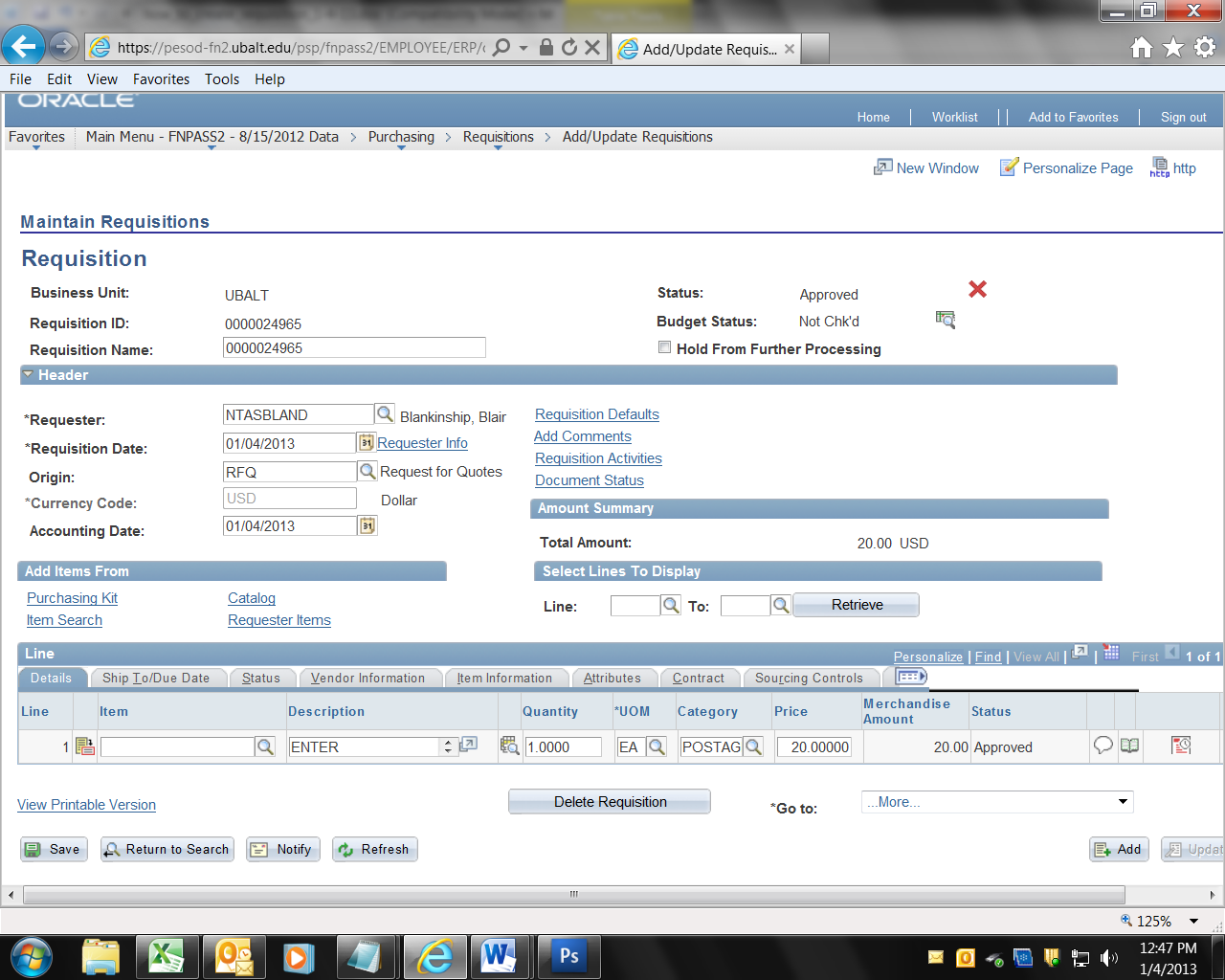
29. You should receive a message that the budget is “Valid”.  If the Budget Status changes to “Error”, check your financial reports to see if you have a deficit in the Department and Account on the Requisition. If so, transfer funds as necessary, and run the Budget Check (by clicking the icon) again. | 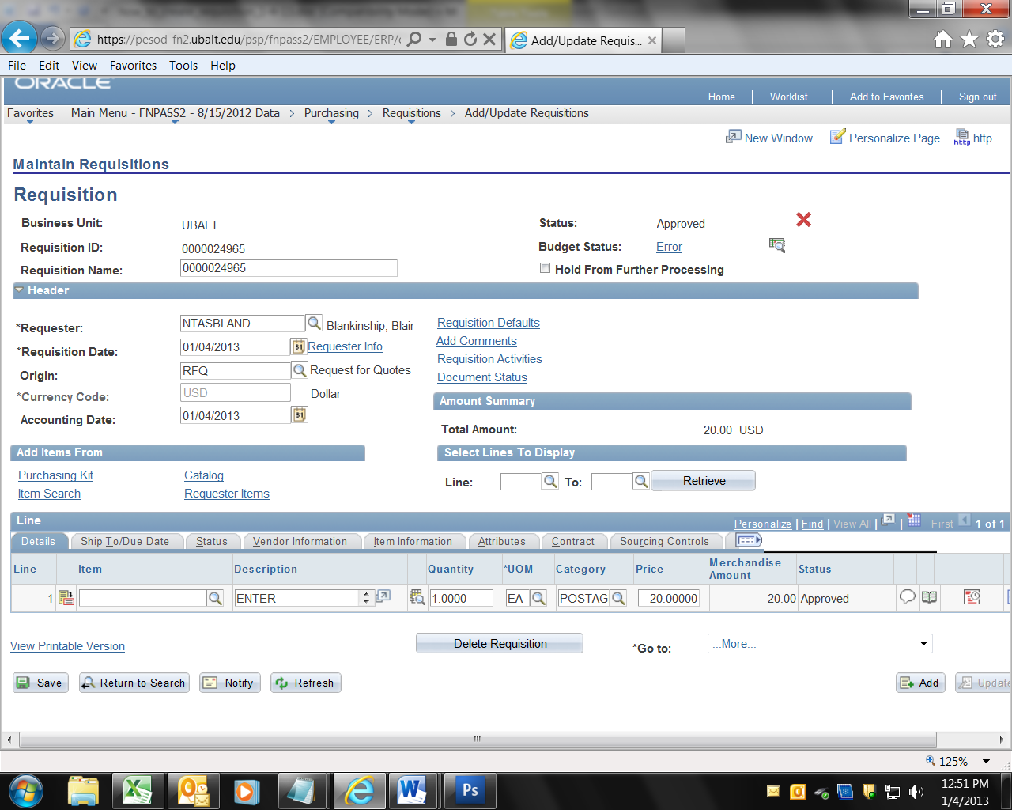

If the Status is Approved, and the Budget Status is “Valid”, procurement will begin work on the Requisition. The procurement process is determined by the dollar amount of the transaction, the type of item or service being purchased, the number of vendors available in the marketplace, and other factors. In general, we try to turn-around Requisitions under $5,000 within three business days; Requisitions over $5k but under $25k in one week, Requisitions over $25k but under $100k in three weeks. If you create a Requisition over $100k, you will need the additional approval of the Sr. VP for Administration and Finance. Once the Requisition has been approved, the Department Contact listed on the Requisition will be contacted by Procurement to work out a Procurement “time and action milestone plan” for the transaction.

Frequently Asked Questions:

1. What if I do not know the Buyer to whom the Requisition will be assigned?
ANSWER: Leave “Buyer” blank on the Requisition Defaults.

2. What if I can’t find the vendor, or the vendor has a new/additional address?
ANSWER: Leave “Vendor” blank on the Requisition Defaults, and enter the vendor’s name, address, telephone number (and e-mail if available) and tax ID number in “Add Comments”. Procurement will add the vendor to the vendor file and to your PO.

3. What do I enter in the (pick one):
- Category
- Vendor Location
- Ship To
- Ultimate Use Code
- Attention To
- Distribute By:
- Speed Chart (Accounting Distribution on the Requisition Defaults Screen)
That I see on the Requisition Defaults screen?

ANSWER: Nothing. Do not attempt to use those fields. Only enter the Buyer (optional), Vendor, and Due Date

4. What happened to the “Schedule Tab”?
ANSWER: It was replaced by an icon.

5. How do I change the Account number and/or Department?
ANSWER: To change the Account number and/or Department review steps 18.a – 18.d. above.

18.a. Accounting Chartfield Distribution: To correct or change the Accounting Distribution (Account, Department, Fund, Program and (sometimes) Project), Click the Schedule Icon.

18.b. Now click the Distribution icon.
18.c. If you need to change the Account number, First you MUST delete the entry in the Alt Acct field. That MUST BE DONE FIRST. Then click in the Account field and enter the correct Account number. Change the Department, Fund, Program and Project as necessary and then,

Click OK,

18.d. Click the hyperlink “Return to Main Page”.

Click Save.

6. What do I do if I can’t fit the entire description in the Description field?
ANSWER: Add additional information in the Comments section (was Line Comments), accessed by clicking the “speech balloon” icon.

If you have a detailed quote from the vendor, add the following to the Line Comments field, “Reference Quote ___quote number or name___, attached” and then attach the quote to the Requisition. To attach the quote, click the Line Comment bubble on the Description line, to the right of where you enter the Price; that will open the comments box. Below the box you will see a button labeled “Attach”. Click the Attach button, navigate to the document and attach it, much like you would do an attachment to an e-mail note. Be sure to Save again after doing the attachment.

If you do use an attachment, please include something like the following in the Description “see quote 12345 attached” or “see award form attached” so that we will know to look for the attachment.

7. How do I know which Buyer is working on my Requisition?
ANSWER: We will update the “Buyer” field on the “Requisition Defaults”. Check that field, or just call Procurement.

8. How do I know if my Requisition has been converted to a PO?
ANSWER: Generally, we will send a copy of the PO to you, generally as an e-mail attachment. You can also check the Requisition Document Status.
Purchasing > Requisitions > Review Requisition Info > Document Status
If a PO has been issued, it will be listed under “Associate Documents”. If there is nothing listed, please call Procurement for an update.

9. After I get the PO, what is the next step?
ANSWER: The vendor will ship the goods or perform the service. Then you will do the Receiving in PeopleSoft as an acknowledgement that the goods were received in good order, or the work was performed satisfactorily. Then write the PO number and Receipt number on the invoice and send that to Accounts Payable for payment processing.

10. What if I have other questions?
ANSWER: Please call Procurement.
Nancy Wright: Contract Specialist (Buyer) 410-837-5175
Toni Wallington, Assistant Director of Procurement: 410-837-5130
Dee McGhin, Purchasing Card Program Manager: 410-837-5717
Blair Blankinship, Director of Procurement: 410-837-5714

