Baltimore Renaissance Scholars Seed Fund FY 2015

Overview: BRSSF aims to support projects that create University of Baltimore involvement with the greater Baltimore community through action research, service-learning, or other forms of academic engagement. It is based on the belief that for UB, deliberate and purposeful initiatives with the larger community is an appropriate way to pursue our scholarship, teaching, and service. Furthermore, such projects work best when an external partner (a civic, community, or nonprofit organization; a governmental entity; or a business) actively participates.
Building on UB’s tradition of community engagement and action research, BRSSF seeks to support new initiatives or extensions of existing ones. We encourage projects that have the potential to generate external funding, institute a new policy or program, generate a product desired by the community, or otherwise lead to lasting change and benefits.
Projects in Central Baltimore are of special interest (the area from our campus north to Hopkins’ Homewood campus and from Greenmount Cemetery on the east to the railroad tracks and 83 on the west – please see attached map).
Eligibility: All individuals who hold regular faculty appointments at the University of Baltimore, including tenured, tenure-track, contractual faculty and librarians. While past Seed Fund winners are encouraged to apply, funding will not be granted for consecutive award periods.

Application Process: Proposals should be submitted to the Office of Sponsored Research, AC 209, on or before October 24, 2014. Interested individuals should submit a written proposal that describes in a clear and concise manner the significance of the proposed project, a description of the project goals and objectives, the assessment of outcomes, plans for future funding or continuation and a detailed budget request. Proposal narrative should be no longer than 3 pages, single spaced, 12-point font, standard 1-inch margins (exclusive of literature references, tables or drawings, survey instruments or letters from collaborators). The proposal should include a signed cover sheet (download here) and letter(s) of support from community partners. An electronic copy should also be emailed to Magui Cardona at mcardona@ubalt.edu.

Review Process: Proposals will be reviewed by a team of Provost Office staff and prior award winners. Successful applicants will be notified by November 21, 2014. Successful applications must meet criteria 1 below, and one or more of criteria 2-5:
- Projects that actively involve external constituencies in the Baltimore metropolitan area.
- Research projects that add to the base of knowledge on the Baltimore area.
- Instructional projects that teach, or develop new curriculum or teaching methods
- Applied or service projects that involve students and/or faculty in directly assisting public, private, or nonprofit organizations in the Baltimore area.
- Projects with the potential to generate external funding, institute a new policy or program, generate a product desired by the community, or otherwise lead to lasting change and benefits, rather than one-time activities.

Funding: The BRSSF will provide support up to $5,000 for projects that strengthen UB’s faculty and student engagement in our region. Please request the minimum amount of funds that will allow you to conduct the project, itemized and justified (please use budget template provided). We expect to make 6-10 awards, most ranging from $250 to $3,500. Funds must be expended in Fiscal Year 2015 (with all purchases and expenditures in process by May 15, 2015 and completed by June 30, 2015).
- In general, allowable expenses include salaries & benefits, consumable supplies, required travel and necessary equipment.
- Equipment purchases require 50% match

Reporting Requirements: All work must be completed and a final report submitted by August 31, 2015. Those funded are also required to make a public presentation about their projects during the 2014-2015 academic year.

For specific project questions, please contact Magui Cardona, ext. 6191 or mcardona@ubalt.edu.
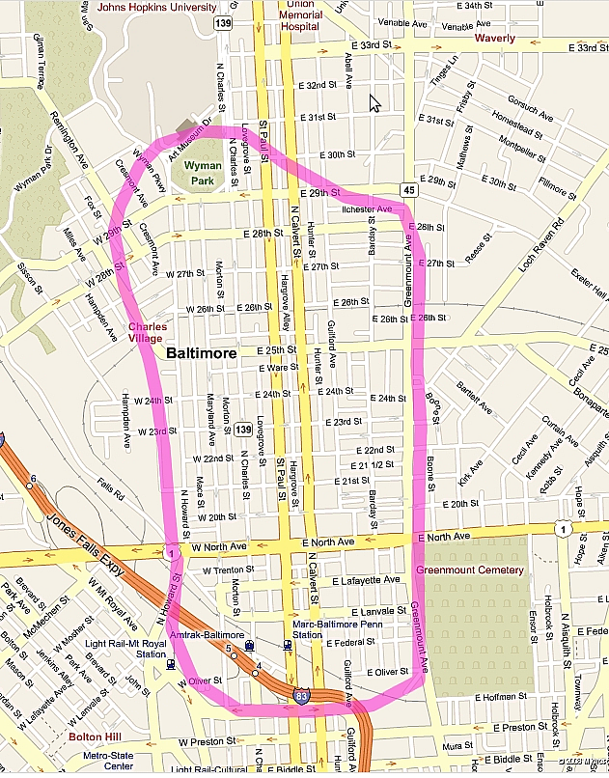

University of Baltimore
Baltimore Renaissance Seed Scholars Fund Application, FY 2015

(Please fill in form using Word, print and sign.)

Project Title:

Key words describing proposal:

Executive Summary of Project (100 words):

Principal Investigator:

Signature: _________________________________

Title/Department:

College/School:

Phone: Email:

Collaborators:
One principal investigator must be noted on the application. Identify co-investigators as collaborators; include a signed letter detailing their responsibilities.
Name/Department:

In what geographic area is your project focused?

Statement From Department/Unit Head/Library Director:
All necessary space and supplies that are not requested in this application will be made available in the unit. This is also to confirm that the Principal Investigator is a faculty member in my department/unit. If the faculty member is part-time, I certify that he/she is teaching in fall 2014 and is scheduled to teach in spring or summer 2015.
Department/Unit Head/Library Director

Signature: ______________________________________ Date: __________
Dean or Responsible Vice President

Signature: ______________________________________ Date: __________

