VMWare Horizon Instructions

Below you will find the step by step instructions for logging into the Ubalt VM environment, which can be accessed from any browser.

 | - Go to https://horizon.ubalt.edu/
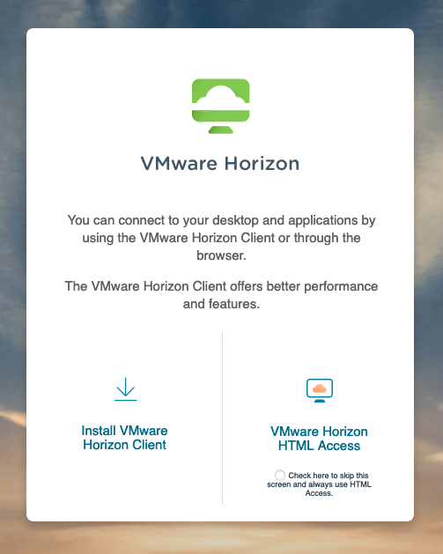 | - Select VMware Horizon HTML Access
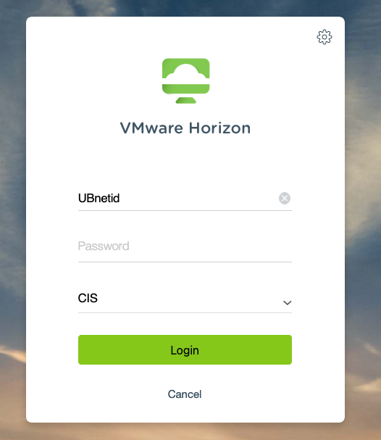 | - Signin with your myUB username and Password
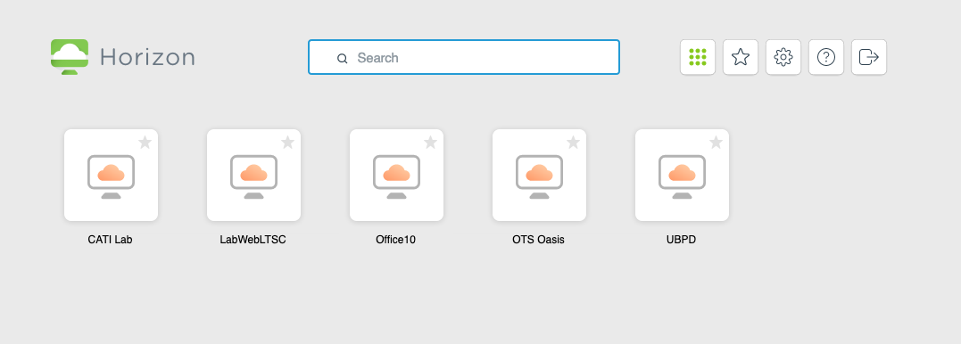 | - Select the Office 10 VM
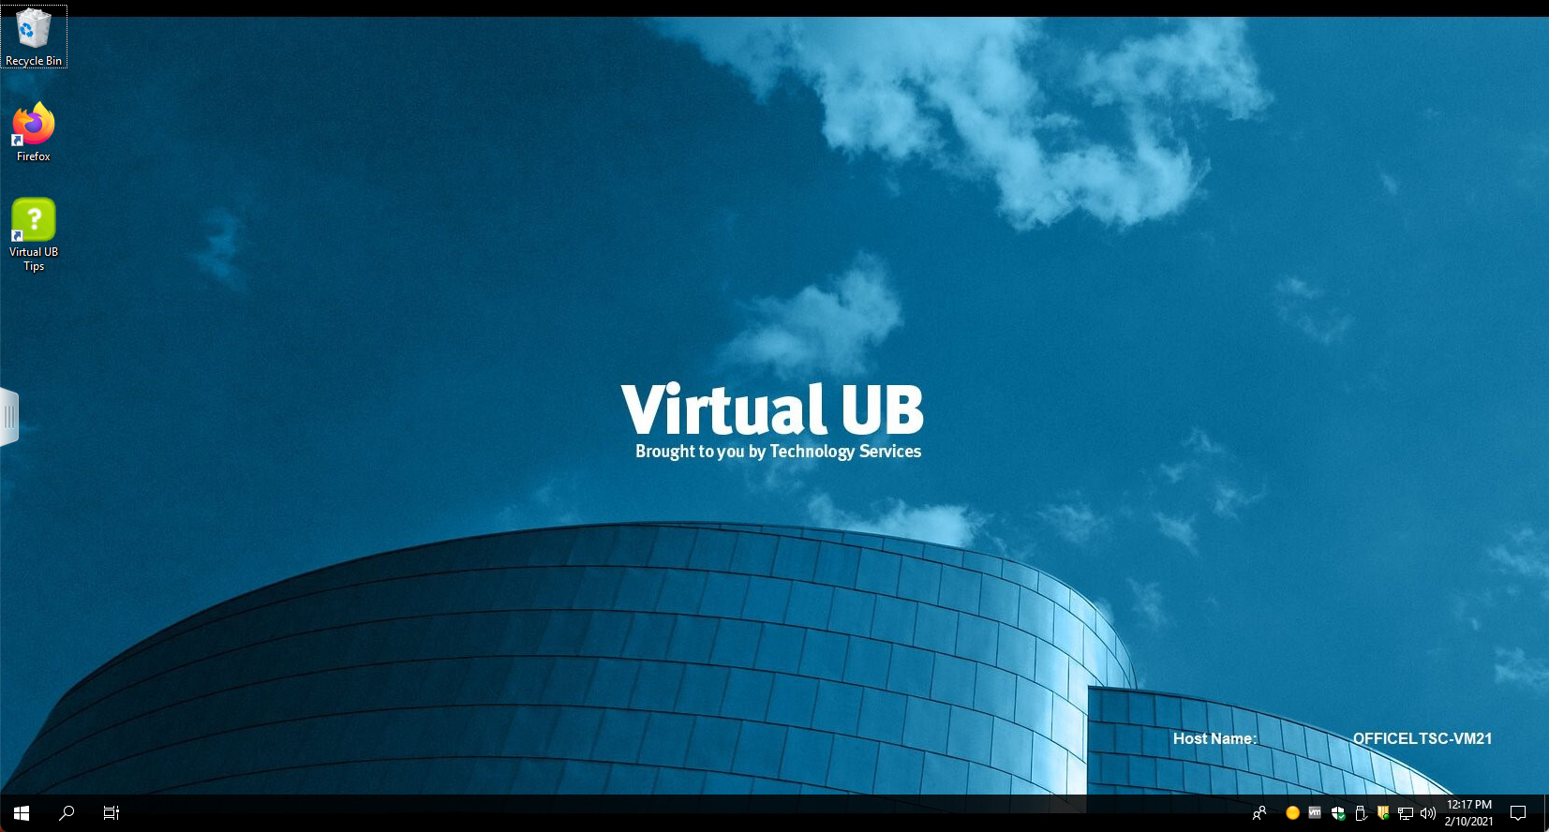 | - Your now signed into the VM.  Note: Always sign-out when you are done using the VM. All settings get erased when you sign-out, so save all documents to your network drive.

