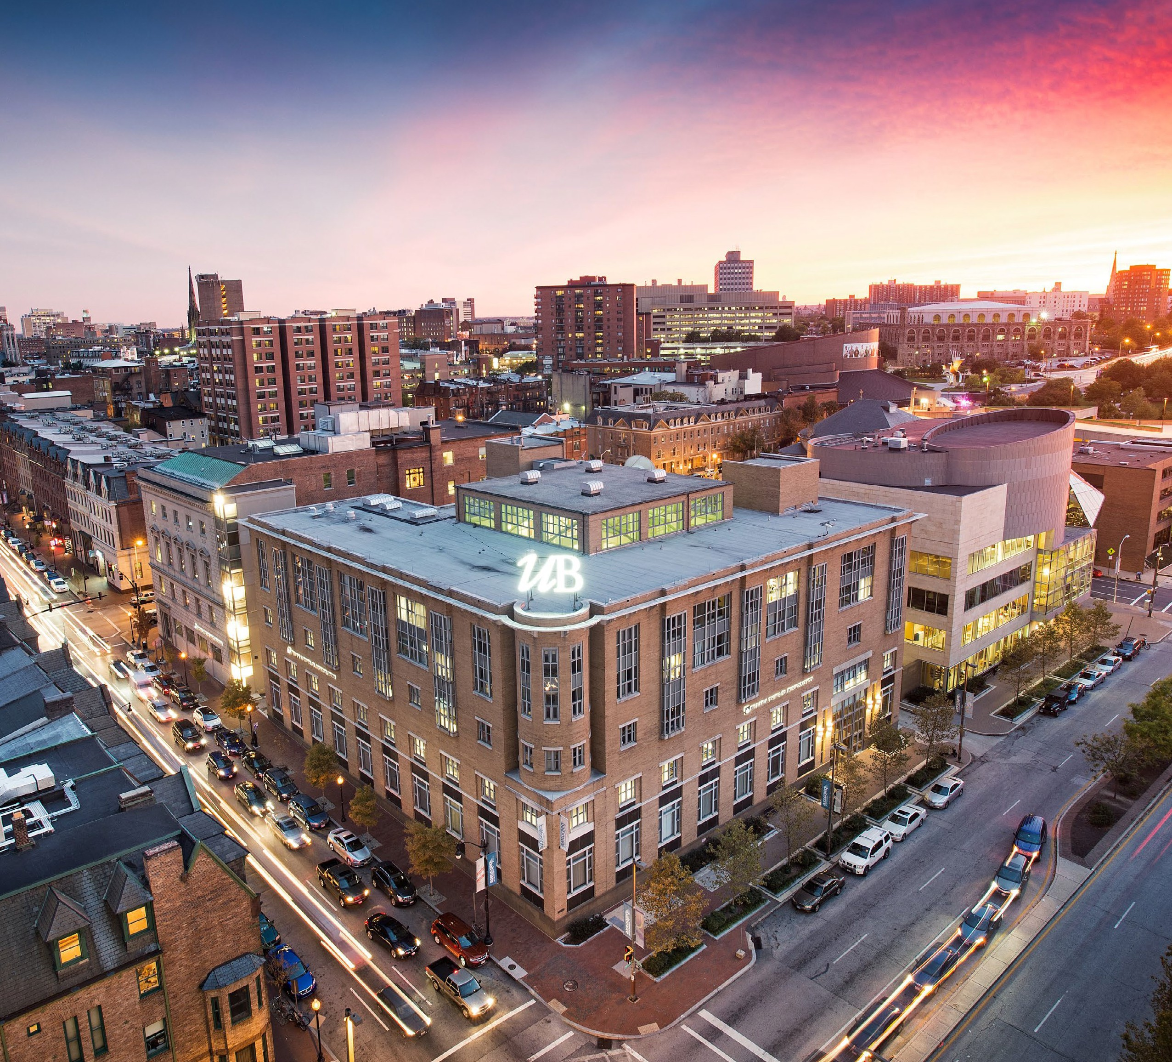


Executive Summary

THE UNIVERSITY OF BALTIMORE FACILITIES MASTER PLAN
2024
THE UNIVERSITY OF BALTIMORE FACILITIES MASTER PLAN 1

INTRODUCTION, PROFILE, AND PROCESS

The University of Baltimore offers career-focused education for aspiring and current professionals, providing the region with highly educated leaders who make distinctive contributions to the broader community. At UBalt, we are the University of Baltimore and the University for Baltimore, as we are actively involved in the progress of the City and State and engaged with our surrounding communities.

UBalt offers 44 academic degrees (25 graduate and 19 undergraduate) as well as certificate programs. Part of the University System of Maryland, UBalt has four schools and colleges: the College of Public Affairs, the Merrick School of Business, the School
of Law, and the Yale Gordon College of Arts and Sciences. Our campus is located in vibrant Midtown Baltimore, surrounded by arts, entertainment, education, and residential communities. We are steps from Penn Station along major vehicular, transit, and bicycle routes.

UBalt is different by design. UBalt students differ from traditional students and within UBalt, our students have differing needs and preferences that are important to their academic success. Unlike most universities, the majority (58%) of UBalt students are graduate students, by design. Our undergraduate students are mostly upper division (juniors and seniors) who come to UBalt as transfers, and the median undergraduate age is 28 compared with 22 for the USM system as a whole. 46% of all UBalt students attend part-time, reflecting their
status as working adults. Additionally, the majority of our undergraduate students are low-income or first- generation. UBalt is Maryland’s only 4-year university designated as a Predominantly Black Institution (PBI) based on our undergraduate student profile.

UBalt focuses on what matters to our students, and we strive to keep costs to students low. At UBalt, we enable older, working students to fulfill their educational goals while balancing the realities of their responsibilities for their families and work. Our flexible scheduling includes in-person, online, and hybrid courses available during daytime, evening, and weekend hours to accommodate students’ varied schedules. We understand our unique student populations have different scheduling needs, different space needs, different modality needs, and different amenity preferences, and we operate intentionally with these differences in the forefront to support the success of our students. UBalt ranks in the top 17% nationally for social mobility according to the 2023 Washington Monthly College Guide.
The 2024 UBalt Facilities Master Plan (FMP) aligns the vision for our physical campus in Midtown Baltimore with our mission, vision, values, and the students we serve. As we prepare for the University’s centennial in 2025, the FMP addresses the key issues and opportunities facing our campus. It considers future enrollment patterns and educational delivery methods to anticipate space needs and renewal opportunities that support UBalt’s strategic goals. The FMP better aligns the physical campus with the needs, preferences, and success of UBalt’s non-traditional student populations, now and into the future. It uses future enrollment growth and educational delivery methods to identify renewal opportunities for the core of campus that support the institution’s strategic goals. The FMP better aligns the physical campus with the needs, preferences, and success of UBalt’s non-traditional student populations, now and into the future.

2 Executive Summary

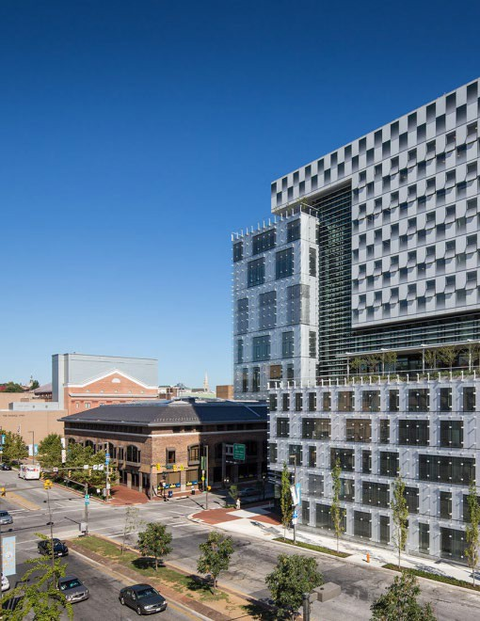

THE UNIVERSITY OF BALTIMORE IS DIFFERENT BY DESIGN

UBalt focuses on what matters to our students and strives to keep costs to students low. We enable our older, working students to fulfill their educational goals while balancing the realities of their responsibilities for their families and work.

86%
Of all UBalt students originate from MD (and 30% from Baltimore City)

47%
Of all UBalt students are members of an Underrepresented Minority race

50%
Consistent percentage of undergraduate students that are
low-income or first-
generation

UBalt is Maryland’s only 4-year University
designated as a Primarily Black Institution
58%
Of UBalt students are graduate students

UBalt Ranks High for Earning Performance, Social Mobility, and ROI

- Ranked #1 for earning performance among Maryland public master’s universities and within the top
5 percent among all master’s universities nationwide by Washington Monthly, 2023.

- Positioned in the top 17 percent nationally of master’s universities for social mobility by Washington Monthly, 2023.

- Ranked in the top 25 percent in the Best Bang for the Buck – Northeast, a measure of schools that help non- wealthy students attain marketable degrees at affordable prices as reported by Washington Monthly, 2023.

46%
Of all UBalt students attend part-time

28
Median age for undergraduate students (compared with USM median of 22)

UBalt has no residence halls and no athletics programs

4 Executive Summary

Mission
The University of Baltimore offers career-focused education for aspiring and current professionals, providing the region with highly educated leaders who make distinctive contributions to the broader community.

Strategic Goals

1 Position UBalt as the region’s premier 4 Organize for long-term
professional, career-focused university. financial stability.

2 Strengthen student success.

3 Solidify UBalt’s commitment to
community engagement and service. diversity, equity and inclusion.

Achieve excellence in research,

scholarship and creative activity.
5

6 Strengthen UBalt’s commitment to

THE UNIVERSITY OF BALTIMORE FACILITIES MASTER PLAN 5

Campus engagement with the FMP planning process kicked off in September of 2023. It was
organized into three phases: campus assessment, concept development, and recommendations. Each phase was reinforced by engagement with the campus community and key leadership to guide the development and refinement of the plan and reflect the voice of the UBalt community.

Key themes that emerged from the early engagement included a desire for more consistent physical space across the campus buildings that better aligns with UBalt’s values; co- location of spaces of similar space type to increase vibrancy; specific desired space types including hybrid active learning classrooms; improved definition of the physical campus grounds; and potential for strategic partnerships to further activate campus facilities during the day when fewer students are taking classes. An FMP task force with representatives from student, faculty, and staff
worked closely as part of the Planning Team throughout the year-long process of developing and refining the plan. Executive
leadership and shared governance were formally consulted regularly throughout and regular, monthly campus updates were provided.
Presentations and engagement sessions also occurred with representatives of UBalt alumni leaders and representatives of Baltimore City, surrounding neighborhood groups, and nearby stakeholders.

The Facilities Master Plan addresses University System of Maryland requirements, outlines proposed investments in modern teaching and learning spaces, reduces deferred maintenance, and incorporates new sustainability targets for existing campus buildings. It serves as a framework for physical planning for the first decade and longer of the University of Baltimore’s next hundred years serving Baltimore City and Maryland.



EXISTING CONDITIONS

The University of Baltimore is located in Midtown Baltimore, proximate to multiple modes of transit and many cultural institutions including the Penn Station Redevelopment, MICA, and the Charles Street retail and dining corridor. As such, the physical campus is experienced by many community members beyond students, faculty, and staff.

The core campus includes eight buildings that comprise of 871,203 gross square feet (GSF) and serve an enrollment of 3,101. Over a quarter of the core campus by gross square feet is represented by the Academic Center alone. Due to our unique student body, UBalt does not have residence halls, significant food service, or intercollegiate
athletic programs. The campus is centered around Gordon Plaza and immediately flanked by the
Academic Center and the H. Mebane Turner Learning Commons. The John and Frances Angelos Law Center, the William H. Thumel Sr. Business Center, the UBalt Student Center, and the Robert L. Bogomolny Library all face this block. The Liberal Arts and Policy
building and the primary structured parking for the campus are located approximately one block from this core. Parts of the upper floors of
the Turner Learning Commons are currently leased to Baltimore City for use as the Police Academy training center.

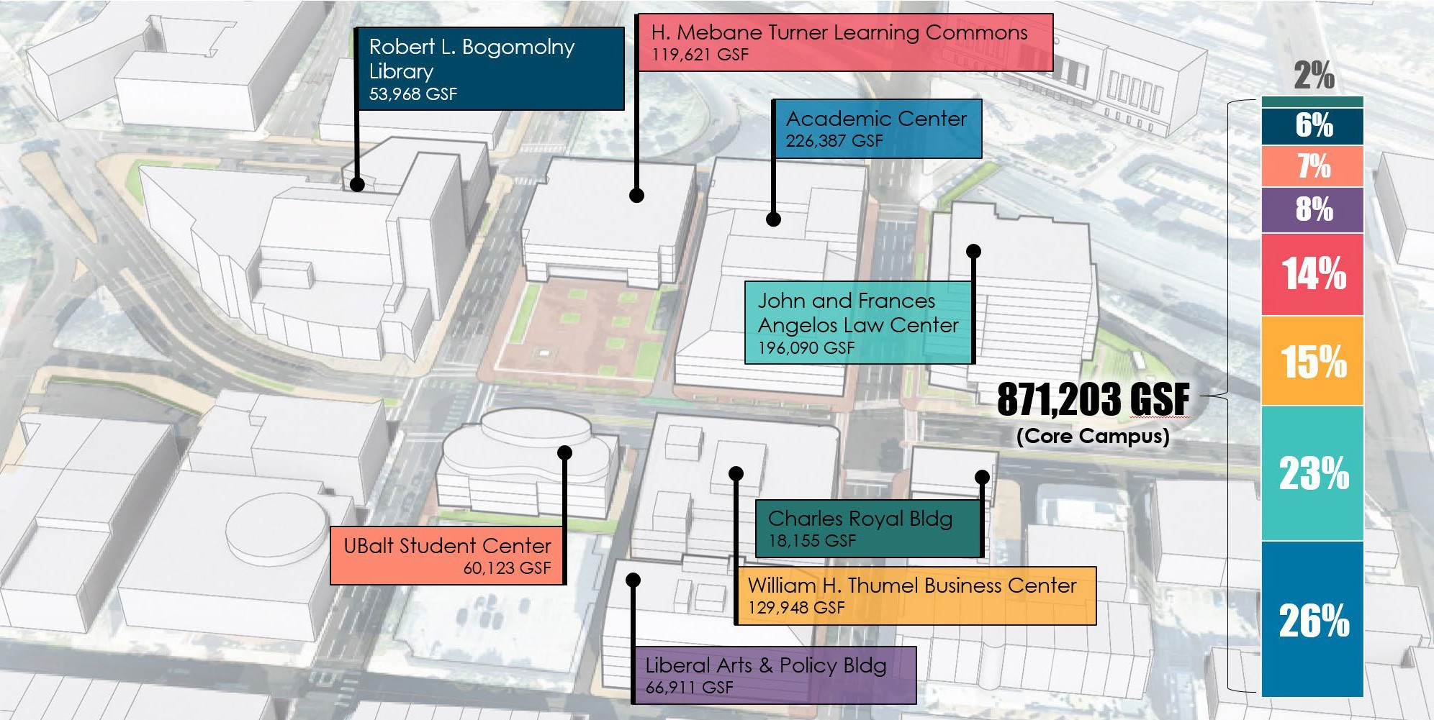
CR RLB
7% SC LAP
14%
15%
LC
LAP
23% ALC
AC
Liberal Arts & Policy Bldg
66,911 GSF
Charles Royal Bldg
18,155 GSF
Core campus space distribution by building

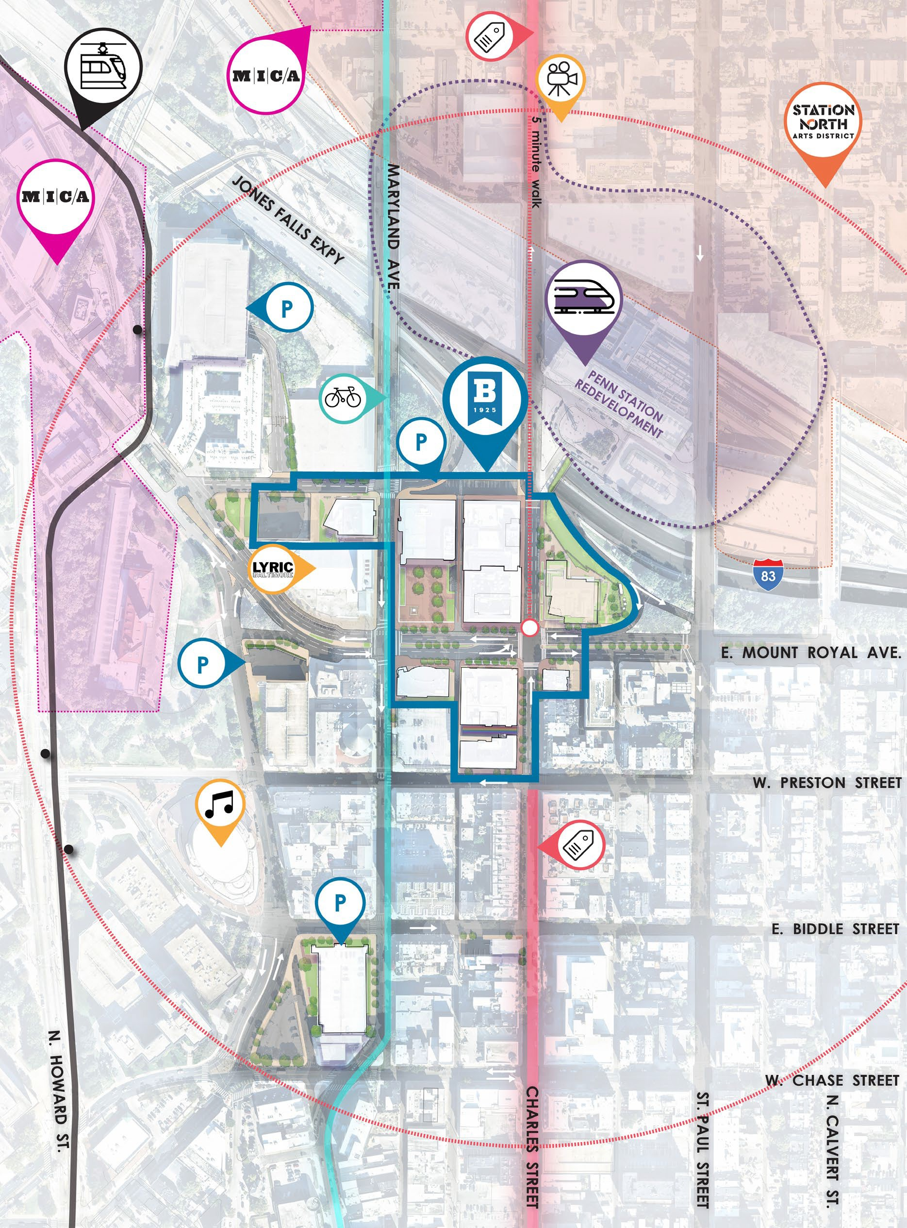

CAMPUS CONTEXT

UBalt Core Campus

Charles Street Commercial Corridor

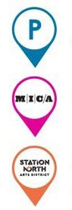
Maryland Avenue Bike Route

UBalt Parking MICA Campus
Station North Arts District


Meyerhoff Symphony Hall

The Charles Theatre

The Lyric Baltimore
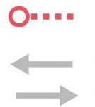
1/4 Mile Walking Radius
Vehicular Flow
of Traffic

N

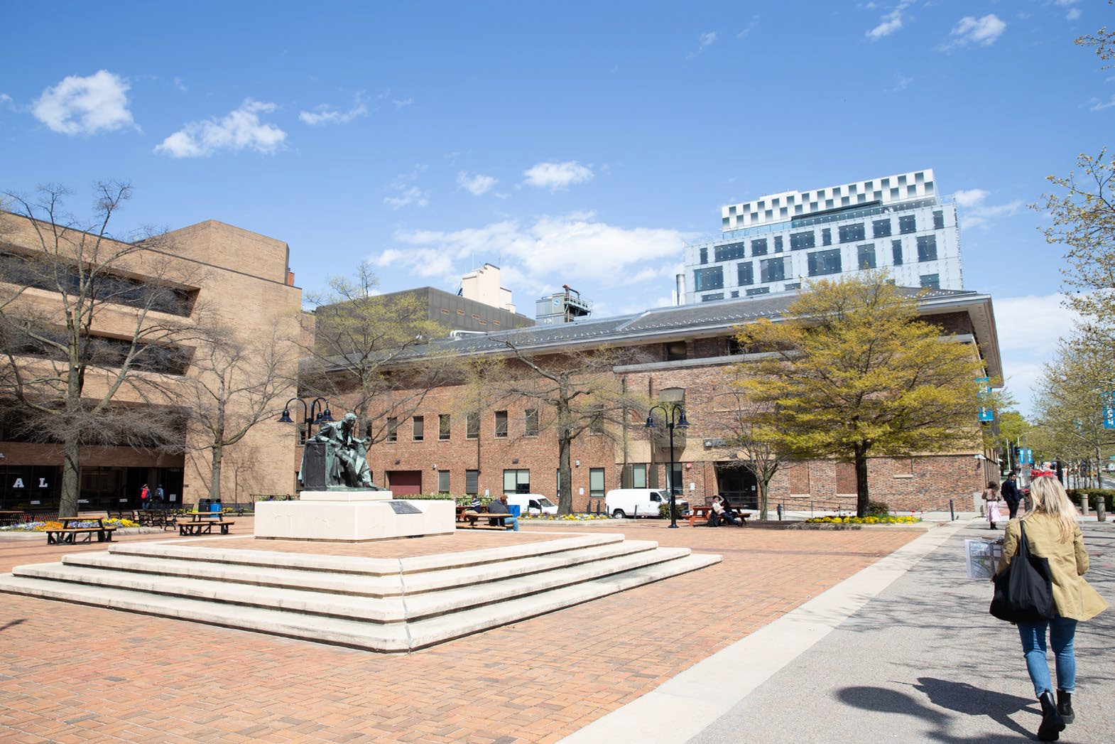
Open Space
Gordon Plaza serves as the primary open space for the campus, occupying the northeast corner of Mount Royal Avenue and Maryland Avenue. The largely brick plaza features a statue of Edgar Allen Poe with shade trees and limited planting beds. Other open spaces include Inclusion Alley between the Liberal Arts and Policy Building and
the Student Center and small spaces adjacent to the RLB Library and
the Angelos Law Center. The green spaces directly to the north of the Academic Center and Turner Learning Commons between Oliver Street
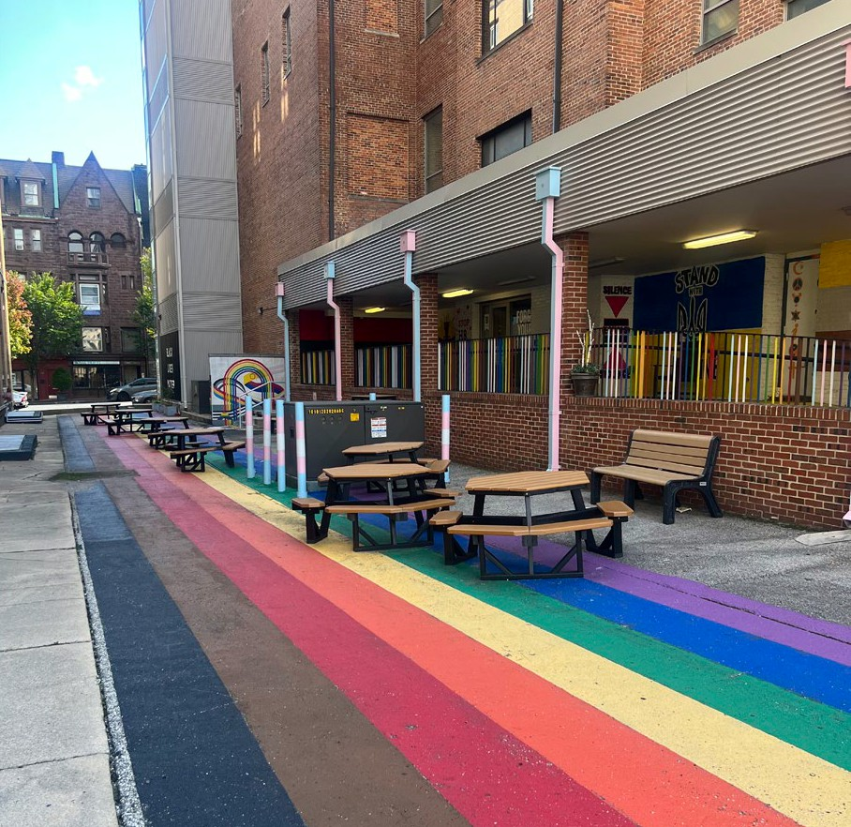
and I-83 are not owned by UBalt but contribute to the arrival experience by car and foot from the north. While the campus borders many of the major commuting routes for those who work in the central business district, there is a lack of cohesiveness and branded presence in building design and signage to promote awareness of the campus boundaries and identity.

Gordon Plaza (Top image); Inclusion Alley (Bottom Image)

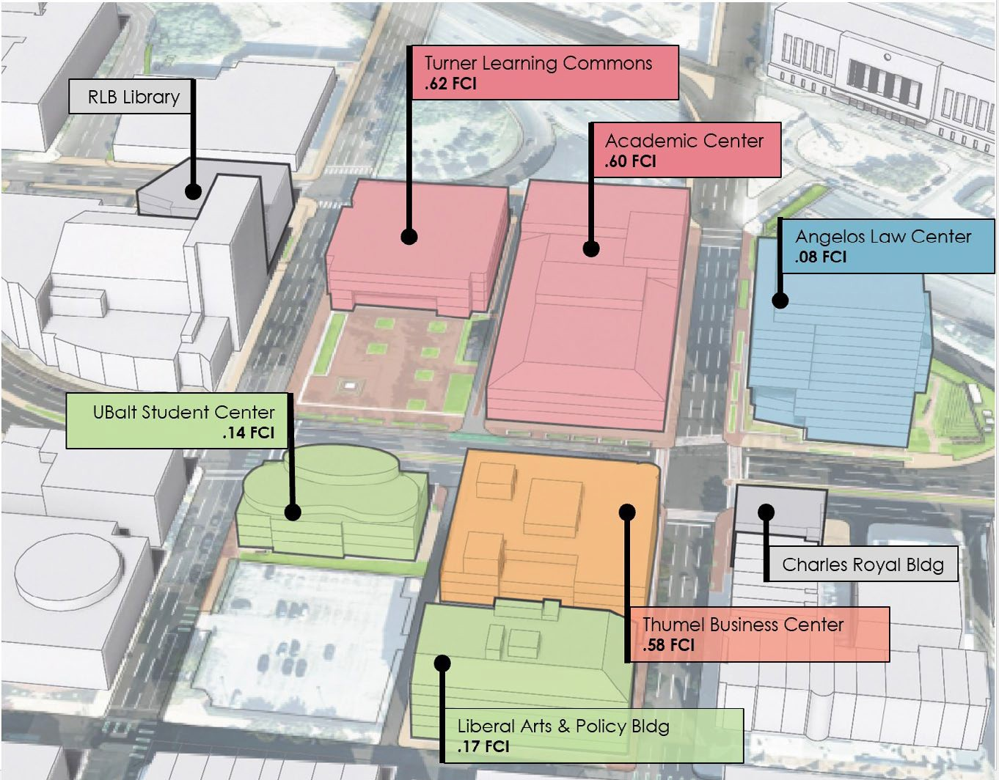
Deferred Maintenance and Building Condition
Not Assessed

☼
★
GORDON PLAZA
★
‡
⌂
►
☼
⌂
Not AsNseostsAedssessed

Building age varies greatly, and the quality of facilities varies significantly by building. The Academic Center alone represents 43% of campus deferred maintenance, and 87% is represented by just the Academic Center, Thumel Business Center, and Turner Learning Commons. These three buildings are all deficient or nearly deficient according to their facilities condition index (FCI).

For the Academic Center, in particular, even if the significant deferred maintenance were fully remediated, the facility would still be inadequate due to its functional and programmatic limitations. The Academic Center is made up of three original buildings, that were
constructed at differing times (two are
over 100 years old) and for differing

*Excludes W Chase Buildings, Cathedral Building, Maryland Ave Building + Garage

SPACE QUALITY
The Academic Center, Thumel Business

purposes, and then subsequently ‡ connected for use as an academic ⌂ building. The building has many well- ◊
►
documented deficiencies beyond the
need for facilities renewal that cause ★
☼
it to underperform.

New State building energy performance standards that will apply to all but the Charles Royal Building will also require substantial sustainability upgrades to reduce onsite building carbon emissions.
<10% FCI = Excellent
11-20% FCI = Good
21-40% FCI = Fair
41-60% FCI = Poor
>60% FCI = Deficient
FCI not assessed

Center, and Turner Learning Commons are
deficient or nearly deficient.

Addressing deferred maintenance alone does not address the functional or
programmatic limitations of these buildings.

38%

Building requirements for active learning have also evolved since most of the facilities were originally
2024 OVERALL CAMPUS FCI ($161.2M)

constructed, and UBalt’s pedagogical nature of combining virtual, hybrid, and in-person coursework results in a need for high-performing, technology- forward active learning classrooms that can integrate a hybrid learning experience and better support
adult learners.
43%
Of total FCI cost is represented by the Academic Center
87%
Of total FCI cost is represented by the Academic Center,
Thumel Business Center, and Turner Learning Commons

Information from 2024 Facilities Condition Assessment performed by Gordian.

PLANNING VISION

The 2024 UBalt Facilities Master Plan aligns the vision for our physical campus in Midtown Baltimore with our mission, vision, values, and the students
we serve. The FMP addresses the key issues and opportunities facing our campus today. It considers future enrollment patterns and educational delivery methods to anticipate future space needs and renewal opportunities to revitalize key campus spaces that support UBalt’s strategic goals. The FMP better aligns the physical campus with the needs, preferences, and success of UBalt’s non-traditional student populations, now and into the future.

The Facilities Master Plan is intended to be a framework for physical planning over the next decade and beyond. The following planning principles were developed with strong campus community engagement and serve as a foundation for the FMP to guide its development, priorities, and implementation.

1
2
3

Foster a sense of place | Create a vibrant and | Ensure learning
that reinforces the | inclusive campus that | environments are flexible
identity of UBalt as an | matches the unique | and adaptable to meet
anchor institution of and | needs and priorities | the evolving needs and
for Baltimore. | of our non-traditional | priorities of our students
 | professional and career- | and community.
 | focused student body.

4
5

Realign and renew Strengthen the existing space to reduce pedestrian experience deferred maintenance through safe streets and prioritize student and active first-floor
recruitment, retention, experiences.
growth and success.

THE UNIVERSITY OF BALTIMORE FACILITIES MASTER PLAN 13

In understanding the core opportunities and challenges for UBalt over the horizon of this plan, three drivers became evident:





VIBRANCY
To meet the diverse needs of our student body, UBalt offers a wide range of educational and service delivery methods. Consequently, at any given time, some of our students may be on campus while others
are engaging remotely. A desired aspect of the FMP is to enhance the campus environment by
intentionally creating vibrant clusters of students, faculty, staff, and community members—rather than physically dispersing them—and to build strong infrastructure to foster meaningful engagement among those who are interacting remotely and those who are on campus.
DENSITY
Active environments thrive when there is density of space and people. Currently, the densest building on campus, Angelos Law Center, is also the most active.
UBalt’s proximity to Penn Station and incredible transit access also positions campus to be good stewards of density through transit- oriented development.
IDENTITY
UBalt enjoys some of the most iconic buildings and spaces in Baltimore City, such as the Angelos Law Center and
the RLB Library. However, other campus buildings have varying, nondescript styles,
creating a lack of architectural cohesion. Therefore, enhancing streetscapes, establishing
a branded presence, and incorporating thoughtful design in new buildings and facades are important for improving campus visibility and identity.

Space Strategy
UBalt has recently assessed our current and future space needs in consideration of space inventory, course and service delivery methods, enrollment, and student body profile. Presently, our assessment shows calculated surpluses in classrooms, teaching labs, and office spaces.
We will be implementing two actions to address the space surpluses: (1) right sizing the Academic Center (AC) Replacement for current and future needs, with the AC Replacement anticipated to be smaller than the existing facility, and (2) proposing revisions to existing classroom and
lab space allowance methodologies to better reflect UBalt’s unique student population.

Past enrollment declines along with other factors have resulted in calculated surpluses in current net assignable spaces in classrooms
and labs. Classrooms continue to be heavily used in the evening, often exceeding recommended usage. The current space surplus represents an opportunity to renew campus spaces and potentially re-align building programs for increased vibrancy and functionality.

UBalt projects to grow our enrollment over the next decade by 3% on average annually. The 10-year space needs projection more closely aligns with current space availability.

Moving forward, focused and regular investment in instructional spaces for active and flexible technology-forward hybrid courses is important for our adult learners and to accommodate evening peak hours. Classrooms should be co- located to cultivate vibrancy and informal learning and collaboration spaces should be infused throughout academic facilities. Student comfort and belonging should be prioritized inside and outside the classroom through space, furniture, and
technology choices targeted to adult learners. Where beneficial, student- facing services and amenities should be co-located for easy access and interchange across programs that support student success.



CORE CAMPUS EXISTING NASF BREAKDOWN BY SPACE GROUPING

Campus Support

Inactive, Alteration/ Conversion

4%

Academic &
PROJECTED SPACE NEEDS BY SPACE GROUPING

Student Space

26%
7%

412,200
NASF
24%
Research

Projected 10-year Need based on 10 YRS HENCE population figures and space metrics that separate Law and Non-Law instructional space needs

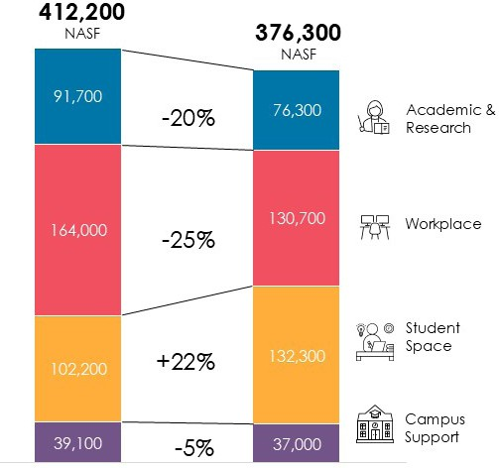
43%
164,000
130,700
102,200
132,300

Workplace
Fall 2023 Projected
Existing 10-year Need NASF NASF
Not shown; 15,200 NASF of Inactive, Alteration
/ Conversion Space

Core Campus defined as the following buildings: Academic Center, Bogomolny Library, Thumel Business Center, Charles-Royal Bldg, Angelos Law Center, Turner Learning Commons, Liberal Arts & Policy Building, UBalt Student Center.

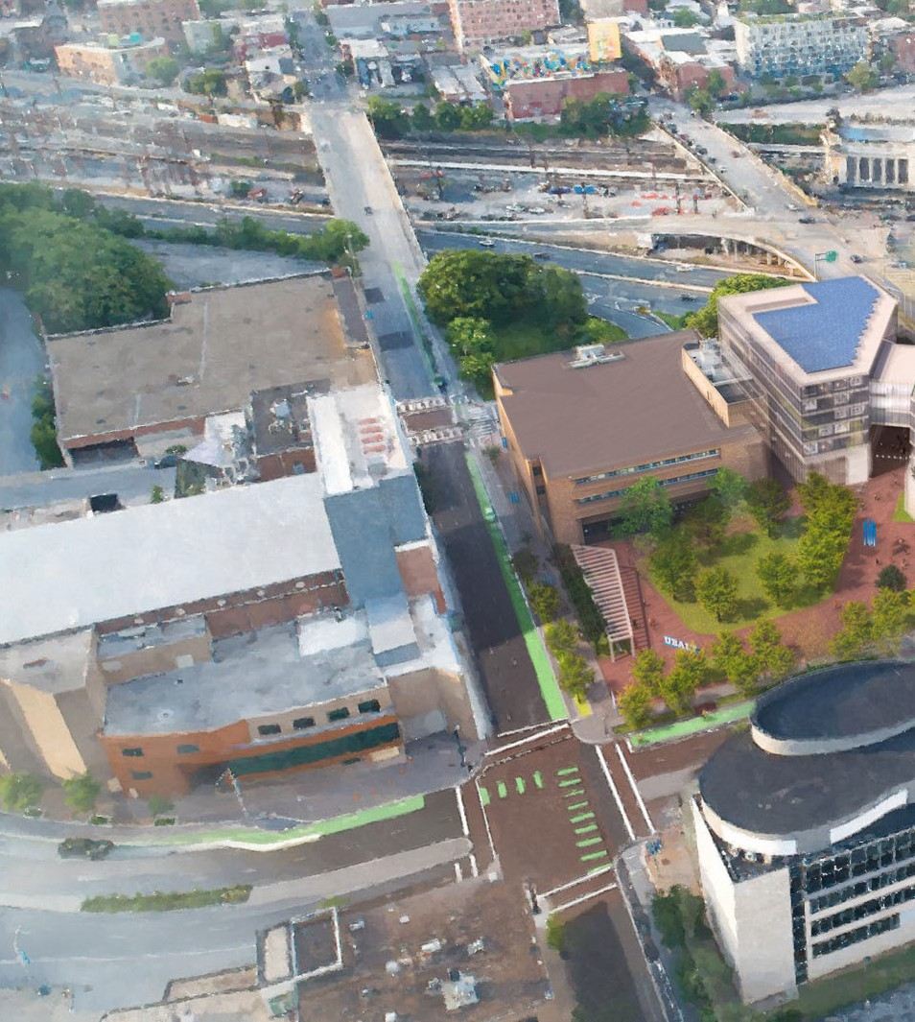

UBalt’s future

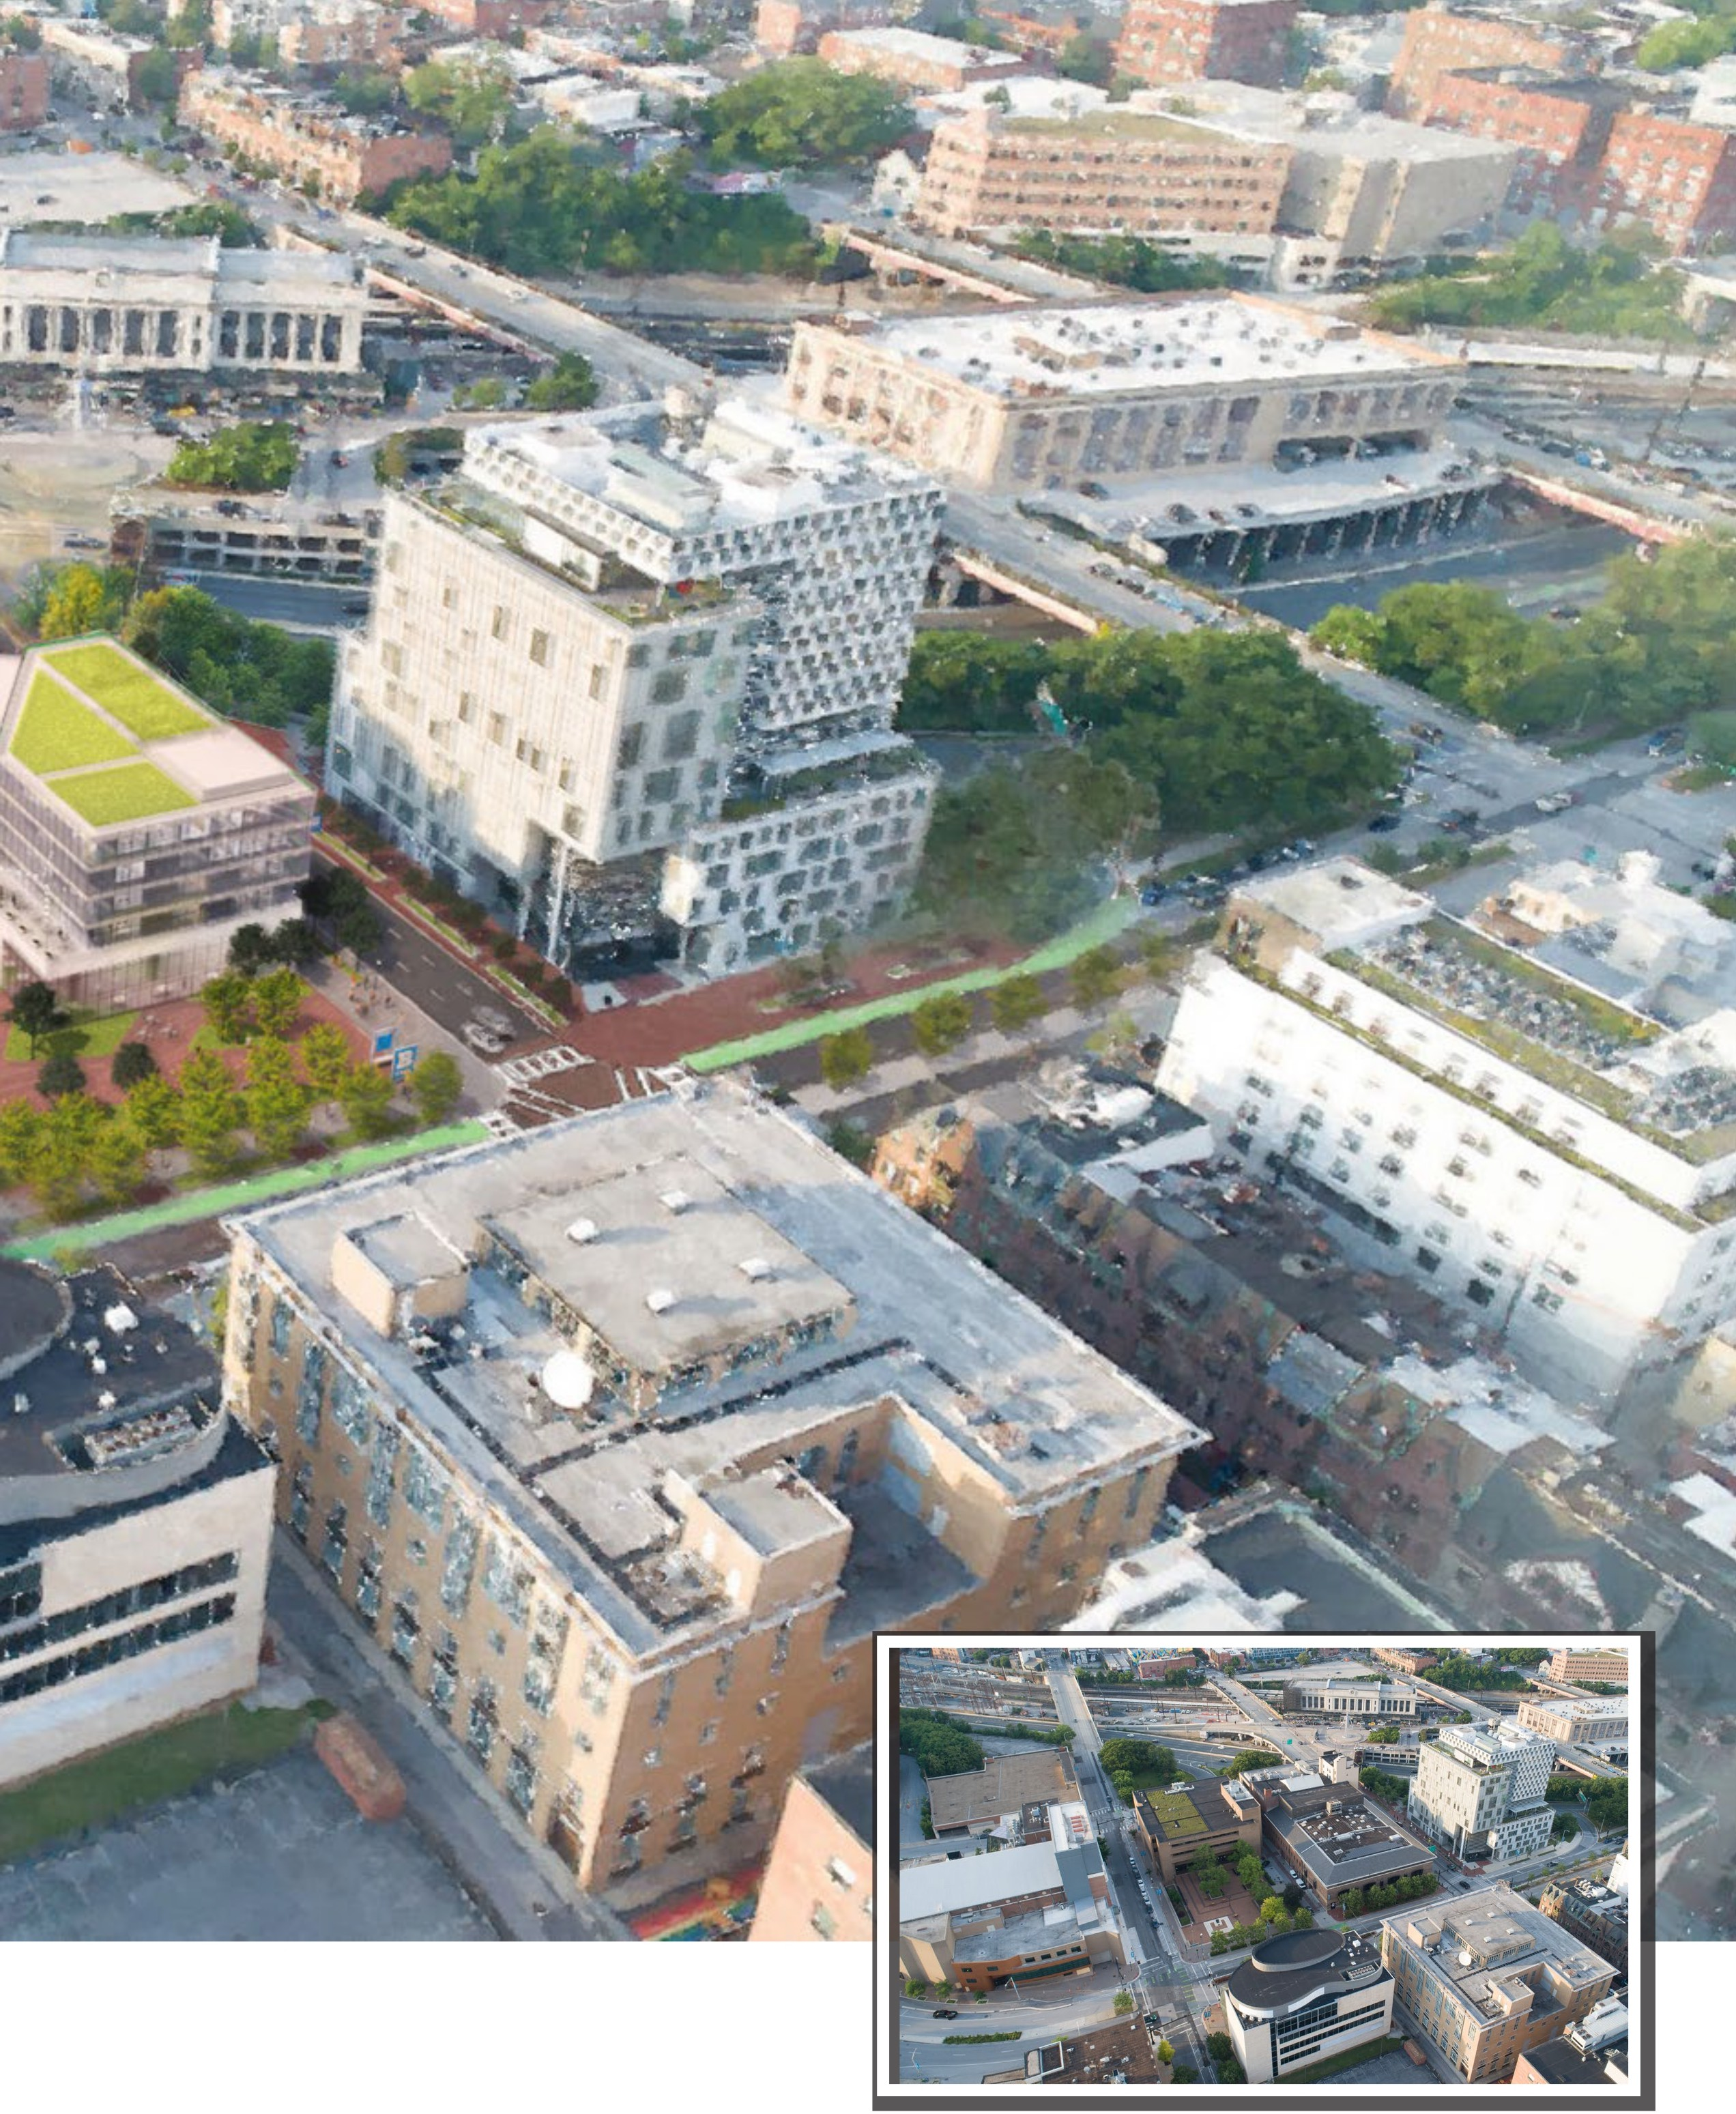

UBalt today

Proposed Projects
The Facilities Master Plan will renew campus spaces through a targeted strategy of replacement, acquisition, and renovation. The key opportunity on which the plan focuses is the replacement of the Academic Center, which currently represents over a quarter of the campus internal space and 43% of the deferred maintenance. A new, smaller, and more efficient academic building on this site will include modern, hybrid learning spaces that prioritize the adult learning experience. It will encourage interdisciplinary learning, collaboration, and innovation by
co-locating lab, classroom, and study spaces for multiple colleges, and support student-faculty interaction through shared spaces for informal and formal collaboration. A smaller footprint will allow for a renewal
and expansion of Gordon Plaza to connect more strongly to the Angelos Law Center to the west and Penn Station to the north. This improved, dynamic outdoor space will serve
as the heart of campus for the UBalt community and bring improvement to our surrounding neighborhoods, featuring additional trees and native plantings, stormwater management best practices, and a variety of outdoor places for people to study, eat, and gather.

PROJECT LIST
- Academic Center Replacement & Site Improvements

- Welcome Center

- Energy Performance and Sustainability Upgrades*

- Facilities Renewal

  - Thumel Business Center

  - Turner Learning Commons

  - Angelos Law Center (limited)

- Strategic Programmatic Renovations
  - Charles Royal Building

  - UBalt Student Center

  - RLB Library

  - Liberal Arts and Policy

- Pedestrian Safety Improvements**

- Campus Branding and Lighting (throughout campus)

*Required by MD Building Energy Performance Standards

**All streetscape improvements require coordination with Baltimore City DOT and DPW for traffic and stormwater

PENN STATION
MARYLAND AVENUE

6
OLIVER STREET
CHARLES STREET

3 5 3 4
RLB LIBRARY TURNER LEARNING COMMONS

ACADEMIC CENTER

1

GORDON PLAZA 3 4

6
ANGELOS LAW
CENTER

MOUNT ROYAL AVENUE

2 3 3 UBALT 5

WELCOME CENTER
STUDENT 3 4
5 CENTER
THUMEL BUSINESS
CENTER
CRB

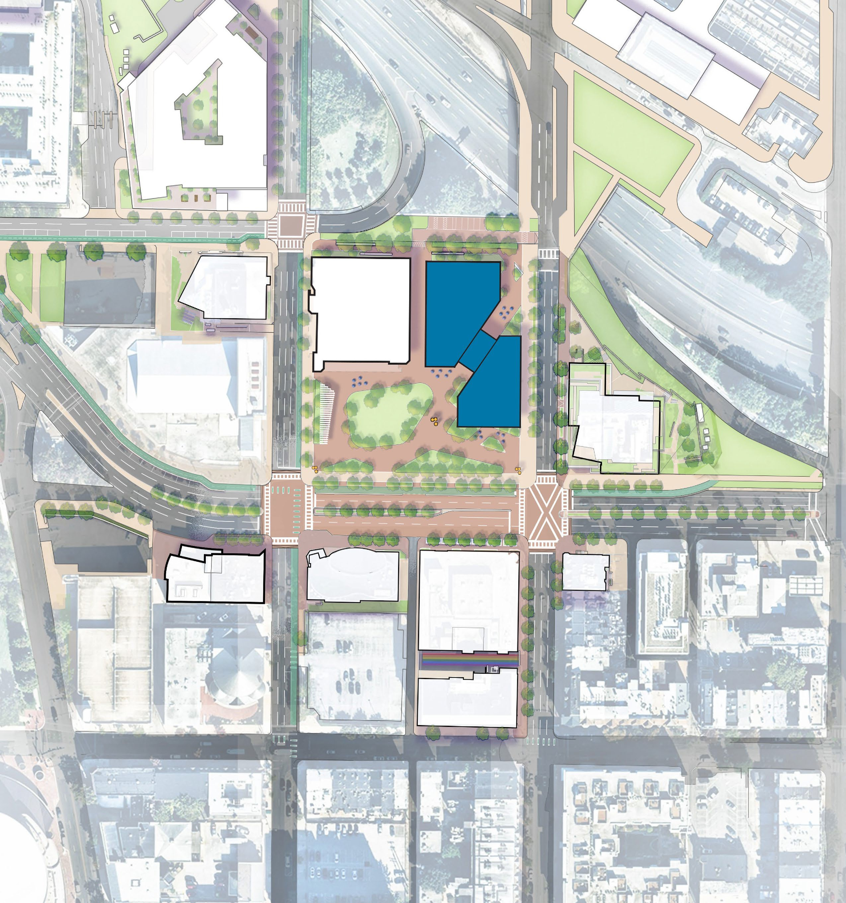

3 5
LIBERAL ARTS & POLICY
PRESTON STREET

N

CHARLES ST
MARYLAND AVE.
MARYLAND AVE.
MT ROYAL AVE.
MT ROYAL AVE.

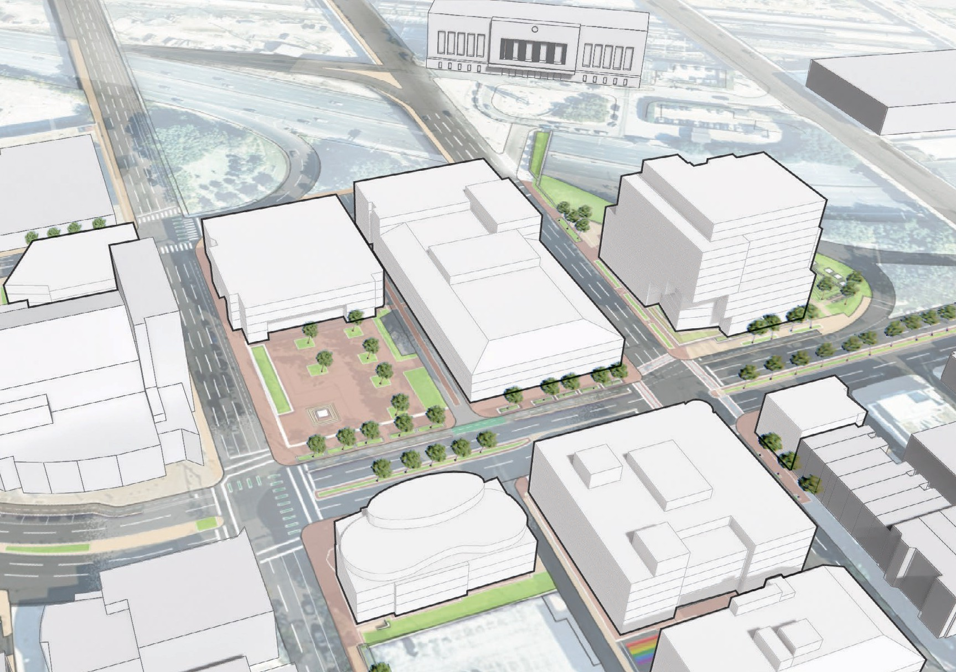
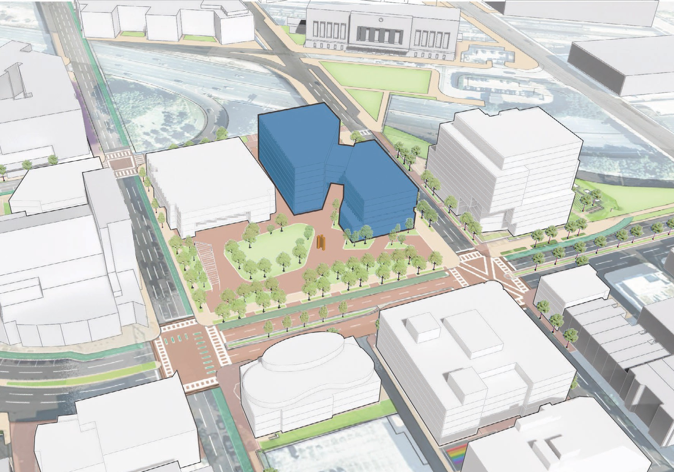
Existing
Thumel Business Center
Royal
Charles
Liberal Arts & Policy
UBalt Student Center
Academic Center

RLB Library
Turner Learning Commons
Angelos Law Center
Penn Station
Penn Station
Academic Center
Royal
Charles
Liberal Arts & Policy
Welcome Center
UBalt Student Center
Thumel Business Center

RLB Library
Turner Learning Commons
Angelos Law Center
CHARLES ST

Proposed

The FMP recommends the creation of a UBalt Welcome Center through acquisition of the existing building at 101 West Mount Royal Avenue.
The four-story, 36,340 GSF building is adjacent to the UBalt Student Center and diagonally across from
Gordon Plaza. Securing this strategic location in the core campus enables related, outward-facing administrative functions to co-locate there from
the Academic Center and serve prospective and enrolled students in non-academic matters as well as donors, alumni, and other UBalt friends. Purchasing this facility will directly reduce the needed size of
the Academic Center Replacement, resulting in lower costs to the
State, net of the acquisition, plus operational improvements for UBalt when compared with proceeding with Academic Center Replacement project alone.

Renovations of varying degrees and scope are recommended for the remaining seven primary buildings on UBalt’s core campus. The new Building Energy Performance Standards coming from the Climate Solutions Now Act of 2022 require
decarbonization of all primary existing campus buildings except the Charles Royal Building by 2040. Alternate compliance fees for not meeting interim emissions standards start in 2030. Sustainability upgrades are an opportunity to also address required
building systems renewals and replacements. The Turner Learning Commons and the Thumel Business Center represent a combined 44% of total deferred maintenance. With the Academic Center Replacement, 87% of deferred maintenance is addressed through these three buildings.
Additional updates to building skin and glazing at the Angelos Law Center are planned.

In addition, the UBalt Student Center and RLB Library and some other buildings may have strategic programmatic changes to align with a long-term space strategy that organizes campus through hubs.
This hub strategy will concentrate similar activities, promote vibrancy, break down programmatic silos, and encourage interdisciplinary collaboration while promoting clear wayfinding. A study is underway to
evaluate the benefits and renovations associated with moving the our Special Collections and Archives
to the Charles Royal Building for increased visibility and access to the UBalt community and patrons from the Baltimore City region. Additional projects are queued for evaluation at the Liberal Arts & Policy Building, and possibly the Thumel Business Center. Minor façade and entryway renovations may occur to align with campus open space and identity strategies.

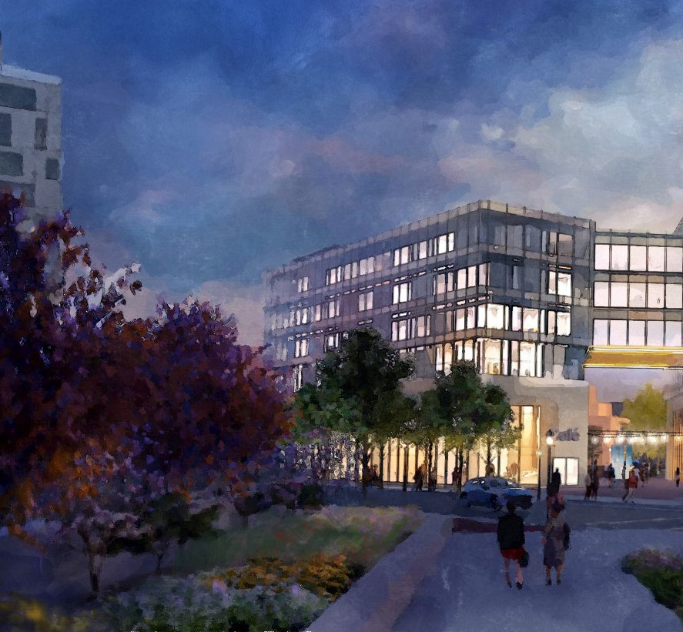
UBalt seen from Penn Station in the future

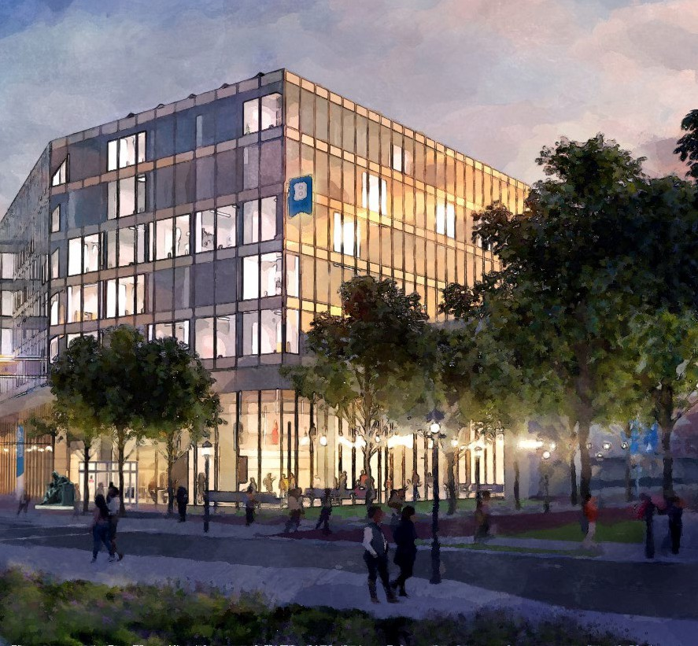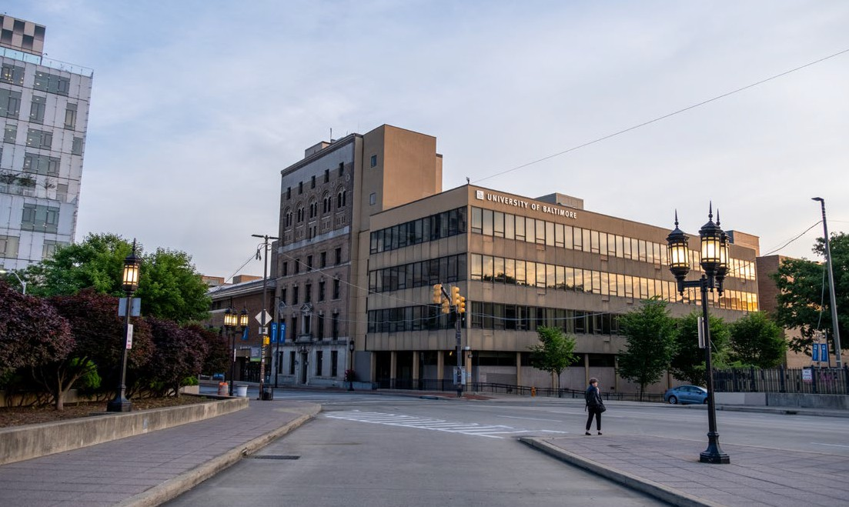
UBalt seen from Penn Station today

Street improvements are recommended to improve pedestrian safety and nurture a sense of place that is uniquely UBalt but also interwoven with and welcoming
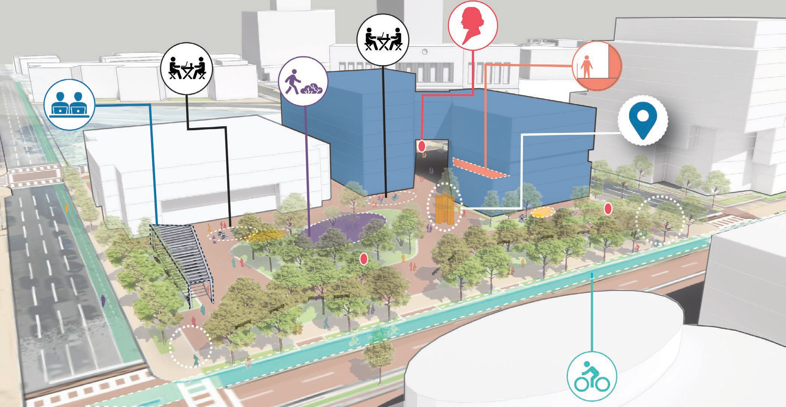
to the surrounding community. All improvements in the public right-of-way including crosswalks, roadway changes, and signaling adjustments require coordination with the Baltimore City agencies.
UBalt Gateways & Icons
Roof Terrace
Potential Poe Statue Relocation
While the timing of work at Gordon Plaza is tied to the Academic Center Replacement, other projects on the surrounding primary streets can be completed as funding is available. Identified campus branding and lighting projects include a new signage monument at the Maryland Avenue exit off of I-83, improved
building and entryway signage, and new pedestrian-level lighting. As evening is a peak time for on- campus classes, building-mounted
and open space lighting becomes a critical element of cultivating campus identity.

Flexible Open Lawn
Flexible Seating
Area
Flexible Outdoor Classroom
/ Gathering Area & Iconic
Shade Structure
Realigned Bike Lanes

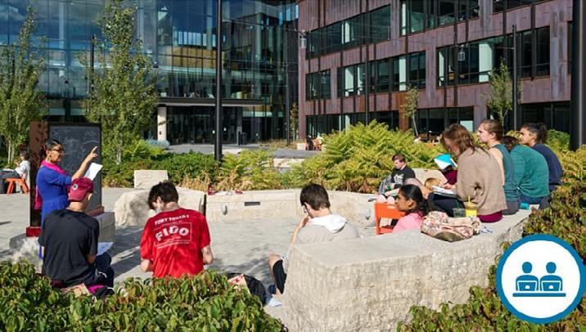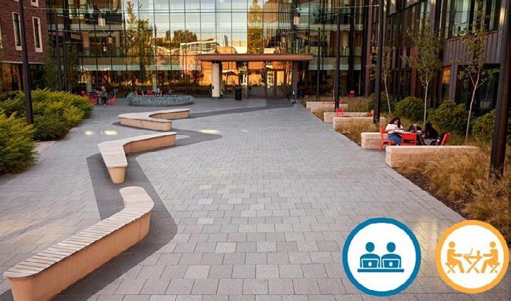

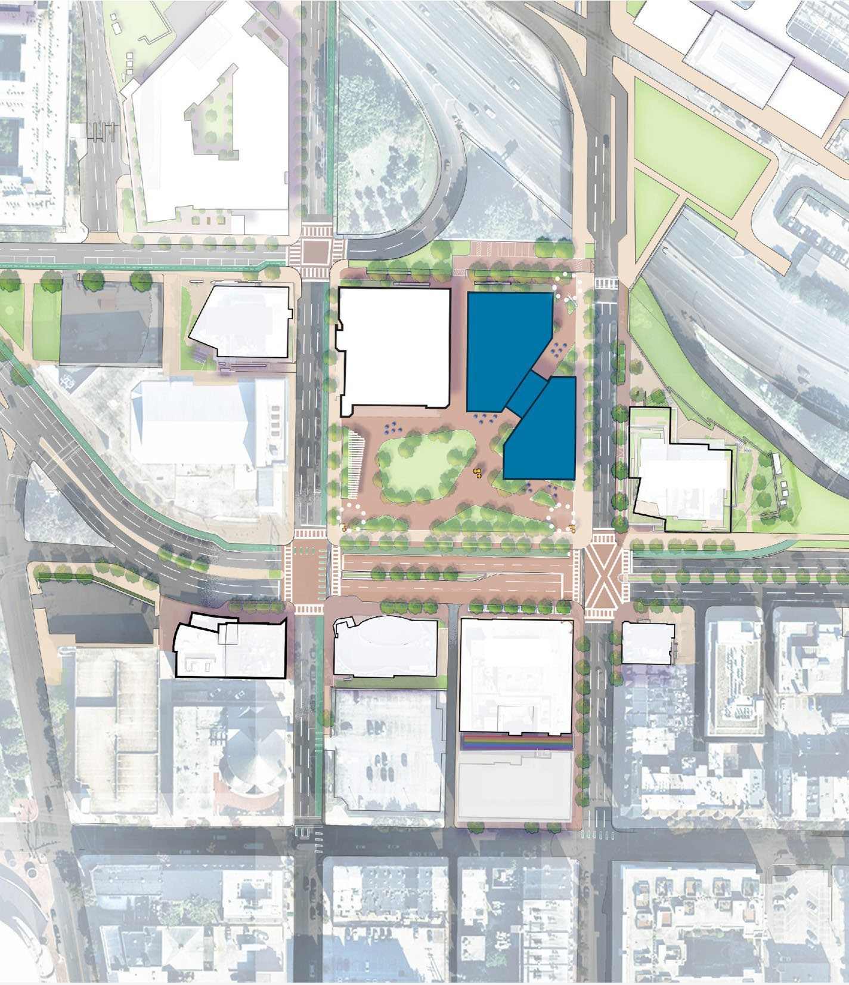
Street Improvements
PENN STATION
3
2
1
GORDON PLAZA
4
5
3
N
PRESTON STREET
MOUNT ROYAL AVENUE
OLIVER STREET
PEDESTRIAN SAFETY AND SENSE OF PLACE*
MARYLAND AVENUE
CHARLES STREET

- Academic Center Replacement & Site Improvements
  - Reduce North Charles Street from 4 to 3 lanes between Mount Royal Avenue and Oliver Street

- Oliver Street Promenade

- Crossing Improvements**

  - Raised crosswalks at Maryland Avenue and Oliver Street

  - Signal change for pedestrian scramble at North Charles Street and Mount Royal Avenue

- Partial closure of I-83 exit 4
offramp**

- Tabletop Mount Royal Avenue between Maryland Avenue and Charles Street
*All require coordination with Baltimore DOT and DPW for traffic and stormwater

**Timing independent of other projects

Conclusion
The 2024 University of Baltimore Facilities Master Plan aligns the physical campus more closely with the institution’s mission, vision, and values. It addresses key issues and opportunities facing the campus today and looks ahead both towards UBalt’s Centennial in 2025 and towards a 10-year future and beyond. The five principles outlined in the planning vision are a flexible framework to guide decision-making as the institution continues to evolve and grow.

UBalt serves a unique student body that is composed of distinct groups of students who require a more modern campus that better supports multi-modal active learning and operations for non-traditional adult students. The plan leverages needed redevelopment in the campus core to address deferred maintenance and reimagine the heart of campus. This new core will reinforce the campus identity while knitting into the surrounding urban fabric. It will thoughtfully create concentrations

of students and cultivate a vibrant atmosphere of collaboration. These investments will position the institution to remain The University of Baltimore- and-The University for Baltimore for years to come.




1420 N. Charles St. Baltimore, MD 21201

www.ubalt.edu

